

Delft University of Technology
Faculty of Electrical Engineering, Mathematics, and Computer Science (EEMCS)
Man-Machine Interaction Group
May, 2006

Traffic Prediction in ABC Networks

B. Sc. Thesis of Octavian Cota

Table of contents
1. Introduction 6
1.1 Ants’ Behaviour in Real Life 6
2. Previous Work 10
2.1 Ants Behaviour and Communicating Networks 10
2.1.1 Network Routing System 11
2.1.2 Ad-hoc Network Model 12
2.1.3 Buffers at a Node 14
2.1.4 Routing Tables and Local Traffic Statistics 17
2.1.5 Routing and Data Packets in the Network 20
2.2 H-ABC: A scalable Dynamic Routing Algorithm 20
2.2.1 Network Model 22
2.2.2 Local Ants 23
2.2.3 Backward Ants 25
2.2.4 Exploring Ants 26
2.2.5 Simulation Environment and Experimental Results 27
2.3 Optimal Vehicle Routing With Real-Time Traffic Information 30
2.3.1 The Model Used 30
2.3.2 Experimental Results 31
3. Literature Survey 33
3.1 Link Travel Time Prediction for Decentralized Route Guidance Architectures 33
3.2 Adaptations of the A* Algorithm for the Computation of Fastest Paths in Deterministic Discrete-Time Dynamic Networks 34
3.3 Traffic Flow Modeling of Large-Scale Motorway Networks Using the Macroscopic Modeling Tool METANET 36
3.4 A Simple and Effective Method for Predicting Travel Times on Freeways 38
3.5 Travel-Time Prediction With Support Vector Regression 42
3.6 State Space Reduction for Nonstationary Stochastic Shortest Path Problems with Real-Time Traffic Information 44
3.7 Literature Survey Conclusions 45
4. Prediction Theory 46
4.1. The Reasons for Traffic Prediction 46
4.2. Traffic Prediction Fundaments 46
5. System Design 52
5.1 The Common Part of the System 52
5.1.1 TNetwork Class 52
5.1.2 TNode Class 55
5.1.3 TLink Class 57
5.2 The City Program 59
5.2.1 TTrafficNetwork Class 61
5.2.2 TTrafficNode Class 63
5.2.3 TTrafficLink Class 63
5.3 The Routing System 64
5.3.1 TAntNetwork Class 66
5.3.2 TAntNode Class 67
5.3.3 TAntLink Class 69
5.3.4 TRoutingTable Class 69
5.3.5 TAnt Class 70
5.3.5.3 Backward Ants Upgrade 71
5.4 The Communication Layer 72
6. System Functionality 74
7. Bibliography 75

Cota, Octavian
(E-mail: octavian.cota@gmail.com)

Scientific Coordinators:
Drs.Dr.L.J.M ROTHKRANTZ, Delft University of Technology
(E-mail: L.J.M.Rothkrantz@ewi.tudelft.nl)
PhD student, Bogdan Tatomir, Delft University of Technology
(E-mail: B.Tatomir@ewi.tudelft.nl)

Keywords: Artificial Intelligence, Intelligent Agents, Dynamic Route Planning, Traffic Prediction

Abbreviations and Notations

ABC – Ant Based Control
H-ABC – Hierarchical Ant Based Control
RIP – Routing Information Protocol
OSPF – Open Shortest Path First (protocol)
MDP – Markov Decision Process
SVR – Support Vector Regression
SVM – Support Vector Machine
TCP/IP – Transmission Control Protocol/Internet Protocol

Implementation conventions:

- All class names begin with the “T” letter, which stands for “type”. When “T” is not preceding a name, an object is being specified.
- Parameter names are preceded by the “P” letter.

Abstract

When dealing with shortest-path algorithms, one might find that the problem is not as easy if the network-model is added more aspects of real-life. Dijkstra-like methods are best suitable for static simple networks, while in graphs with changing properties, questions still arise. The reader will find in this thesis the description of a method for approaching city road traffic and prediction.

An adaptive distributed routing algorithm is being presented, in order to answer the problem of traffic jams. This algorithm also uses prediction, so that vehicle crowds are unlikely to form in certain regions of time and space. The problem is regarded, certainly, in terms of solvable situations.

1. Introduction

This paper deals with the problem of dynamic routing for vehicles in a network. A simulator was built during development of the project. It has two parts containing the same network, one of them dealing with traffic of vehicles, and the other with traffic of intelligent agents, called ants. We will discuss their behaviour further in this chapter. By taking account of the present and future load on the links, a new fast method was discovered, in order to improve the algorithm’s purpose.

This is not the first time when science deals with such routing algorithm. Ant colony behaviour and swarm intelligence was experimented before, by means of distributed protocols, such as AntNet (a routing system which has overtaken the performance of classic protocols, like RIP and OSPF), and H-ABC (a more general variation of ABC, which provides scalability). Like anticipated, these protocols were firstly experimented on packet-switched networks. They all have in common the properties of being dynamic (algorithms that are adaptive to the network’s changes in properties and topology) and distributed (there is no control from a central point, all information being shared among the network).

1.1 Ants’ Behaviour in Real Life

Small animals usually have only local knowledge. When a group of such animals forms, they will interact with each other, exhibiting a higher level of behavior. This is called, in literature, emergent behaviour. A group of social insects like ants does not have a central authority, like a leader that directs them. The social complex behaviour related to ants, displays the following aspects:

- finding the shortest routes from the nest to a food source;
- preferentially exploiting the richest available food source.
- raiding particular areas for food;
- forming bridges;
- sorting brood and food items;
- cooperating in carrying large items;
- emigration of a colony;

Depending on the species, ants may lay pheromone trails when traveling from the nest to food, or from food to the nest, or when traveling in either direction (Fig. 1).

They also will follow these trails, depending on the trail strength, among other variables. Ants drop pheromones as they walk by stopping briefly and touching their gaster, which carries the pheromone secreting gland, on the ground.

The strength of the trail they lay is a function of the rate at which they make deposits, and the amount per deposit. Since pheromones evaporate and diffuse away, the strength of the trail when it is encountered by another ant is a function of the original strength, and the time since the trail was laid.

Fig. 1: The ant lays a pheromone trail

In fig. 2, the ants have to choose between two possible routes. There are no pheromone trails on the road as yet, so we will assume that with a probability of 0.5, each ant will explore one of the roads. Furthermore, we will assume that they will act like this exactly. Fig. 3 shows the pheromone trails left on the ground by the two exploring ants.

Fig. 2: Two ants in search of food

Fig. 3: The ant that chooses the shortest branch will arrive
to destination first.

In general, ants will choose the road with the higher concentration of pheromone (the path where more ants have traveled recently). When the third ant reaches the intersection, it will have a greater probability to choose for the shortest path, because a higher amount of pheromone will arise.
Fig. 4: The third ant will choose biased

In the simulated process of ant based algorithms, the ants will continuously travel among the network, gathering information that will be used in routing, as a process analogous to the one found in nature.

2. Previous Work

Chapter 2 deals with the latest work on traffic routing, especially in the domain of ABC.

A common feature of all the routing algorithms is the presence in every network node of a data structure, called routing table, holding all the information used by the algorithm to make the local forwarding decisions. The routing table is both a local database and a local model of the global network status. Each node i in the network has a probability table for every possible final destination d. The tables have entries for each next neighbouring node n, P_{dn}. This expresses the goodness of choosing node n as its next node from the current node i if the packet has to go to the destination node d.

2.1 Ants Behaviour and Communicating Networks

Ant colonies and behaviour inspired a new kind of routing protocols for fixed, wired communication networks. One of these ‘ant-based’ routing protocols is AntNet. AntNet is an adaptive distributed routing protocol for packet-switched communication network (like the Internet). In distributed routing systems there is no control from a central point, the information is shared among the network nodes. AntNet is also adaptive (dynamic), which means that the routing tables are created by automated construction and by updating. In the dynamic systems, the routing policy adapts to the changes in the traffic conditions and changes in the network topology. The changes in the network topology can be caused, for example, by break down of the links or the nodes in the network. AntNet uses “artificial ants” that would repeatedly travel through the network and collect the information about the current traffic conditions. This information was used to direct the data packets towards their destination. AntNet showed very promising results and turned out to be highly adaptive in dynamic network environments. The capability of AntNet to adapt to dynamic environments seems to make AntNet-like protocol well suited for the routing immobile AntNet. In this thesis, the problem of implementing AntNet to a network topology where the nodes can move is addressed. AntNet is made for fixed network and could not work with the mobile nodes. In order to apply AntNet in this environment, the activities of the artificial ants were adjusted in such a way that they can function in a network with mobile nodes. The dynamic network topology required also changes in the model of nodes. This resulted in a dynamic node model and the introduction of a new buffer. Finally, AntNet and the adjustments resulted into Mobile AntNet.

Mobile AntNet was tested on a software tool AntNet for Ad-hoc network, which is the Java version of Ant Simulator developed by Bogdan Tatomir. The purpose of this conversion to Java is to make the software work on PDAs.

2.1.1 Network Routing System

A network is modeled as a directed graph G= (N, E), consisting of N nodes connected by E edges. Each node is functioning as a communication end-point (a host) and as a forwarding unit. As a host, each node generates data and routing packets with a randomly chosen destination. After that, a packet is sent towards its destination. If a node is not the destination of a packet, the packet is queued in the buffer space in the node and will be forwarded towards its target node. To be able to forward a packet towards its destination node, the node is using information from the routing table.

The main task of a routing algorithm is to direct data flow from source to destination nodes maximizing network performance. In the problems of interest, the data flow is not statistically assigned and it follows a stochastic profile that is very hard to model. In the specific case of communication networks, the routing algorithm has to manage a set of basic functionalities and it tightly interacts with the congestion and admission control algorithms, with the links queuing policy and with the user-generated traffic.

A board classification of routing algorithms is the following:
- centralized versus distributed;
- static versus adaptive.

In centralized algorithms, a main controller is responsible for updating all the node’s routing tables and/or to make every routing decision. Centralized algorithms can be used only in particular cases and for small networks. In general, the delays necessary to gather information about the network status and to broadcast the decisions/updates make them infeasible in practice. Moreover, centralized systems are not fault-tolerant. In this work, exclusively distributed routing is being considered.

In distributed routing systems, the computation of routes is shared among the network nodes, which exchange the necessary information. The distributed paradigm is currently used in the majority of network systems.

In static (or obvious) routing systems, the path taken by a packet is determined only on the basis of its source and destination, without regard to the current network state. This path is usually chosen as the shortest one according to some cost criterion, and it can be changed only to account for faulty links or nodes.

Adaptive routers are, in principle, more desirable, because they can adapt the routing policy to time and spatially varying traffic conditions. As a drawback, they can cause oscillations in selected paths. This fact can cause circular paths, as well as large fluctuations in measured performance. In addition, adaptive routing can lead more easily to inconsistent situations, associated with node or link failures or local topological changes. These stability and inconsistency problems are evident for connection-less than for connection-oriented networks.

2.1.2 Ad-hoc Network Model

The nodes and the links in this model could be explained as follows.
• The nodes in the graph are representing the computing devices. Each node has a node identifier (unique number) and it is functioning as both a host and a router .As a host, the node can be a communication end-point. This means that it can be a source and a possible destination of a data message. Each node holds a buffer space where the incoming and the outgoing packets are stored. This space is limited by a node capacity [bits]. The nodes are also the routers. They are able to forward data messages, and to send and receive routing packets. Fig. 5 expresses the way connections between nodes are established.

Fig. 5: Making connection between nodes. The circles around C and D are
giving the transceiver range of these nodes. The nodes
A and B are in the range of the node C and they are
connected to C while D is out of range and not connected to C

• In Mobile AntNet, the nodes communicate via wireless links. Each node has a limited transceiver range. It is assumed that two nodes are connected with each other if the distance between them is smaller than a given maximum distance. All the links in the network are bi-directional. They are characterized by a bandwidth [bit/sec] and a transmission delay [sec]. Although wireless communication deals with the effects of radio communication, such as noise, fading, and interference, they were not taken in consideration. The links are assumed to be reliable.

Because the intention is to simulate the reality as much as possible, the fixed bandwidth was replaced by a flexible one. The bandwidth changes according to the link’s length, as shown in table 1.

Table 1: Link lengths and corresponding bandwidths

In Mobile AntNet, network topology is dynamic, because the connectivity among the nodes is changing as they are moving. While moving, the nodes can stay connected to other nodes but they can also be completely without neighbours. In this particular approach, the nodes are spread over previously defined area. They can move everywhere within this area but they are unable to go out of this area. No new nodes can be introduced in the network. A node in the network will always know who its neighbours are. So, while moving, a node will immediately know its new neighbours, and in every moment during the simulation it knows how many neighbours it has.

Four different moving modes of a node were investigated. The moving modes and the speed that a node would have in the real world (between the brackets is given a step size) are the following:

- Fixed mode 0 km/h - the network is connected and the nodes are not moving.
- Walk mode 5 km/h (step size is 0.0175 of the maximum distance) ;
- Bike mode 15 km/h (step size is 0.0525 of the maximum distance);
- Car mode 72 km/h (step size is 0.25 of the maximum distance).

Each node has four levels of liberty (up, down, left or right). All nodes are making their steps at the same time, and after that they will automatically update their list of neighbours.

2.1.3 Buffers at a Node

Every node in Mobile AntNet works both as a host and a router and it has also the possibility to move. These properties have influence on the structure of the nodes’ model. This section will discuss buffers at the nodes’ model used in Mobile AntNet.

Each connected node has three kinds of buffers:

- Input buffer;
- Output buffer with high- and low-priority queues for every neighbour;
- Ad-hoc buffer with one queue for each destination in the network.

The originally AntNet uses nodes with two buffers: the input and the output buffer.
In the Mobile AntNet an extra buffer was implemented – the Ad-hoc buffer. All these can be seen in fig. 6.

Fig. 6: Compared to AntNet, Mobile AntNet was added one
extra buffer, called Ad-hoc buffer.

The topology of the Ad-hoc network may change rapidly due to node’s ability to move. The node’s model strongly depends on the number of node’s neighbours. This means that as it is moving, the node’s structure will change as a result of getting or losing the neighbour(-s). Obviously, the dynamic properties of the network demand also a dynamic structure of the nodes.
To describe the functioning of the buffers in a node, the following situations that may occur were analyzed:

- connected network with no topology changes;
- topology of the network is changing
- a node becomes isolated.

Nodes communicate directly with each other if the distance between the nodes is smaller than the given maximum distance. As they are moving, the distances between the nodes will vary, and in this way the neighbourhood of a node is changing. A node will lose its neighbour, for example, if the distance between the node and its former neighbour becomes bigger then the maximum distance. Thus, while moving, a node can get a new neighbour, lose a neighbour or current neighbours remain the same. The changes in the neighbourhood of the node will influence its structure. Fig.7 illustrates these aspects.

a. b.
Fig. 7. The impact of the mobility of nodes to network topology. In a, a network is given at the beginning of the simulation, and in b the ‘same network’ during the simulation.

If a node gets a new neighbour or loses a neighbour, its structure is changing. The reason for this is that each node has in its outgoing buffer, the (low- and high-priority) buffer queues for every neighbour. Therefore, when a node gets a new neighbour, the node will create new queues that are corresponding with the link to the new neighbour. Otherwise, if a node loses its neighbour, then the node will destroy the queues that are leading to that neighbour. The data packets that were in the destroyed buffer queue are put back in the input buffer, and they will be re-routed. The routing packets (ants) from the high-buffer queue are immediately destroyed. They are destroyed, because if they have to wait again in the input buffer, the information that they carry with them would be too old to be taken into the consideration. Therefore some ants will not get back to their source. If a node doesn't get any response for a while, and that is if there are no ants that are coming back from a certain node, then it is said that node is seen as unreachable. If such situation occurs, then a data packet that has this unreachable node as its destination is put from the input buffer to the Ad-hoc buffer. In this buffer the packet will stay until its destination node becomes reachable again or until its lifetime expires. Before putting a new packet in the Ad-hoc buffer, its contents will be checked to see if there are packets whose lifetime has expired. These packets will be destroyed. To be able to control this buffer regularly, each node has a queue for every possible destination in the Ad-hoc buffer. As soon as some destination is reachable again, the Ad-hoc buffer that responds with this node is emptied and the packets are re-routed to that destination. These packets are not going back to the input buffer, but they are put directly to the queue in the output buffer that corresponds to their next hop. As there are at least two nodes that were disconnected from each other, both of them will send their packets towards each other. The final result of this process is that at the certain moment (when the nodes become reachable again for each other) a large amount of packets will be sent and received in short period of time. This is called the Ad-hoc buffer effect. This effect may have impact on the data flow in the network.

If a node has no neighbours, then the node will have only the input and the Ad-hoc buffer. As soon as this situation occurs, all the data packets that were in the node’s output buffer are put in the corresponding queues in the Ad-hoc buffer. At the same time, all routing packets in that node are destroyed. The node keeps generating both classes of packets. As long as the node is disconnected from the rest of the network (has no neighbours), the routing packets are destroyed immediately, and the data packets are put in the Ad-hoc buffer.

2.1.4 Routing Tables and Local Traffic Statistics

A routing table is a local database that helps router to decide where to forward data packets. It contains the information which specifies the next (neighbour) node that should be taken by a data packet to get to any possible destination in the network. Each routing table is organized as a set of:
- all the possible destinations (all the nodes in the network),
- the probabilities to reach these destinations through each of the neighbours of the node (next hops).

A routing table in a node i is given as Pi= {pjd} with pjd, a probability value that expresses the goodness of choosing node j as its next node from the current node i if the packet has to go to the destination node d. For any connected node i it holds that Σj Pjd=1; where j is a neighbour of node i and d is an arbitrary destination from all nodes in the network.

This means that the sum of all probabilities to get to a randomly chosen destination d from the node i is equal to 1. Considering the routing table in fig. 8 for example, the sum pi1+ pj1+ pk1 is always 1. This corresponds to a situation that exists in the fixed networks, but if the nodes are moving (like stated in the Mobile AntNet model), then some destinations will not be reachable. For these destinations, the ants will be unable to update the routing tables. Therefore there will be no probabilities corresponding to these destinations. In the case when a node has no neighbours, the node is unable to send any ants. Obviously, all destinations are unreachable, and the routing table will be empty.

From the ant colony point of view, the probabilities in the routing tables can be seen as amount of pheromone. The probabilities are the product of continuous exploration process of the ants. They are updated by the ants that previously used a path that is leading to the same destination.

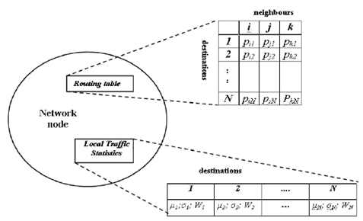
Fig. 8: The data structures in a node: routing table and local traffic statistics.
The presented node has i, j and k as its neighbours, and the destinations are all
nodes in the network. The network has N nodes

Local traffic statistics is a second data-structure that each node holds. The main task of this structure is to follow the traffic fluctuations in the network. It is given by an array Mi (μd, σd², Wd) that represents a sample means μd and variance σd² computed over the packet’s delay from node i to all the nodes d in the network, and value Wd where the packet’s best trip time towards destination d is stored. The array Mi contains statistics about the traffic from node i towards each possible destination d. The mean μd and variance σd² are giving an expected trip time and its stability:
$μ_{d}←μ_{d}+η(o_{k→d}−μ_{d})$ (1)
$σ_{d^{2}}←σ_{d^{2}}+η[(o_{k→d}−μ_{d})^{2}−σ_{d^{2}}]$ (2)

where o_{k->d} is the new observed agent’s trip time from node k to destination d.

W_{d} is obtained by applying a moving observation window of size x to store the agents’ trip time to destination d. This window is used to compute the best agents’ trip time towards destination d, W_{best} as observed in the last x samples. W_{best} represents a short term memory and it should follow the fluctuations of the traffic in the network. Obviously, this can not be the best trip time, but only a moving (temporary) lower bound of the time needed to travel from the current node to some destination node d. The factor η weights the number of most recent samples that will really affect the average. The weight of the t_{i} sample used to estimate the value of μ_{d} after j sampling, with j>i, is: η (1- η )^{j-i}. In this way, for example, if η =0.1, approximately only the latest 50 observation will really influence the estimate, for η = 0.05, the latest 100, and so on. Therefore the number of effective observations is ≈ 5(1/η).

2.1.5 Routing and Data Packets in the Network

Nodes in the network generate packets with a randomly chosen destination. All the packets in the network are subdivided in two classes:

- Routing packets are generated constantly with a defined generation period over an exponential distribution. They have a task to collect and distribute information about the traffic load in the network. The routing packets are the artificial ants (ants) or agents.
- Data packets are representing information that the end-users exchange with each other. These packets are generated with a Poisson distribution.

2.2 H-ABC: A scalable Dynamic Routing Algorithm

It has been shown in [1] that for small networks, ant based algorithms proved to perform better than conventional routing algorithms. Their performance decreases when increasing of the number of nodes in the network. The scalability of the algorithms is affected by the increasing number of agents used. They are carrying no stack which reduces the overhead in the network. The algorithm was implemented and its performance compared with the well known AntNet.

The AntNet adaptive agent-based routing algorithm [2], [3], is the best-known routing algorithm for packet-switched communications networks, which is inspired from the ants’ life. Besides the probability tables, at each node the average trip time, the best trip time, and the variance of the trip times for each destination are saved. Routing is determined through complex interactions of network exploration agents. These agents (ants) are divided into two classes, the forward ants and the backward ants. The idea behind this sub-division of agents is to allow the backward ants to utilize the useful information gathered by the forward ants on their trip from source to destination. Based on this principle, no node routing updates are performed by the forward ants, whose only purpose in life is to report network delay conditions to the backward ants. This information appears in the form of trip times between each network node. The backward ants inherit this raw data and use it to update the routing tables of the nodes. In [4] AntNet was improved with an intelligent routing table initialization, a restriction on the number of ants in the network and a special pheromone update after node failures. An increased adaptivity of ants [5] and reduced size of the routing tables [6] was achieved by combining AntNet with genetic algorithms.

Although proved to perform better than the best classic algorithms like RIP and OSPF, AntNet and ABC have scalability problems [7]. Since each node has to send an ant to all the other nodes of the network, for large networks, the amount of traffic generated by the ants would be prohibitive. Furthermore, for distant destinations there is a larger likelihood of the ants to be lost. Moreover, the large traveling times of the ant render the information they carry outdated.
One way to solve this load problem and attain scalability is by using hierarchical routing. Adaptive-SDR [7] groups nodes into clusters and directs data packets from a source node to a destination by using intra and inter-cluster routing. Two types of agents are introduced into the network. The first type is colony ants and the second type is local ants. The task of the colony ants is to find routes from one cluster to the other, while local ants are confined within a colony and are responsible for finding routes within their colonies. The colony ants are launched at every node. This keeps the overhead high. The algorithm used in [1] will be described step by step by means of the following sections.

2.2.1 Network Model

The network was split into sectors. The nodes situated at the border of a sector and which have connection with other sectors are called routing nodes [1]. These nodes will play a special role, their activity being different than the one of an inner sector node. An example of such a network is shown in fig. 9 representing the Japanese Backbone NTTNet divided in 3 sectors. The routing nodes are circled.

Fig. 9 The Japanese NTTNet

In this case, the routing tables need to be modified. For every sector of the network, a virtual node is introduced. This can be understood as an abstraction for all the nodes of the sector. Each virtual node will have an entry in the data structures of every node. They will be used to route the data between different sectors. Considering the network with 3 sectors in fig. 9, one can give the following example:

Table 2: Routing table for node 12

Every node i has also been added the following additional data structure:
- μ_{d}: an array storing the mean value of the delay encountered for destination d
- S[d]: an array which maps every node in the network to the corresponding sector
- U[d]: an array of flags which mention if a node d is 'up' or 'down'

2.2.2 Local Ants

The purpose of the local ants is to maintain the routes between nodes of the same sector or to the closest routing node for another sector. Each node s inside a sector periodically generates a local ant F_{sd}. The destination d can be another node in the sector or a virtual node:

d is
- a node in the same sector(S[d] = S[s]) with probability of 0.9
- a virtual node(S[d] ≠S[s]) with probability of 0.1

The routing nodes have a different behaviour. In this case:

F_{sd} is
- local ant(S[d] = S[s]) with probability of 0.1
- exploring ant (S[d] ≠S[s]) with probability of 0.9

A local ant behaves similar with the forward ant in AntNet. It keeps a memory about the visited nodes and the estimated time to reach them. At each node i, before going to the next neighbour n, the ant memorizes the identifier of the next node n and a virtual delay T_{in}. This delay represents the estimative time necessary for the ant to travel from node i to n using the same queues as the data packets.

$T_{\text{in}}=\frac{q_{n}+\text{Size}(F_{\text{sd}})}{B_{\text{in}}}+D_{\text{in}}$ (3)

- q_{n} [bits] is the length of the packets buffer queue towards the link connecting node i and its neighbour n;
- B_{in} is the bandwidth of the link between i and n in [bit/s];
- Size(F_{sd}) [bits] is the size of the local ant;
- D_{in} is the propagation delay of the link.

The selection of the next node n, to move to, is done according with the probabilities P_{d} and the traffic load in node i.

$P_{\text{dn}}'=\frac{P_{\text{dn}}+α⋅l_{n}}{1+α⋅(|\text{Ni}−1|)},α=0\text{.}4∈[0,1]$ (4)

l_{n}∈ [0; 1] is a normalized value proportional to the amount q_{n} (in bits waiting to be sent) on the link connecting the node i with its neighbour n:

$l_{n}=1−\frac{q_{n}}{\sum_{j=1}^{|N_{i}|}{q_{j}}}$ (5)

If a cycle is detected, the cycle's nodes are popped from the ant's stack and all the memory about them is destroyed. If the cycle is greater than half the ant's age, the complete ant is destroyed.
A local ant is not allowed to leave his sector. In this way all the probability tables of the routing nodes will have P_{dn} = 0 (see Table 2 - N15) if:

- S[d] = S[i]: the destination is a node inside the sector
- S[n] ≠S[i]: the neighbour n is in another sector

For a local ant there are two possibilities to reach its destination. One is of course when it arrives in the node d. But when d is a virtual node it stops at the first encountered routing node. In this case it pushes on the stack the node d identifier and μ_{d}, the average time to go from node i to the sector d. At this moment the agent F_{sd} finishes its trip. It transfers all of its memory to a new generated backward ant B_{ds} and dies.

2.2.3 Backward Ants

A backward ant takes the same path as that of its corresponding local ant, but in the opposite direction. At each node i along the path it pops its stack to know the next hop node. It updates the routing tables for the node d but also for all the subpaths from i to d. The time T_{id} to reach d is the sum of all the segments T_{jk} on the path:

$T_{\text{id}}=\sum{T_{\text{jk}}}$, where j, k∈ i→d (6)

First it modifies the value of μ_{d}.

$μ_{d}=μ_{d}+η(T_{\text{id}}−μ_{d}),η=0\text{.}1$ (7)

After this it updates the probability table with a reinforcement value r. This is a function of the time T_{id} and its mean value μ_{d..}

$r=\left\{\begin{matrix}\begin{aligned}\frac{T_{\text{id}}}{c⋅μ_{d}};\frac{T_{\text{id}}}{c⋅μ_{d}}<1,c=1\text{.}1>1 \\ \end{aligned} \\ 1,\text{otherwise}\end{matrix}\right.$ (8)

$P_{\text{dn}}'=P_{\text{dn}}+(1−r)(1−P_{\text{dn}})$for n - the node chosen by the ant (9)

$P_{\text{dj}}'=P_{\text{dj}}+(1−r)(1−P_{\text{dj}})$ for j ≠ n (10)

When the source node s is reached again, the agent B_{ds} dies.

2.2.4 Exploring Ants

The purpose of exploring ants is to find and maintain the routes between different sectors. They are 'light' and keep no track about the path they followed. The only information they register is an estimate time to reach their source sector T_{s}.

The exploring ants are generated only by the routing nodes of each sector s. They receive as destination d, a virtual node representing another sector. In this case, s is being referred not to the source node, but to the sector.

They are forwarded to destination using the same mechanism as the local ants. If a cycle is detected it is removed, and in case it is bigger than half of the ant age, the ant is killed.

As the local ants which are not allowed to get out of the current sector, the exploring ants are not allowed to move to a node inside their source sector. Once they left the home sector they can't return. If this still happens, the exploring ant is killed. This is because there are other routing nodes in the same sector which are closer to the destination sector d of the ant. The ants generated there will be more efficient with that destination. When an exploring ant arrives in a node i coming from a node p, it adds to its trip time T_{s} the trip time necessary for ant to travel from i to p.

$T_{s}=T_{s}+T_{\text{ip}}$ (11)

$T_{\text{ip}}=\frac{q_{p}+\text{Size}(F_{\text{sd}})}{B_{\text{ip}}}+D_{\text{ip}}$ (12)

The new computed T_{s} value is used to update the routing table at node i. The changes are similar with the ones made by the backward ants, but they are done only for the source sector s.

$μ_{s}=μ_{s}+η(T_{\text{is}}−μ_{s})$ (13)
$r=\left\{\begin{matrix}\begin{aligned}\frac{T_{s}}{c⋅μ_{s}};\frac{T_{s}}{c⋅μ_{s}}<1 \\ \end{aligned} \\ 1,\text{otherwise}\end{matrix}\right.$ (14)

The reinforcement is given to the link i→p:

$P_{\text{sp}}'=P_{\text{sp}}+(1−r)(1−P_{\text{sp}})$ (15)

$P_{\text{sj}}'=P_{\text{sj}}+(1−r)P_{\text{sj}}$ for jp (16)

An exploring ant ends its trip when arrives at a routing node of the destination sector d.

2.2.5 Simulation Environment and Experimental Results

The algorithm was integrated in a new simulation environment, and compared to the AntNet. In literature, the most complex network instance that was mostly used in simulations is the Japanese Internet Backbone (NTTNET) (see fig. 9). It is a 57 node, 81 bidirectional link network. The link bandwidth is 6 Mbits/sec and propagation delay rages from 0.3 to 12 milliseconds. In order to create a more challenging environment, two copies of the NTTNet network were linked and added 10 extra links (see fig. 10). The result is a network with 114 nodes and 172 bidirectional links.

Traffic is defined in terms of open sessions between two different nodes. At each node, traffic destination is randomly chosen between the active nodes in the network and remains fixed until a certain number of packets (50) have been sent in that direction. The mean size of data packet is 4 Kbytes, the size of an agent is 192 bytes. The queue size is limited to 1 Gb in all experiments. The H-ABC performance was studied by relating to the number of sectors the network was divided into. Three versions of the H-ABC algorithm were tested:

- H-ABC2: network with 2 sectors
- H-ABC4: network with 4 sectors
- H-ABC6: network with 6 sectors

It is stated that H-ABC is a more general algorithm than AntNet, because AntNet is exactly H-ABC1 (The hierarchical ABC with a single sector).

Fig. 10: Traffic network between three cities

A routing algorithm should perform well not only under heavy traffic load but also under low load over the network. To achieve such a traffic the mean packet generation period (PGP) was set to 0.3s. Fig. 11 shows the average packet delay. The average packet delay for H-ABC6 and H-ABC4 is below 250ms, around 250ms for H-ABC2 and above 300ms for AntNet.

Fig. 11: Average packet delay under low traffic load

For the test of high link load the mean packet generation period was decreased to 2ms. Again
H-ABC4 and H-ABC6 scored the best. They delivered 99% of the packets with an average delay below 1s. H-ABC2 delivered 98% of the packets and after an increasing slope the average delay went down to 1s. The AntNet had not so good performance. Just 83% of the packets reached the destination with an average delay of more than 5s. As expected from the difference between the packets delivered ratios, the throughput of H-ABC algorithms ≈ 2250Kb/s is higher than the average throughput of AntNet ≈ 1900Kb/s.

a. b.
Fig. 12: Experimental results under high traffic load:
a. Average packet delay; b. Average throughput

The overhead of the algorithms was computed in the following manner: a short
50s test was run with only agents running in the network and measured bandwidth capacity usage. The overhead decreased with the number of sectors. AntNet agents used about 0.375%, H-ABC2 ≈ 0.175%, H-ABC4 ≈ 0.095% and H-ABC6 ≈ 0.065% of the network capacity.

Features from several ant based algorithms were combined to obtain a highly scalable and robust algorithm. Its performance was tested in a simulation environment and compared with AntNet. H-ABC performed better both in low and high traffic load, but also in case of transient overloads over the network. With a low overhead it delivered faster the packets to destination, decreasing also the number of lost ones. Dividing the network in sectors was very effective. The results of the H-ABC4 and H-ABC6 are similar so a granular fragmentation of the network is not necessary.

2.3 Optimal Vehicle Routing With Real-Time Traffic Information

This is one of the most recent techniques in traffic routing. It deals with improving service levels for just-in-time delivery [8].

The network used by the authors is composed of links having nonstationary travel times, where a subset of these links are observed in real time.

Two algorithms are being described for this problem:
- algorithm 1: for determining an optimal departure time
- algorithm 2: for determining an optimal departure time minimizing vehicle usage

2.3.1 The Model Used
Tthe nonstationary stochastic shortest path problem with real-time traffic information is formulated as a discrete time, finite horizon MDP (Markov decision process). Consider an underlying network G ≡ (N, A), where the finite set N represents the set of nodes and A ⊆ N x N is the set of directed links in the network. This network serves as a model of a network of roads (links) and intersections (nodes). By this, it is meant that (n, n’) ∈ A if and only if there is a road segment that permits traffic to travel from intersection n to intersection n’. Let n₀ ∈ N be the start node and the set Γ ⊆ N be the goal node set. For each element n ∈ N define the successor set of n (denoted SCS(n)) to be the set of nodes that have an incoming link emanating from n. That is, SCS(n) ≡ {n’ | (n, n’) ∈ A}. A path p = (n₀, . . . , n_{K} ) from n₀ ∈ N is a sequence of nodes such that n_{k+1} ∈ SCS(n_{K}) for k = 0, 1, . . . , K − 1. A path from any node in the network to the goal node set is assumed to exist.
A link (n, n’) ∈ A is said to be observed if real-time traffic is measured and reported on (n, n’). Suppose that there are Q observed links in A. The (random) road congestion status vector at time t to be Z(t) = {Z¹(t), . . . , Z^{Q}(t)} is defined so that the random variable Z^{Q}(t) is:

$Z^{Q}(t)=\left\{\begin{matrix}\begin{matrix}0, & \text{if} & \text{the} & \text{qth} & \text{link} & \text{is} & \text{uncongested}\end{matrix} \\ \begin{matrix}1, & \text{if} & \text{the} & \text{qth} & \text{link} & \text{is} & \text{congested}\end{matrix}\end{matrix}\right.$(17)

for q = 1, 2, . . . ,Q. A realization of Z(t) is denoted by z. Thus, z ∈ H ≡ {0, 1}^{Q}. It is assumed that {Z^{i}(t), t = t₀, t₀ + 1, . . .} and {Z^{j}(t), t = t₀, t₀ + 1, . . .} are independent Markov chains for
i ≠ j. For each q = 1, 2, . . . ,Q, the dynamics of the corresponding Markov chain are assumed to be described by the one step transition matrix:

$R_{q}^{t,t+1}=\left[\begin{matrix}α_{t}^{q} & 1−α_{t}^{q} \\ 1−β_{t}^{q} & β_{t}^{q}\end{matrix}\right]$(18)

2.3.2 Experimental Results
The algorithms described have been tested on the path shown in fig. 13. The cost savings achieved are illustrated in fig. 14. For instance, between 6:00 and 9:00 A.M., the percentage savings in total cost by using historical traffic data compared to the base case with commercial logistics software is 4.39%. An additional savings of 2.57% can be achieved by using real-time traffic information together with historical traffic data.

Fig. 13: An example of the origin and destination pair analyzed

The results exhibit the intuitive idea that real-time information can be quite useful during times of potential heavy congestion like during rush hour times and less useful when the traffic volumes are low. By analyzing the results, it is suggested that an appropriate level of traffic information should be provided for each trucking company. For example, if a package delivery company usually ships packages at night, expensive real-time traffic information may not be warranted. However, for a trucking company, that is responsible for the just-in-time delivery of products to automobile assembly plants arriving in the morning or afternoon rush hours, a real-time traffic information system can provide a significant payoff.

Fig. 15 shows the reduction of vehicle usage (percent) by using historical and real-time traffic information over different time zones achieving at most the same cost as the minimal cost in the case with commercial logistics software. The results show that the vehicle usage reduction due to real-time traffic information is about 28% of the total reduction in vehicle usage during rush hours in the morning. During rush hours in the afternoon, the vehicle usage reduction due to real-time traffic information constitutes about 58% of total. Even when the traffic volume is relatively low, for example, between 6 P.M. and 6 A.M., the reduction in vehicle usage due to real-time traffic information is approximately 22%. This implies that no matter what time of day (during rush hours or not), the real-time traffic information may play a major role in vehicle usage reduction.

Fig. 14: Cost savings by historical and real-time traffic
information over time

Fig. 15: Reduction in vehicle usage by historical and real-time
traffic information over time

3. Literature Survey

This chapter deals with the various prediction approaches in traffic routing. It provides information about state of the art prediction techniques in routing systems/guidance architectures. A description of a fast robust ‘on-the-fly’ method can be found in section chapter 4.

3.1 Link Travel Time Prediction for Decentralized Route Guidance Architectures

This approach is similar to our project's “backward ants” [1]. It uses a discrete space for timing (called 'time slices' [9]). There are only updates related to a single link at a time (ABC uses updates for each link in a path).

Initial applications of SAVaNT [9] demonstrated that anticipatory route guidance computed by the SAVaNT method can be employed effectively in large-scale application under low ( 30%) market penetration rates. Predictive route guidance at these levels was found to be superior to nonpredictive route guidance methods. At market penetrations above 30%, however, SAVaNT sometimes produced less efficient routings than nonpredictive methods and sometimes produced no solution at all.

Formula used:

(19)

where c_{l}(t) is defined as the predicted link travel time for link l during time slice t, c_{l}^{i}(t) represents the travel time reported by the vehicle making the ith departure from link l during time slice t.

The first valuable idea from this article is to use predictions only once at k steps. If the time space is discretised into {t1, t2, t3,... tn}, we can take k steps and predict link capacity and density as follows: P1: {t1, t2, t3,.. tk}, P2: {tk+1, tk+2,... t2k} etc. The reader can refer to section 5.2 for a more detailed description. A straightforward approach, which is not stated in the article, would be to use backtracking in order to direct ants through nodes (In case of congestion at step s, the previous directing at step s-1 is inefficient. This leads to redirecting at step s-1).

3.2 Adaptations of the A* Algorithm for the Computation of Fastest Paths in Deterministic Discrete-Time Dynamic Networks

This extension of the A* algorithm is suitable for establishing improved lower bounds on the minimum travel time in dynamic time-extended networks. It can also provide a best departure time for a given vehicle. This solves the problem that certain commercial agents have, that is: a wrongly chosen departure time will result in a bigger financial cost than waiting until the path is less congested [10].

For the algorithms described, only mathematical fundaments are provided. There is a consistency assumption involved in these projects, which is a type of triangle inequality. This is useful for further improvements of our routing system. Let n and m, respectively, denote the number of nodes and arcs in a network. It has been proved by Sedgewick and Vitter in [11] that the A* algorithm finds a shortest path in many Euclidean graphs with an average computation effort in O(n) compared to O((m+n)*log(n)) required by a heap implementation of a LS algorithm. However, the adaptations of the A* algorithm can go as far as O((M+n)(m+n)M) time complexity, where M is the number of discrete-time intervals in the dynamic network.
It is important to use aspects of the mathematical model of the time-expanded network described, although implementation details are not yet available.

The main ideas one can further use are related to time expanded networks, which have the following properties:

- Along the time dimension, they are acyclic if arc travel times are positive, and multileveled if arc travel times are nonnegative.

- Every path on the original dynamic network corresponds to a path on the time-expanded network with the same travel time and travel cost. Visiting a node in the original dynamic network at time t corresponds to visiting node-time pair (i, t) in the corresponding time-expanded network.

- A shortest path problem in a dynamic network can be solved by applying a static shortest path algorithm to its equivalent representation as time-expanded network.

- A consequence of the last two properties is: dynamic shortest path problems can be solved by (implicitly) applying static shortest path algorithms to the time-expanded representation of a dynamic network.

Other important aspects of these algorithms are the FIFO property of road traffic, which we can use in our future implementation, the estimations of the cost of a path, the a priori knowledge (like location of the vehicles before simulation) in order to predict the traffic over a time period. The Euclidian distance between two intersections can be an estimation of the path between them, as it preserves the triangle inequality property.

3.3 Traffic Flow Modeling of Large-Scale Motorway Networks Using the Macroscopic Modeling Tool METANET

This paragraph deals with the simulation of traffic along the motorway network around Amsterdam. The model described is used for estimating traffic, not for routing. Consequently, motorway links (m) are divided into N_{m} segments. Each segment’s traffic is estimated over a period of time.
The “macroscopic variables” [12] defined here can be seen as measurements of the load of a particular segment:

• Traffic density: ρ_{m,i}(k) (veh/km/lane) is the number of vehicles in segment i of link m at
time k*T divided by the length of the segment L_{m} and by the number of lanes λ_{m}.
• Mean speed: v_{m,i}(k) (km/h) is the mean speed of the vehicles included in segment i of
link m at time k*T.
• Traffic volume or flow: q_{m,i}(k) (veh/h) is the number of vehicles leaving segment i of
link m during the period [k*T, (k+1)*T], divided by T.

For the “destination-oriented mode” [12] of operation, the following variables are introduced:
• The partial density ρ_{m,i,j}(k) is the density of vehicles in segment i of link m at time k*T
destined to destination j∈J_{m}, where J_{m} is the set of destinations reachable via link m.
• The composition rate γ_{m,i,j}(k)∈[0,1], is the portion of traffic volume q_{m,i}(k) which is destined to destination j∈J_{m}.

Origin and Store-and-Forward Links: For origin links, i.e., links that receive traffic demand and subsequently forward it into the motorway network, a simple queue model is used. Origin links are characterized by their flow capacity and their queue length. The outflow q_{o}(k) of an origin link o is given by:

(20)

where d_{o}(k) is the demand flow at time period k at origin o, w_{o}(k) is the length (in vehicles) of a possibly existing queue at time period k, q _{max,o} (k) is the flow capacity at the specific period and r_{o} (k)∈[r_{min},1] is the metering rate for origin link o at period k. If r_{o} (k)=1, no ramp metering is applied. If r_{o} (k)<1 then ramp metering becomes active. The flow capacity depends on the density of the primary downstream leaving link μ in the following way:

(21)

where Q_{o} is the (constant) flow capacity of the origin link and p(k) is the portion of Q_{o} that can enter link μ, where

(22)
with ρ_{max} the maximum possible density in the network’s links. Thus, eqs. (21), (22) reduce the (geometrical) flow capacity Q_{o} when traffic conditions on the mainstream become congested.
The conservation equation for an origin link yields

(23)

In the destination-oriented model, the notion of partial queues is introduced. Partial queues at an origin link evolve according to the relationship

(24)

where w_{o,j}(k) is the number of vehicles in the queue of origin link o with destination j, γ_{o,j}(k), = w_{o,j}(k)/w_{o}(k), and v_{o,j}(k) is the portion of the demand originating in o at period k and having j as its destination. In order to enable the model to consider mtm control measures and also to approximately consider urban zones, the store-and-forward links are used. These links are characterized by their flow capacity, their queue length, and their constant travel time. For the determination of their outflow and their queue length, equations similar to (20)–(24) hold.

An interesting idea would be to add Amsterdam’s motorway network described here to our simulation maps. Some of the measurements used for traffic prediction can be added to the ABC project (and maybe some of our own). The ABC routing system can also compute measurements of the load of a link, without transforming the actual link into several segments. This is because one can assume that the traffic is uniformly distributed over a link (there is no reason to overload our model with data, as we can compute, for example, the density, for homogenous links). It is also straightforward to assume that the traffic is loaded in the vicinity of the end of a link, considering the link sense.

3.4 A Simple and Effective Method for Predicting Travel Times on Freeways

The method described does not aim for sophistication or statistical optimality, but for “ease of implementation and computational efficiency” [13].
Two naive predictors of T(d,t+δ) are the instantaneous travel time T*(d,t) and the historical average T_{av}(d,t+δ). It is expected - and, indeed, this is confirmed by an experiment—that T*(d,t) predicts well for small δ and T_{av}(d,t+δ) predicts better for large δ. These predictors are being improved by the method described for all δ.

Linear Regression
The following model is being proposed:
(25)

where ε is a zero-mean random variable modeling random fluctuations and measurement errors. Note that the parameters α and β are allowed to vary with t and δ. Linear models with varying parameters are discussed by Hastie and Tibshirani [14].

At the time of this algorithm’s publication (2004), an Internet application was under development. It was intended to give the commuters of CalTrans District 7 (Los Angeles) [13] the opportunity to query the prediction algorithm.
Consider an array v(d, l, t), d∈D, l∈L, t∈T denoting the velocity that was measured on day d at loop l at time t. In Fig. 16, an example of a velocity field for one day can be seen. From v, one can approximate the time T(d, t) needed to travel from loop 1 to loop L starting on d at time t. This travel time can be thought of as belonging to a path through the velocity field. It is important to note that in order to actually compute T(d, t) one needs information after time t.
Using information available at time, one can compute a proxy for the travel time defined as:

(26)

where d_{l} denotes the distance from loop l to loop (l+1). T* is the travel time that would have resulted from the departure from loop 1 at time on day when no significant changes in traffic occurred until loop L was reached. It is called the instantaneous or current status travel time.

Fig. 16: Velocity field v(d, l, t) where day d = June 16, 2000. Darker shades refer to lower speeds. Note that the typical triangular shapes indicate the morning and afternoon congestions building and easing. The horizontal streaks are most likely due to detector malfunction.

The goal is to predict T(d, t+δ) for δ≥0 (δ is called “time lag”[13]) on the basis of the available data on day d at time t. This problem, even when δ=0, is not trivial.
It has been proven that there are relationships between T*(d, t) the actual time T(d, t+δ), for all t and δ. This is illustrated in fig. 17 and 18.

Fig. 17: T (9AM) versus T (9AM). Also shown is the regression line with intercept α = 17.3 and slope β = 0.65.

Fig. 18: T (3PM) versus T (4PM). Also shown is the regression line with intercept α = 9.5 and slope β = 1.1.

In the context of linear regression, the results of applying the algorithm is shown in fig. 19.

Fig. 19: Estimated root-mean-square error (rmse), lag = 0min. Historical mean (– . –), current status (– – –), and linear regression (—).

3.5 Travel-Time Prediction With Support Vector Regression

This paragraph introduces the idea of using SVR (Support Vector Regression) as a prediction method [15].

Support Vector Regression
The basic idea of SVM (Support Vector Machine) [15] is to solve the binary classification problem, separating circular balls from square tiles.

Fig. 20: The transformation method described by the SVR classifier

The generic SVR estimating function takes the form:

(27)

where w⊂R^{n}, b⊂R , and Φ denotes a nonlinear transformation from R^{n} to high-dimensional space.
The SVR model is a non-linear one. In order to apply it, one needs some accurate training non-missing data. Traffic information used for training the SVM is a 28 days dataset provided by the Intelligent Transportation Web Service Project (ITWS) [16], [17] at Academia Sinica, a governmental research center based in Taipei, Taiwan.
The kernel functions that were experimented with are “linear”, “polynomial” and “Radial Basis Function (RBF)” [15]. The predictors are defined for current travel-time and historical mean. The formula for the first one is:

(28)

where Δ is the data delay, L is the number of sections, (x_{i+1}-x_{i}) denotes the distance of a section of a highway, and v(xi, t - Δ) is the speed at the start of the highway section. The historical mean is the average travel time of the historical traffic:

(29)

where w is the number of weeks trained and T(i, t) is the past travel time at time t of historical week i.

The results obtained by applying SVR [15] are shown in fig. 21.

Fig. 21: Results of SVR approach to traffic prediction

3.6 State Space Reduction for Nonstationary Stochastic Shortest Path Problems with Real-Time Traffic Information

The idea of state space reduction goes hand in hand with the SVR prediction. It is an optimization of the previous method and deals with a method of identifying and selecting links in a road network that even when observed do not stand to aid in optimal route determination. There is an approach to each one of the following two problems:
A. A Priori State Space Reduction
B. Dynamic State Space Reduction

3.7 Literature Survey Conclusions

The measurements that one can introduce in order to evaluate the usefulness of a predicted step
- efficiency of the routing at step s (global). This consists of the following aspects:
- local density:
- we can suggest to a car to wait for 10 minutes before it leaves the parking space, in order not to overwhelm overall traffic. This is also economical, as a commercial vehicle on the road is more expensive than a parked commercial vehicle.
- we do not want to fill roads with traffic over a certain limit, while alternative comparable roads are free.
- how close is a car to its destination (use Euclidian distance from current position to destination) in order to evaluate how good step s is. That is, sum up all Euclidian distances from current positions of vehicles to their destination, and define a utility function for the step.

For a non-linear prediction, SVM can be used. For linear prediction, maybe Kalman filtering would be more appropriate, because of noisy measurements.

Noise: The situation when a vehicle decides not to take our suggestion for routing (because of gas, length or time extra cost reasons), it would follow its own route. This can lead to a noisy environment, because one cannot know for sure that a car would follow the suggested path or not.

4. Prediction Theory

4.1. The Reasons for Traffic Prediction

Vehicles are different than network packets. Roughly speaking, they cannot be split into smaller pieces (a vehicle is an atom, an individual) and sent to their destination, and cover speed is considerably smaller (they do not just hop from one node to the other). This results in a bigger time difference between the ants’ exploration and actual traffic. Because of this, a vehicle’s route needs predicted information in order to be accurate.

Another difference between network and traffic routing, which introduces supplementary adaptation to our network model, is that vehicles do not start or end their trip at a node. They must be generated and removed at some point on the link. For the simplicity of the model, this point was considered the middle of the link. An aspect related to this problem is that a vehicle has a fixed position on a link at a given moment.

Another characteristic of vehicle routing is that a car has to reach at least a node in order to update prediction tables. When traffic overload happens, this event will happen very late, when cars would have already taken the wrong path.

When starting at a source node, all traffic routing is done with respect to the current moment in time. The routing table lookup is not accurate, because a node can change probabilities in a few minutes’ time. This is once more very late, because it has already chosen a road (and it is hard, sometimes impossible to undo that).

4.2. Traffic Prediction Fundaments

After reading the literature survey, one can draw the conclusion that prediction methods which use training in the first phase (SVR and Linear Regression) are network-related. Regarding the Linear Regression, at this stage of the project, one cannot state that the system is linear in some manner. On the other hand, training requires data in a form that can be interpreted during the learning process. It is very difficult to manipulate data in order to use it as an input. We are seeking for a more general method, which can be robust enough to apply in a non-a priori environment.

It is also very difficult to build a model for Kalman filtering. This requires two types of equations (the observation equation and system equation, respectively [19]), in which coefficients are unknown. Even though, it is expected that Kalman filtering would provide poor estimations for future steps.

It is known that, once a route is requested, the speed on the links to be followed can be approximated. This depends only on the maximum link speed and the number of vehicles expected at a certain moment. The function v(n(l, t)), where v is the expected speed, l is the link of the network, t is the moment in the future we refer to, and n(l, t) is the number of vehicles on link l at time t, has the allure shown in fig. 22.

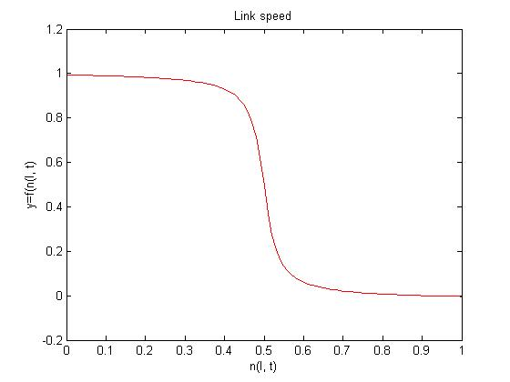
Fig. 22: The allure of the expected speed function

Once we have the information regarding the number of vehicles that shall be on a link, the predicted speed can be computed. This has been tried to interpolate by usual methods (such as linear, third order spline, Lagrange and Hermite). The output of the last two can be seen in fig. 23. We consider the results as being unsatisfactory, because of the strong oscillations that occur. Also, most of the interpolation methods applied provide a polynomial for each of the intervals in between the measurement data (shown in blue circles).

We reached the conclusion that we need a different approach for having a better quality function. The start in our new approach was to analyze the trigonometry function arctan (atan) [20]. It has the advantage that is a continuous, can be integrated and infinitely derivated. A plot of the arctan function can be seen in fig. 24.

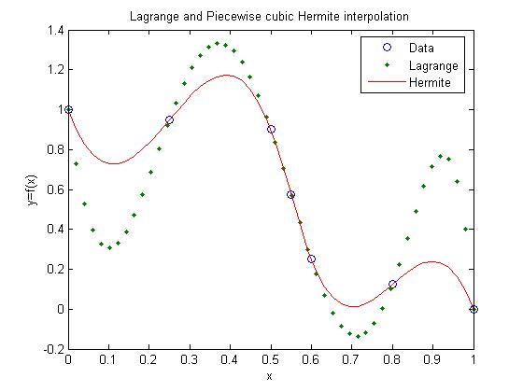
Fig. 23: Interpolation methods for expected speed function

From this moment, we started adapting and scaling the curve obtained until we had two approximating functions, which are shown in fig. 22 and 25, respectively. The associated functions are:

$v_{1}(n)=v_{\text{max}}\frac{1\text{.}\text{51}−\text{arctan}(\text{40}\frac{n}{C_{\text{max}}}−\text{20})}{3\text{.}\text{05}}$ (30)

$v_{2}(n)=v_{\text{max}}\frac{1\text{.}\text{3258}−\text{arctan}\frac{\text{50}\frac{n}{C_{\text{max}}}−\text{30}}{5}}{2\text{.}\text{7314}}$ (31)

where vmax and Cmax are the maximum accepted legal speed and the maximum capacity of the link, respectively.

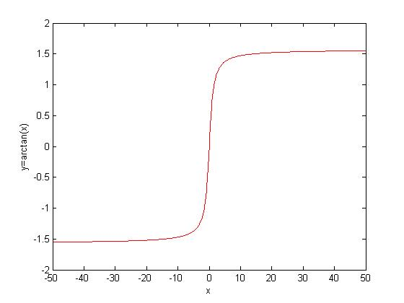
Fig. 24: The arctan function

The both functions we found were used in our experiments. The reader should refer to section 8 for more details.

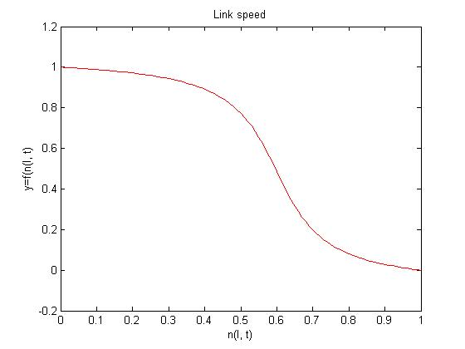
Fig. 25: The second link speed prediction function

The predicted traffic speed on a link determines the predicted travel time. There are, however, vehicles that do not update the routing system in our simulator. This determines the fact that data gathered from the updating vehicles is not enough to make a traffic prediction. The simulator user can only modify the ratio of updating vehicles. In real life, this input can come from sensors that count the updating and non-updating vehicles and compute the percentages.

The routing system uses the ratio of updating vehicles/total number of vehicles to make an evaluation of the predicted traffic load. Predicted load is, however, affected by errors, because the real number of vehicles is unknown. One can compute a very good approximation, but the exact predicted load cannot be computed (the number of non-updating vehicles is subject to a random process).

The random process of non-updating link load can be estimated by the process of simulated annealing. This is an iterative improvement algorithm, which has the following steps (in pseudocode) [21]:

function SIMULATED-ANNEALING(problem, schedule) returns a solution state
inputs: problem, a problem
schedule, a mapping from time to "temperature"
static: current, a node
next, a node
T, a "temperature" controlling the probability of downward steps

Current <- MAKE-NODE(lNITIAL-STATE[problem])
for t ← 1 to ∞ do
T' ← schedule[t]
if T=0 then return current
next ← a randomly selected successor of current
ΔE←VALUE[next] - VALUE[current]
if ΔE > 0 then current←next
else current← next only with probability e^{ΔE/T}

The VALUE function corresponds to the total energy of the atoms in the material, and T corresponds to the temperature. In the case of traffic, the VALUE function gives a utility from 0 to 10 for the chosen prediction, while T is the absolute value of the difference between the expected number of vehicles and the measured number of vehicles at time t.

T = |N _{expected} – N _{measured}|

By combining the route acknowledgement with simulated annealing, we are aiming at an ‘on-the-fly’ routing algorithm which behaves accordingly. This method is intended for integration in a real-time system.

5. System Design

The system architecture is being described by means of the following sections. There are three important parts of this system: the city program (the actual traffic simulator), the routing system and the communication layer. The traffic simulator contains a medium traversed by cars, while the routing system is built upon a graph traversed by ants. Because of the strong similarities between the city program and the routing system (exactly the same graph is used, links and nodes are treated in the same manner), abstract classes have been declared for the common parts.

Each of the classes has a constructor and a destructor method, according to the Delphi object-oriented paradigm.

5.1 The Common Part of the System

5.1.1 TNetwork Class

This class is the central part for each of the two projects included in the system, from a logical point of view. TNetwork contains general information about the graph used in these two projects. It is intended for working with the files attached to a network. All files necessary are loaded before a simulation. These files are:

- city file (.city) – container for the associated file names
- map file (.map) – contains building data for the map. Intersections and roads are being stored in the following manner:
  - each intersection is specified by number, x-position and y-position
  - roads are specified by number, from node, and to node
- intersection file (.int) – contains data regarding intersection types. Intersection types are:
  - NORMAL – right-hand precedence is applied
  - TRAFFIC_LIGHTS – the green light cycles are stored in the .light file
  - ROUNDABOUT – intersections of this kind will be transformed in the application into normal intersections which have right-hand precedence
- lights file (.light) – contains the data for a TRAFFIC_LIGHTS intersection. Each intersection has a total cycle time. A cycle is stored by means of begin and end times (in seconds) for a green light. There is a ‘from’ direction number, and with respect to this, the following directives are used:
  - LEFT
  - AHEAD
  - RIGHT
- road file (.road) – contains data regarding the road. A road is a directed arc, which permits existence of one way roads. The properties of a road are:
  - number of lanes
  - length (in meters)
  - speed (in km/h) – the maximum legal speed on this road
  - priority (HIGH or LOW)
- distribution file (.dis) – contains the main structure when using hierarchical routing (with multiple routing systems).
- route file (.route) – contains the default routing information for standard (non-smart) vehicles, using a Dijkstra-like algorithm. Default routes can be automatically computed by means of the City application.
- rate file (.rate) – specifies each link’s rates as source and destination link (in percent).

The main attributes of this class are:

Bitmap – the bitmap which contains the canvas where this network is being drawn;
Communication – stores the TCommunication object, which sets up the connection, processes incoming packets, and responds to requests via sockets;
FilesForm – a graphical form (window) which permits specifying the file names associated with this network;
CityFile, DistributionFile, IntersectionFile, LightFile, MapFile, RateFile, RoadFile, RouteFile – the file names (stored as strings) for each file previously described;
MinX, MinY, MaxX, MaxY – the coordinates of the square that circumscribes this network.

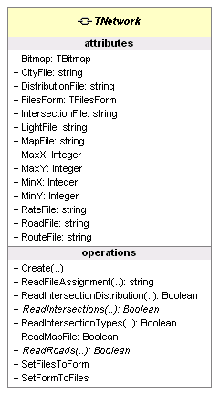
Fig. 26: TNetwork class

The following paragraphs deal with the methods of this class.

ReadFileAssignment Method
The method reads a file assignment (file type = quoted name) from a script and returns the file name.

ReadIntersectionDistribution Method
Reads the distribution of the intersections from the distribution file. It has a script parameter and returns a Boolean value which states whether the read is successful.

ReadIntersections Method
A virtual abstract method for reading the intersections from a file specified in a script. It returns a Boolean value which states whether the read is successful. This will be implemented in the descending classes. The virtual identifier specifies that the method may be replaced (overridden) in a descending class. The abstract identifier tells Delphi not to expect any code for the named method (same as in Java).

ReadIntersectionTypes Method
Reads the intersection types from the intersection file. It has a script as its parameter and returns a Boolean value which states whether the read is successful.

ReadMapFile Method
This function is intended for reading the map file and adding the intersections and roads to the NodeList, LinkList respectively. It is a virtual abstract method.

ReadRoads Method
Virtual abstract function that will read the data for each road and store it to the LinkList.

SetFilesToForm Method
Copies the file names from the traffic network to the files form.

SetFormToFiles Method
Copies the file names on the files form back to the traffic network.

5.1.2 TNode Class

An object of TNode class corresponds to a node in the network. Besides the general attributes of a node, it stores the incoming and outgoing links. It contains the following main attributes:

X, Y – this node’s position on the map
Bitmap – the bitmap which contains a graphic representation of this node;
Communication – stores the TCommunication object, which sets up the connection, processes incoming packets, and responds to requests via sockets;
InCommingLinks, OutGoingLinks – arrays which contain pointers to all the incoming and outgoing links of this node;
IPAddress, IPPort – the IP address and port where this node will send its messages by means of sockets;
NodeForm – a window that contains the properties of this form;
NodeType – a node’s type can be: NT_UNKNOWN, NT_NORMAL, NT_TRAFFIC_LIGHTS,
NT_ROUNDABOUT;
Number – the node’s integer identifier.

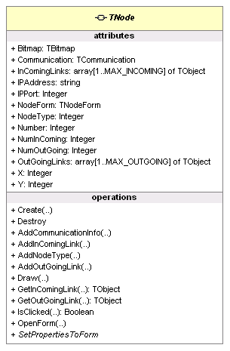
Fig. 27: TNode class

The following paragraphs deal with the methods of this class.

AddCommunicationInfo Method
Setter for the connection data of this node: IP address, IP port, and Communication object.

AddInComingLink and AddOutGoingLink Methods
These methods are used for adding an incoming link, or an outgoing link for this node, respectively.

AddNodeType Method
This method is a setter for this node’s type.

Draw Method
The method is used for drawing this node as a ball with its number.

GetInComingLink and GetOutGoingLink Methods
These functions get an incoming or outgoing link as an object, given an index number.

IsClicked Method
Returns a Boolean value which states whether this node is clicked or not. It processes the message received in the event queue of the main form. When a node is clicked, its NodeForm is being shown.

5.1.3 TLink Class

An object of TLink class corresponds to a link in the network. It contains the following main attributes:

FromNode, ToNode – this link’s start and end node;
Bitmap – the bitmap which contains a graphic representation of this link;

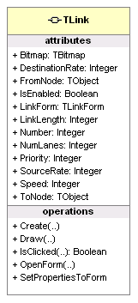
Fig. 28: TLink class

SourceRate, DestinationRate – the rates at which this link is a source or a destination for vehicles (in percent);
IsEnabled – a Boolean attribute which states if this link is enabled (True) or is currently unavailable (False);
LinkForm – this link’s form, which contains its properties;
LinkLength – the link’s length (in meters);
Number – this link’s identifier;
NumLanes – stores the number of lanes of this link;
Priority – can have one of the following values: LP_UNKNOWN, LP_HIGH, and LP_LOW;
Speed – the maximum speed allowed on this link

The following paragraphs deal with the methods of this class.

Draw Method
Draws this link on the bitmap’s canvas. A link is drawn as a directed arc with arrows. The arc’s style is determined by the road’s number of lanes. The width and the number of arrows are bigger for a greater number of lanes.
OpenForm Method
Draws this link’s form, which displays information about this link.

SetPropertiesToForm Method
Sets this link’s properties to the form to be displayed.

IsClicked Method
Returns a Boolean value which states whether this node is clicked or not. When a link is clicked, its LinkForm is being shown.

5.2 The City Program

The City program deals with the traffic of vehicles. Its central part is represented by the TTrafficNetwork class. For visibility reasons, this class has not been included in the class diagram. It contains one of each TLinkListFunctions and TNodeListFunctions classes. These are the interfaces to the links and nodes contained in the network. The links and nodes are global variables represented as arrays. TTrafficNode and TTrafficLink are the traffic extensions of the TNode and TLink classes. Each one of them has a form, in order to display their properties.

A TrafficNode also contains a DefaultRoutingTable object. This was intended for direct routing of a vehicle using a Dijkstra-like algorithm. Standard vehicles, as opposed to smart vehicles, use this kind of algorithm. One can use the information provided by standard and smart vehicles (in terms of travel times) for comparing the two routing methods. That is, Ant routing versus Dijkstra.

A TrafficLink object can contain one or more lanes consisting of road blocks. A road block is an entity of fixed length (10 meters), which can contain a vehicle. The vehicle is an object that traverses the graph and can be contained on a single road block at a given moment.

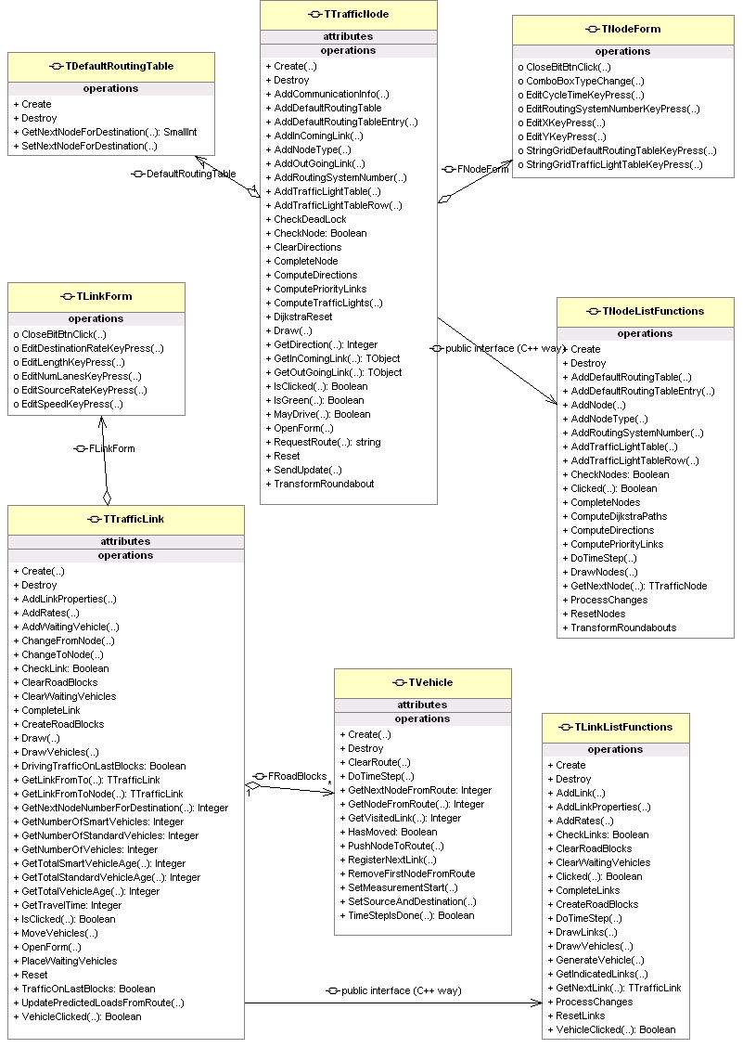
Fig. 29: The software architecture of the City program

5.2.1 TTrafficNetwork Class

This class contains general data regarding the status of the simulation and provides a medium for the vehicles to travel. It is an extension of the TNetwork class.

The main attributes of this class are described as follows:

NodeListFunctions, LinkListFunctions – the basic interface for interacting with the various TTrafficNode and TTrafficLink objects;
FStarted – a Boolean attribute which states whether the simulation has started or not;
FMaxSeconds – the number of seconds per run;
FMaxRuns – the total number of runs during a simulation;
FAntStepsPerSecond – the number of ant steps in a second, which is being transmitted to the routing system at the begin of a simulation;
FVehiclesPerSecond – the number of vehicles generated in a second;
FUpdateTimetablePercentage – the quantity of vehicles which update the timetable (in percent);
FRequestRoutePercentage – the quantity of vehicles which request route (in percent). The vehicles that request route are considered smart vehicles;
FFirstLaneRight – a Boolean attribute which states whether vehicles should take the first lane on the right hand when they move to the next road;
FShowIntersections – a Boolean attribute which states whether intersections should be drawn;
FCommunication – reference to the Communication object which sends data to the routing system.

The following paragraphs refer to this class’s methods.

ReadIntersectionFile, ReadRoadFile, ReadDistributionFile, ReadRouteFile, ReadIntersections, ReadRoads, ReadRoadProperties, ReadDefaultRoutingTables, WriteCityFile, WriteMapFile, WriteIntersectionFile, WriteRoadFile, WriteDistributionFile, WriteLightFile, WriteRateFile, WriteRouteFile Methods
These methods are intended for working with files. Before starting the simulation, all files that contain the information about the network are loaded. The traffic simulator also allows manipulation of the given map, so the map’s data can be saved directly from the traffic simulator.

AssignRoutingSystemAddresses Method
This method adds the communication information to each node in the network.
StopAndReset, InitSimulation and InitRun Methods
These procedures are used for initializing the simulation. During their executions, road blocks are cleared, and simulation time is set back to zero.

SendDisableLink, SendEnableLink Method
Procedures used for sending the information that a link has been enabled/disabled to the routing system.

TransformRoundabouts Method
Roundabout intersections cannot be processed by the system. This procedure splits a roundabout into more normal intersections.

DoTimeStep Method
Calls DoTimeStep method for all nodes and links in this network.

DrawVehicles Method
Draws all vehicles in the network to the canvas.

5.2.2 TTrafficNode Class

This is an extension of the TNode class. Besides the traffic light tables introduced, no major change has been made. The DefaultRoutingTable attached to this node has destination entries and outputs the next node given by the Dijkstra algorithm.

5.2.3 TTrafficLink Class

This is an extension of the TLink class. The additional design is presented as follows:
Attributes:

FRoadBlocks – provides an array of road blocks for each lane, where vehicles are stored;
FNumRoadBlocks – the total number of road blocks;
FWaitingVehicles – a list of created vehicles waiting to be placed on the link;
FArrivedStandardVehicles, FArrivedSmartVehicles – the number of arrived standard/smart vehicles, used for traffic statistics and traffic chart;
FSumOfStandardRouteTimes, FSumOfSmartRouteTimes – the sums of travel times for arrived vehicles, also used for traffic statistics and traffic chart.

MoveVehicle Method
Moves the vehicle across this link. The method keeps track of the traffic on this link, determines the distance that can be covered. If the vehicle is at the end of the link, it will be scheduled to the next link it follows, according to the vehicle’s type.

FreeRoadBlockLane Method
This function checks a road block for availability.

ConditionalRequest and RequestRoute Methods
ConditionalRequest method is called periodically for each vehicle on the link before sending a request route message to the routing system. It checks the vehicle type so that only appropriate vehicles will actually send a message. It also checks whether it is time for a route request, following a requesting frequency. The call is then transferred to the RequestRoute procedure, which builds the request message. The message is then sent. A route nodes reply to this message determines the new nodes on the vehicle’s route to be pushed on the vehicle’s route stack.

ConditionalUpdate Method
The method is called in order to update the routing system with data from the present. An update message is built, consisting of the start time and end time of the measurement, and the visited links. This method is also called periodically. The sent message is processed at the other end of the connection by the routing system.

UpdatePredictedLoadsFromRoute Method
This procedure sends a message to the routing system, in order to increment the predicted loads for future moments in time. The vehicle sends its route by means of the links it will follow, starting with the present time. Because a vehicle starts and ends at the middle of a road (where parking spaces are thought to exist), covered distances on each road are added to the message.

5.3 The Routing System

The routing system is the part of the simulator which deals with computing the route for a vehicle. It communicates with the actual traffic simulator via sockets. The central part is represented by the TAntNetwork class.

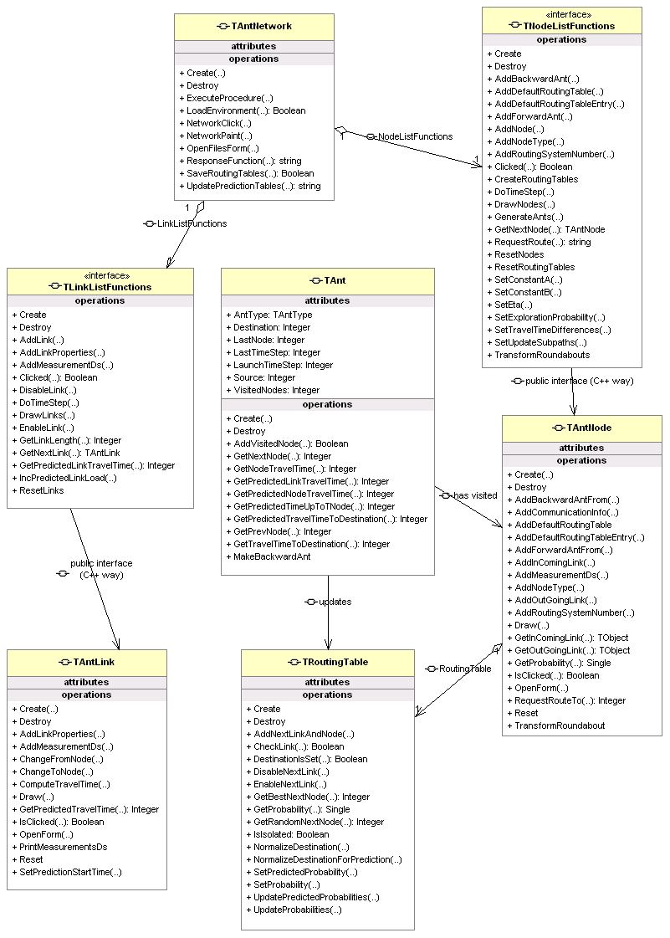
Fig. 30: The software architecture of the routing system

5.3.1 TAntNetwork Class

TAntNetwork is a virtual graph which is identical to the traffic network and it is meant for ant exploration. The network communicates with the links and nodes by using their interfaces (LinkListFunctions, NodeListFunctions). Ants travel and evolve in the AntNetwork. This class contains the following main attributes:

FStarted – a Boolean attribute which states whether simulation has started or not;
FTimeStep – the Ant time step of the simulation. This attribute’s value is different from the one found in TrafficNetwork class, as the two parts of the simulator can evolve at different time rates;
FMaxTimeSteps and FMaxSeconds – record the maximum time in number of steps (seconds respectively) of a simulation run;
FShowIntersections – a Boolean attribute which states whether intersections should be drawn or not.

The following paragraphs refer to this class’s methods.

ReadIntersectionFile, ReadRoadFile, ReadDistributionFile, ReadRouteFile, ReadIntersections, ReadRoads, ReadRoadProperties, ReadDefaultRoutingTables, WriteRouteFile Methods
These methods are intended for working with files. Before starting the simulation, all files that contain the information about the network are loaded.

Reset, InitRoutingSystem and InitRun Methods
These procedures are used for initializing the simulation. During their executions, ants and their measurements are being removed, and simulation time is set back to zero.

DoTimeStep Method
DoTimeStep procedure mainly calls DoTimeStep procedures for NodeListFunctions and LinkListFunctions. The call is then transmitted to all nodes and links, and finally to all ants.

ResponseFunction Method
The module processes a message received from the City part of the routing system. It first strips the header of the message and calls the appropriate function. The types of messages that are being processed are the following:

- set max seconds message – specifies that the total number of seconds per run has been changed from the City program;
- set max runs – specifies that the number of runs per simulation has been changed from the City program;
- set ant steps per second – specifies a request to change the number of ant steps per second from the City program;
- do timestep – specifies that the City program has ordered a time step to be processed;
- update routing system – specifies that the following message updates the routing system;
- request route– specifies that the following message is a route request received from a vehicle;
- add measurement_ds – specifies that the message contains a travel time measurement for the link;
- disable link, enable link – specifies that the City program has enabled/disabled a link from the network;
- update predicted loads – specifies an updating message, which will be used for traffic prediction.

5.3.2 TAntNode Class
This is an extension class for TNode. It additionally contains a routing table which provides the smart route for a requesting vehicle. It also introduces a list of ants that visited this node.

MoveAnts Method
The method moves each ant from this node to the next one. Each ant hops one node per time step. Ants can be split into two categories:
- forward ants – they try to reach their destination by choosing the next node randomly. They record the travel data for the current time and also for predicted time slices. The data used for prediction is gathered in the same way that a traveling vehicle would do if starting at the same time with the ant. The predictions for travel times are given by the expected link loads and expected speed function. When a forward ant reaches its destination, it is transformed into a backward ant.
- backward ants – they update the probabilities for each of the subpaths, starting with the source node of the forward ant.

s
d
Time
t
Time slice 1
t+k
t+2k
t+3k
t+4k
Time slice 2
Time slice 3
Time slice 4
1
2
3
4

Fig. 31: Prediction data gathered by the forward ant.

AddForwardAnt Method
Adds the forward ant to the ant list and adds this node to the list of visited nodes of the ant together with the travel times.

AddBackwardAnt Method
Adds the backward ant to the ant list and updates the probability tables for the current node.

5.3.3 TAntLink Class
Besides the basic functionality described in the TLink abstract class, TAntLink contains the prediction attributes and methods.

FPredictionStartTime – keeps track of the moment when the prediction has started. Prediction is started, in general, periodically, and a fixed number of time slices is used;
FPredictedLoads – an integer queue which contains the number of vehicles that will be situated on the link over the time slices.

IncPredictedLinkLoad Method
This procedure is called when an update predicted loads message is received. It computes the time slices when the vehicle is expected to be on this link. It then updates the corresponding FPredictedLoads for all time slices.

5.3.4 TRoutingTable Class

The routing table is a collection of data structures. Its methods are called from AntNetwork. It contains the following attributes:
Meantime and predicted_meantime – the array containing the mean of the times for traveling from this node to any other (reachable) node;
FNextLinks and FNextNodes – each TRoutingTable is contained by an AntNode. These attributes keep track of the container node’s neighbours.
FProbabilityTable, FPredictedProbabilityTable – array containing the probabilities for choosing a node. Given the destination node and next node as entries, it outputs the likelihood for choosing the next node for reaching the destination node in terms of a probability.

GetBestNextNode Method
The function outputs the best next node, given a destination. That is, the node with the highest probability for reaching the destination. The method is used for vehicle routing. It is desirable that a vehicle will take the best route for reaching a destination indeed.

GetRandomNextNode Method
The function outputs a random chosen node for reaching the given destination, a chance from the probability table being given. For example, the next node with the greatest probability has the greatest chance for being chosen. The method is used for ant routing. The nodes with lower probabilities are still explored, as there is a lower bound to any probability (usually 0.1), which can be set from the routing system application. The lower bound to the probabilities is called exploration probability.

NormalizeDestination and NormalizeDestinationForPrediction Methods
The methods normalize a destination given its number. When the probability in choosing a node has changed, all other probabilities have to be changed in order to preserve consistency. The sum of all next nodes, given a destination, should always be 1.

5.3.5 TAnt Class
The class corresponds to an ant traveling through the Ant network. The following attributes are contained:

FAntType – the ant’s type. In this project, forward and backward ants are used. The corresponding types are atForward and atBackward;
FSource and FDestination – integer fields which contain the source and destination node numbers for the ant;
FLaunchtimeStep – the timestep when this and was created;
FNodeList – array that contains the visited nodes of the ant;
FTimeList – the recorded times on the links, at the present time, stored as an array of integer. The order is the same as in FNodeList;
FPredictionTimeList – the recorded times on the links, for future times. The times are stored according to the time slices, by keeping track of vehicle travel times on each link.

The TAnt class contains the following main methods:

MakeBackwardAnt Method
Transforms this object into a backward ant by changing its type.

AddVisitedNode Method
This method has been overloaded in order to store the last visited node and last link’s travel time for the present (takes two parameters), and for the future (takes three parameters – the predicted travel time is added).

GetTravelTimeToDestination Method
Returns the total travel time starting with the source node and ending with some node on the path. The method is called when updating the travel time for this route, and also for all subpaths (when Update subpaths in the routing system form is checked).

GetPredictedTravelTimeToDestination Method
The method has the same functionality as the previous one. The difference is that the total time is computed with respect to the future moments when the actual vehicle will arrive at a certain node.

5.3.5.3 Backward Ants Upgrade

In terms of backward ants, a new request was added in order to update not only current time probabilities, but also future ones. From the existing speed expectance functions, predicted travel time can be computed. The philosophy remains mainly the same, only time is not computed via travel time obtained from the vehicle, but from applying the predicted speed function:

$v_{\text{ij}}(p)=\frac{d_{\text{ij}}}{t_{\text{ij}}(p)}$ (32)

where v_{ij} is the speed of the link, p is the prediction step, d_{ij} is the link length, and t_{ij}(p) is the predicted time with respect to time slice p. We know that the speed v_{ij} can be computed directly from the expected link load (see section 5.2 for formula and details). Distance d_{ij} is directly observable. The expected travel time can be computed using the formula that results directly from f1:

$t_{\text{ij}}(p)=d_{\text{ij}}⋅v_{\text{ij}}(p)$ (33)

The time obtained is used for updating predicted probabilities at a given node.

5.4 The Communication Layer
Each of the two applications sets up a server, which receives messages from the other part. Figure 29 illustrates this fact. The sender, in this situation, starts a client thread which will forward the message to the other part of the simulator. A time out is set and a response from the server is expected.

City
Program

Routing
System
control message
‘update’ message
‘done’ message
‘request route’ message
‘routenodes’ message
Fig. 32: Simulator communication

The City program is considered to be the central application, and it is in charge of sending the control messages to the routing system. For instance, do timestep is a control message. For control and update messages, the routing system answers by a message containing only the word done. A request route message is answered by a routenodes message.
Generally speaking, the TCommunication class processes all incoming and outgoing messages.
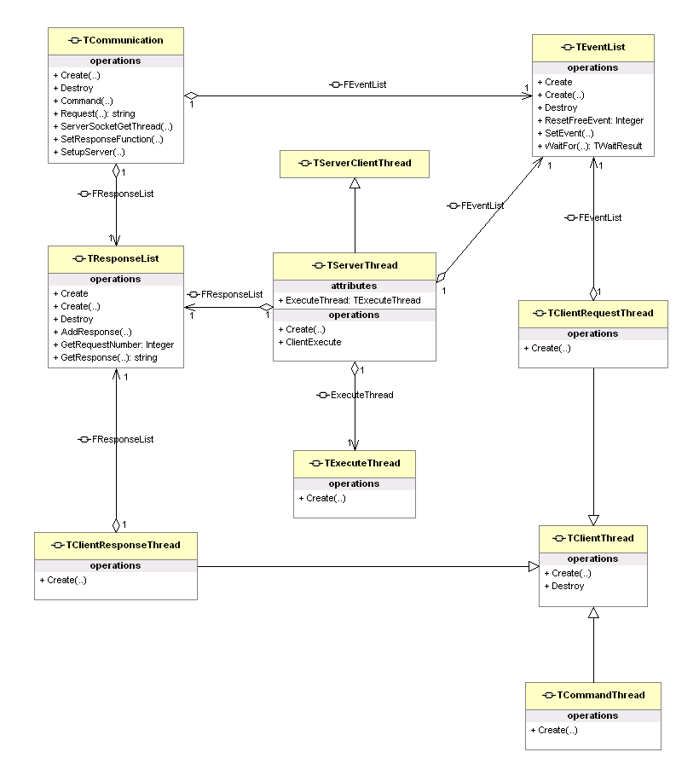
Fig. 33: The software architecture of the communication layer

6. System Functionality

6.1 Running the system

The City program should be started first. This shows the city view form and an Open dialog appears, which allows a .city file to be processed (fig. 34). All files concerning this city map are loaded when the Open button is clicked.
A graphical representation of the city can be seen on the view form’s canvas. If there are roundabouts in this city, they should be transformed by clicking the Transform roundabouts button . The Ant routing algorithm cannot process this kind of intersections.
The routing system, which runs in a different window, should be initiated by clicking the Start distributed routing system button .

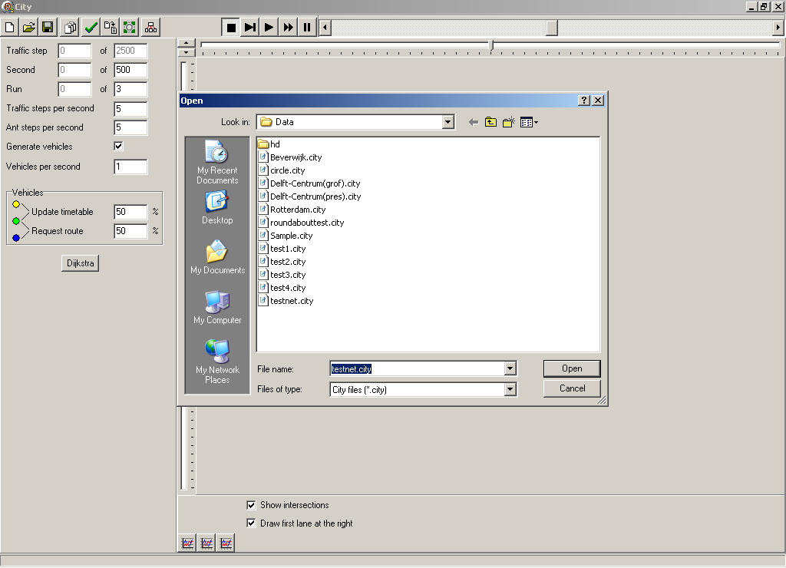
Fig. 34: The City program window
Simulation can then be started by clicking the Run simulation button .

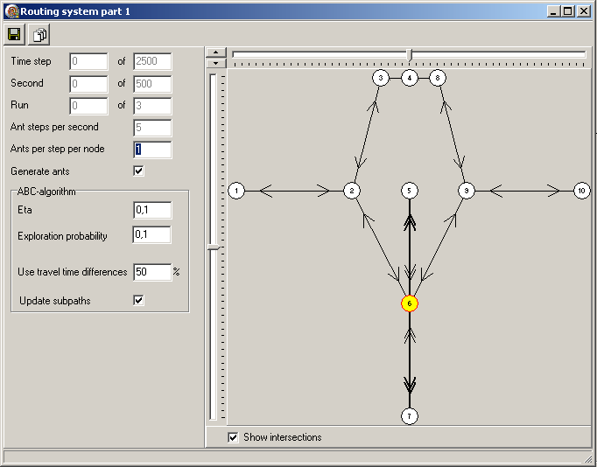
Fig. 35: The routing system window

In the lower part of the City program window, there are three buttons () for showing network statistics in a chart form. The most important are Average standard route time and Average smart route time.

6.2 Experimental Results

6.2.1 Test 1
The network shown in fig. 36 has been tested with an average rate of 2 vehicles per second. The results are presented in fig. 37.
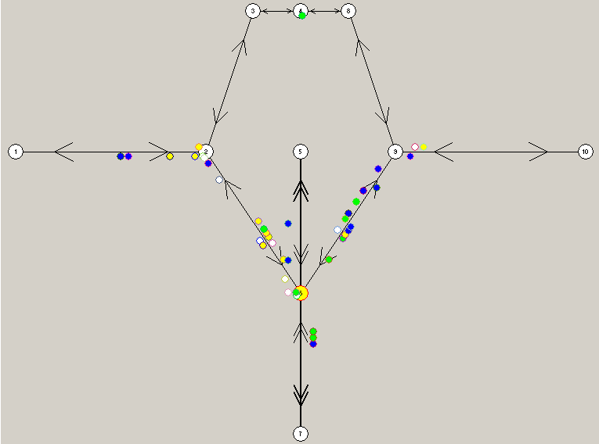
Fig. 36: Test 1 city network

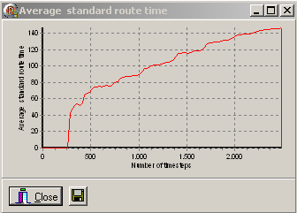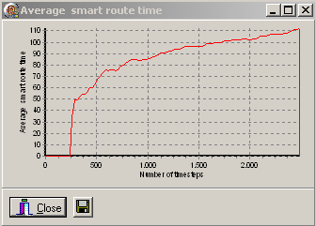
Fig. 37: Experiment 1 results

6.2.2 Test 2
The same experiment has been conducted for the city network in fig. 38. Results are displayed in fig. 39.

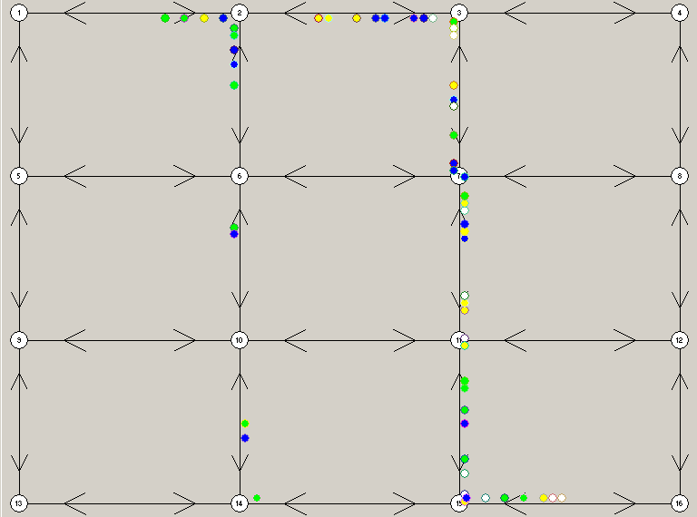

Fig. 38:Test 2 city network

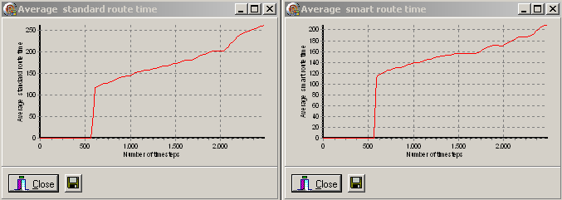
Fig.39: Experiment 2 results

7. Bibliography

[1] B. Tatomir and L.J.M. Rothkrantz, H-ABC: A scalable dynamic routing algorithm, The Second Australian Conference on Artificial Life 2005
[2] G. Di Caro and M. Dorigo. Antnet: A mobile agents approach to adaptive routing.
Technical Report IRIDIA, Universite Libre de Bruxelles, (12), 1997
[3] G. Di Caro and M. Dorigo. Antnet: distributed stigmergetic control for com-
munication networks. Journal of Artifcial Intelligence Research (JAIR), 9:317-365, 1998
[4] B. Baran. Improved antnet routing. SIGCOMM Comput. Commun. Rev., 31(2):42-48, 2001
[5] T. White, B. Pagurek, and F. Oppacher. ASGA: Improving the ant system by integration with genetic algorithms. In Genetic Programming 1998:Proceedings of the Third Annual Conference, pages 610-617, 22-25 1998
[6] S. Liang, A. Zincir-Heywood, and M. Heywood. Intelligent packets for dynamic network routing using distributed genetic algorithm. In Genetic and Evolutionary Computation Conference, GECCO, 2002
[7] I. Kassabalidis, M.A. El-Sharkawi, R.J. Marks II, P. Arabshahi, and A.A. Gray. Adaptive-sdr: Adaptive swarm-based distributed routing. In World Congress on Computational Intelligence, 2002
[8] Seongmoon Kim, Member, IEEE, Mark E. Lewis and Chelsea C. White, III, Fellow, IEEE, Optimal Vehicle Routing With Real-Time Traffic Information
[9] Karl E. Wunderlich, David E. Kaufman, and Robert L. Smith, Link Travel Time Prediction for Decentralized Route Guidance Architectures
[10] Ismail Chabini and Shan Lan, Adaptations of the A* Algorithm for the Computation
of Fastest Paths in Deterministic Discrete-Time Dynamic Networks
[11] R. Sedgewick and J. S. Vitter, “Shortest path in Euclidean graphs”, Algorithmica,
vol. 1, pp. 31–48, 1986.
[12] Apostolos Kotsialos, Markos Papageorgiou, Fellow, IEEE, Christina Diakaki, Yannis Pavlis, and Frans Middelham, Traffic Flow Modeling of Large-Scale Motorway Networks Using the Macroscopic Modeling Tool METANET
[13] John Rice and Erik van Zwet, A Simple and Effective Method for Predicting
Travel Times on Freeways
[14] T. Hastie and R. Tibshirani, “Varying coefficient models”, J. R. Stat. Soc., ser. B, vol. 55, no. 4, pp. 757–796, 1993.
[15] Chun-Hsin Wu, Member, IEEE, Jan-Ming Ho, Member, IEEE, and D. T. Lee, Fellow, IEEE, Travel-Time Prediction With Support Vector Regression
[16] C. H. Wu, D. C. Su, J. Chang, C. C. Wei, J. M. Ho, K. J. Lin, and D. T. Lee, “An advanced traveler information system with emerging network technologies,” in Proc. 6th Asia-Pacific Conf. Intelligent Transportation Systems Forum, Taipei, Taiwan, 2003, pp. 230–231.
[17] C. H. Wu, D. C. Su, J. Chang, C. C. Wei, K. J. Lin, and J. M. Ho, “The design and implementation of intelligent transportation web services,” in Proc. IEEE Conf. E-Commerce, 2003, pp. 49–52.
[18] Seongmoon Kim, Member, IEEE, Mark E. Lewis, and Chelsea C. White, III, Fellow, IEEE, State Space Reduction for Nonstationary Stochastic Shortest Path Problems With Real-Time Traffic Information
[19] Richard J. Meinhold and Nozer D. Singpurwalla, Understanding the Kalman Filter
[20] Wikipedia, the free encyclopedia, Inverse trigonometric function,
http://en.wikipedia.org/wiki/Arctg
[21] Stuart Russell and Peter Norvig, Artificial Intelligence: A Modern Approach
http://aima.cs.berkeley.edu/

