Department of Technical Cybernetics and Military Robotics
Faculty of Air Forces and Air Defence,
MILITARY ACADEMY in Brno, Czech Republic

ACE

Adaptive Cockpit Environment

Report

ACE

System function and task definition

WP4.02 Report

Reference: ACE/NLR/MAB/WP4

Date: September 18-th 2002

The ACE Consortium
NLR (Amsterdam, The Netherlands), Military Academy (Brno, Czech Republic), Delft University of Technology (Delft, The Netherlands)

BRNO 2002

Document identification
Results of the Literature Study |  | ACE/NLR/MAB/WP4A
written by: |  | reviewed by:
Name | Organisation | Name | Organisation
J. Kacer- P. Vašíček-P. Kutílek | MAB | Z. Krupka - V. Řeřucha | MAB
Approved by: V. Řeřucha

Document changes

Issue date | Version | Comments
11/1/02 | 01 | first draft version
18/09/02 | 02 | second draft version

Status of the document

Internal | X
Restricted
Public

Working group

 |  |  | Organization
 | Vladimír Řeřucha | Lt. Col., Assoc. Prof. , DEng. - Ph.D. | MAB
 | Zdeněk Krupka | Prof., DEng. - Ph.D. | MAB
 | Jiří Kacer | Cpt. DEng. - Ph.D. | MAB
 | P. Vašíček | 2-nd-Lt., DEng. | MAB
 | P. Kutílek | 2-nd-Lt., DEng. | MAB

Content
Content 2
1 THE COCKPIT 5
1.1 F-16 Cockpit Systems 6
1.2 The Head Up Display (HUD) 7
1.2.1 Information Common to All HUD Modes 8
1.2.2 Specific HUD modes 13
1.2.3 Flight and Navigation Modes 13
1.2.4 Combat Modes 15
1.2.5 Air-to-air Combat 15
1.2.6 Air-to ground Combat 16
1.2.7 HUD Summary 19
1.3 The Multifunction Display (MFD) 20
1.3.1 Navigation (NAV) MFD Mode 20
1.3.2 Damage (DMG) MFD Mode 21
1.3.3 Armaments (ARM) MFD Mode 22
1.3.4 Satellite (SAT) MFD Mode 22
1.3.5 Air-to-air Radar (JTIDS) MFD Mode 23
1.3.6 JTIDS Symbols 24
1.3.7 Ground Map (GM) MFD Mode 25
1.3.8 Fixed Target Tracking (FTT) MFD Mode 26
1.4 Threat Warning Indicator 27
1.5 Bitching Betty 28
1.6 Integrated Control Panel (ICP) 29
1.6.1 Backup Switch 29
1.6.2 Master Modes 29
1.6.3 Override Modes 30
1.6.4 ICP Functions and Usage 30
1.7 Horizontal Situation Indicator 36
1.8 Fuel Flow Indicator 36
1.9 Data Entry Display 36
1.10 Angle of Attack (AoA) Indexer 36
1.11 Master Warning Indicator 37
1.12 NOS POS 37
1.13 APG-68 Radar System 37
1.13.1 Air-to-Air Radar Modes 37
1.13.2 Air-to-Ground Radar Modes 38
1.14 Electronic Warfare System 40
1.15 Fault and Warning System 42
1.15.1 Warnings and Warning Lights 42
1.15.2 Cautions and Caution Lights 42
1.15.3 Pilot Fault Display 42
1.15.4 Warn Reset 43
1.16 Inertial Navigation System 43
1.16.1 How to Use the INS 43
1.17 Other Switches 44
1.17.1 Avionics Power 44
1.17.2 Radar Altimeter (RALT) 44
1.17.3 Parking Brake 45
1.17.4 Landing Light 45
1.17.5 Exterior Lightning 45
1.17.6 Interior Cockpit Flood Lighting Rheostat 45
1.17.7 Kneepad 45
1.17.8 Seat Arm Switch 45
1.17.9 Tail Hook Switch 46
1.17.10 Alternate Gear Deploy / Reset 46
1.17.11 Speed Brakes 46
1.17.12 Drag Chute 46
1.17.13 Laser Arm 46
1.17.14 RF Switch 47
1.17.15 Ground Jettison Enable Switch 47
1.17.16 Emergency Jettison Button 47
1.17.17 Stores Config Switch 47
1.17.18 Trim Panel 47
1.17.19 Flight Control 47
1.17.20 AVTR Switch 47
1.17.21 Audio Volume 48
1.17.22 Test Panel 48
1.18 Airframe 48
1.18.1 Airframe Overstress 48
1.18.2 Fuel 48
1.19 Engine 50
1.19.1 Definitions And Terminology 50
1.19.2 Functions and Usage 51
1.19.3 Details 51
1.20 Electrical Systems 52
1.21 Lights 52
2 Waepon Systems 54
2.1 Targeting Pod 54
2.2 Weapon Summary 55
2.3 Air-to-air Combat 56
2.3.1 Air-to-air Missile 56
2.3.2 Air-to-air Cannon 58
2.4 Air-to-ground Combat 58
2.4.1 Air-to-ground Missiles 58
2.4.2 Anti Radiation Missiles 59
2.4.3 Air-to-ground Bombs (Unguided) 59
2.4.4 Air-to-ground Bombs (Guided) 60
2.4.5 Rockets and Cannon 60
2.5 Weapon Selection and Related HUD Summary 60
3 SPECIFICATIONS 62
3.1 Weapons 62
3.1.1 AIM-7D SPARROW 62
3.1.2 AIM-7E SPARROW 62
3.1.3 AIM-7F SPARROW 62
3.1.4 AIM-7P SPARROW 63
3.1.5 AIM-7P SPARROW 63
3.1.6 AIM-9B SIDEWINDER 63
3.1.7 AIM-9E SIDEWINDER 64
3.1.8 AIM-9J SIDEWINDER 64
3.1.9 AIM-9L SIDEWINDER 64
3.1.10 AIM-9M SIDEWINDER 65
3.1.11 AIM-120 AMRAAM 65
3.1.12 AGM-45 SHRIKE 65
3.1.13 AGM-88 HARM (D) 66
3.1.14 AGM-65G MAVERICK 66
3.1.15 AGM-84 HARPOON 66
3.1.16 AGM-119A PENGUIN 66
3.1.17 LAU-3A HYDRA ROCKET POD 67
3.1.18 MK82 500LB IRON BOMB 67
3.1.19 MK83 1000LB IRON BOMB 67
3.1.20 MK84 2000LB IRON BOMB 67
3.1.21 CBU-72 (FUEL/AIR BOMB) 68
3.1.22 CBU-87 (CLUSTER BOMB) 68
3.1.23 BLU-107 DURANDAL 68
3.1.24 GBU-10 2000LB BOMB 68
3.1.25 GBU-12 500LB BOMB 69
3.1.26 GBU-16 1000LB BOMB 69
3.1.27 FUEL POD (WING) 69
3.1.28 FUEL POD (FUSELAGE) 69
4 Database 71
Appendix A 73
Acronyms 73
Literature 2

THE COCKPIT
One of the most important aspects in combat aircraft design is the level of visibility offered to the pilot.
The cockpit instruments communicate every aspect of the aircraft's status and position to the pilot. Much of the data is repeated in various formats so that the pilot has access to it in multiple ways. This is to aid rather than confuse the pilot. Depending on circumstance some information may be instantaneously available in one form, for example presented via the HUD, while checking the relative cockpit gauge would require the fractions of a second a fighter pilot can ill afford. In combat that amount of time can easily prove fatal for either you or your opponent. However if your aircraft is damaged one or more of the cockpit systems could be down or at best unreliable. Therefore independent instrument backup is vital.
The most comprehensive cockpit systems such as the HUD and the MFD contain an extensive range of information and are comprehensively covered in respective sections. Most of the other instruments are self explanatory from their specific titles.

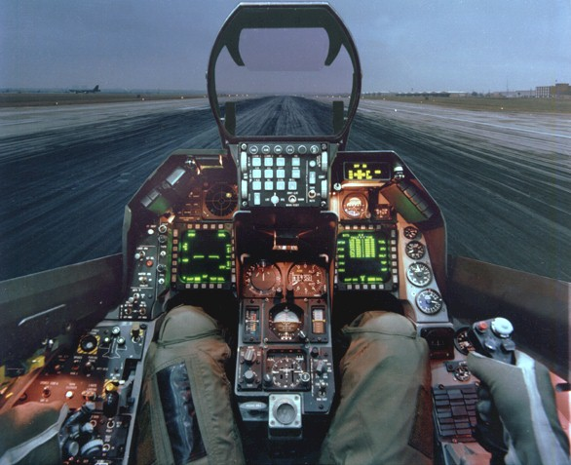

Pic. 1 The cockpit view

F-16 Cockpit Systems
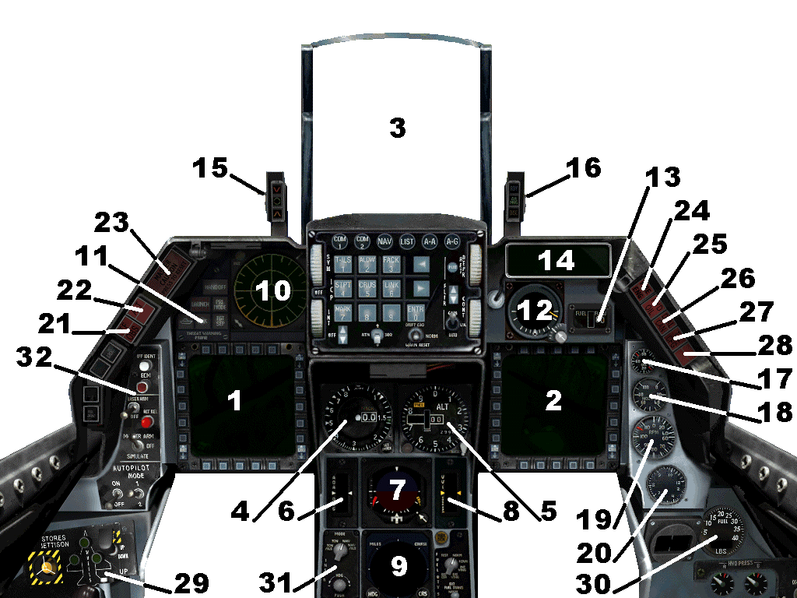

Cockpit Diagram Key

1. Left Multifunction Display (MFD)
2. Right Multifunction Display (MFD)
3. Heads Up display (HUD)
4. Airspeed Indicator
5. Altimeter
6. Angle of Attack Indicator
7. Attitude Direction Indicator - Artificial Horizon
8. Vertical Velocity Indicator
9. Horizontal Situation Indicator
10. Threat Warning Indicator
11. Threat Warning Lights
12. Stand-by Attitude Indicator
13. Fuel Flow Indicator
14. Data Entry Display
15. Angle of Attack Indexer
16. Brake Indicators
17. Engine Oil Pressure
18. NOS POS
19. Engine RPM
20. Engine Temperature
21. Engine Stall Indicator
22. Engine Fire Indicator
23. Master Warning Indicator
24. Air Brake On Indicator
25. Auto Pilot On Indicator
26. TACAN
27. ECM
28. Low Altitude Warning
29. Landingger panel
30. Fuel quantity indicator
31. Instrument mode panel
32. Misc panel

The Head Up Display (HUD)

General Overview of the HUD

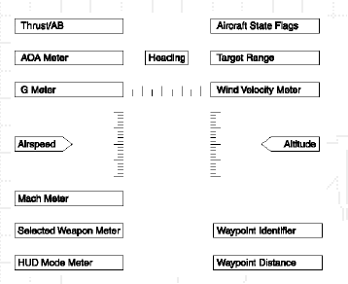

The Head Up Display from now on referred to as the HUD, is a concept which has directed the development of military avionics design and practice. This is particularly true when considering the ever widening role of the modern jet fighter/bomber plane and the pilots who fly them. Basically the HUD is a transparent screen, placed directly in front of the pilot, which displays information relating to all aspects of flight, navigation and battle. Thus vital information is instantly available without the pilot having to look down at numerous instruments and therefore be subject to distraction at critical moments. Almost all the information a pilot needs to know while airborne is available via the HUD.

However, the volume of data the HUD can display creates specific problems. The amount of different information available to a pilot at any given time is vast. This information will also relate to very different scenarios, e.g. from takeoff and landing to laser guided bombing. Rather than attempting to display all the information all the time the HUD is split into different 'modes'. These modes relace directly to specific circumstances that the pilot will encounter.

Therefore the HUD has different 'modes' which can be selected for use in specific circumstances. These modes can be cycled through easily and can, therefore, instantly communicate information relevant to any given situation. The HUD is an interface for the aircraft's computer system allowing the pilot to do specific tasks. If the correct mode is not chosen, the pilot will not be able to perform certain actions. When a pilot selects Navigation mode or 'NAV' mode, the HUD will communicate navigational information such as 'Waypoints'. If the pilot then engages a hostile aircraft and suspects that combat is imminent he can select missile (MSLS) mode. In this mode the HUD will allow the pilot to arm an air-to-air missile e.g. AIM-9 Sidewinder, if one is available. Selecting any missile to arm would not be possible if for example the HUD was in landing (LND) mode. In missile mode the HUD will then display the point at which the hostile plane is in range and whether missile lock has been achieved. The pilot is then able to fire when ready.

The HUD has become indispensable to the modern fighter pilot's environment. However if the HUD system is not clearly understood by the pilot then the data provided is useless. Therefore it is essential that you should possess a clear understanding of the HUD's different modes and in which situations to use them.

Information Common to All HUD Modes
The F-16 has ten separate HUD modes which are examined below. This may seem daunting but each mode is tailored to a different, specific situation, so choosing the correct one is straightforward. Although each mode has special individual features some of the information displayed is present in every mode. The common information shared by all modes is detailed here.

Airspeed
The airspeed of the F-16 is measured in knots and this value is displayed in every HUD mode. There is also an airspeed 'tape' running vertically down the HUD next to the airspeed indicator that measures the speed in increments of ten. This is very helpful in rapidly determining whether the plane is actually decelerating or accelerating without having to concentrate on the exact airspeed figures as the ribbon appears to be moving either up or down respectively. True airspeed is the actual speed of the aircraft over land. Indicated airspeed is the value displayed on the instruments. Indicated air speed is measured by pressure differentiation. The F-16's computer uses this value and, by means of advanced conversion tables, calculates the true airspeed.

Mach Meter
This is a separate measurement showing the speed of the aircraft in terms of the speed of sound. The speed of sound is 1130 ft/per sekond or 330 m/per second at standard temperature and pressure (STP) which is 20°C/70°F and 1 Atmosphere respectively. In aviation this speed is referred to as a Mach value e.g. Mach 1. At high altitudes Mach 1 is achieved at lower airspeeds. This is because at higher altitudes the speed of sound is reduced due to lower air temperatures and reduced air density. For every 1°F reduction, the speed of sound decreases by 1.1ft per second. Equally, reduced air density decreases the speed of sound. Therefore the F-16 will achieve the speed of sound at lower airspeeds. Also, the F-16’s top speed is faster at high altitude
because less dense air gives less drag to the airframe.

Engine Thrust /Afterburner
This displays the percentage of maximum engine RPM. At 50% the engines are considered to be idling and at 100% they are at full thrust. Using the afterburner significantly increases the boost of the engines above 100% but this increases fuel consumption dramatically. Therefore the afterburner is only used when necessary. The afterburner has four levels of boost (1-4), four being the most powerful.

Altitude
The F-16's altitude can be displayed as two values, either the barometric height (the height of the F-16 above Sea Level) or the radar determined height which shows the actual distance between the F-16 and the ground terrain it is flying over. When you are engaged in low flying manoeuvres it is vital that you are aware of the exact distance between the aircraft and the immediate terrain. The altitude readout is also accompanied by a vertical 'tape' display.

Velocity Vector Indicator
Also known as the Flight Path Indicator this is located usually in the centre of the HUD in every mode. It indicates the direction the aircraft is actually flying in. Basically you are in effect flying into whatever area the velocity vector indicator is ‘covering’.

Pitch Ladder
The pitch ladder is always present and is a HUD representation of aircraft pitch.

Bank Indicator
The bank indicator displays the degree of bank of the aircraft within a 180 degree range.

Heading Display
Located at the top of the HUD this displays the compass heading in degrees. North is 0 degrees, East is at 90 degrees, South is at 180 degrees and West is at 270 degrees. Again there is a tape display which is measured in increments of ten degrees. The tape is directly below the heading display and above the heading indicator.

Waypoint Heading Indicator
The waypoint heading indicator, or carat, is positioned below the compass tape. This marker indicates the exact direction of your currently selected waypoint. If the indicator is on the far left or right of the compass tape the F-16 must be turned either to the left or right respectively in order to line up with the waypoint.

Aircraft State Flags
At the top right of the HUD there is a list of letters that appear or disappear as the external state of the aircraft is altered.

HUD Mode Meter
Located at the bottom left of the HUD display, this simply displays which mode the HUD is currently operating in, for instance NAV (Navigation mode) or LND (Landing mode).

Mode Specific HUD Information
The rest of the information that the HUD displays is mode specific. It is split between data relating to flight navigation and data which is relevant to combat only. Therefore when a HUD mode is selected such as NAV (Navigation) or LND (Landing), the waypoint identifier, waypoint distance and wind speed become visible. When a combat mode is selected i.e. MSLS, EO or ARM, specifics such as 'Weapon selection' and 'Range to Target' become visible. The following categories of information are only available in specific modes.

AoA Meter
Registers the angle of the wing in relation to the airflow through which it is travelling. This is vital for landing and specific air manoeuvres because if the angle of attack is too steep the plane is liable to stall (See Flight Physics). It is displayed on the HUD in a variety of modes in which AoA is relevant. However the AoA is always available by checking the cockpit instrument panel which contains a gauge dedicated to angle of attack.

G Meter
The force of gravity is measured in G's. When the F-16 performs aggressive manoeuvres, at high speed, the resulting force vector is added to the force of gravity. The F-16 fuselage and pilot then experience a violent increase of force. The pilot is liable to suffer from blackout as the effects of gravitational force are multiplied proportionally. The G meter monitors the amount of G force exerted on both the pilot and the plane at any given time.

Selected Weapon
This displays which weapon is currently selected or armed. When a pilot decides to use a specific weapon, e.g. a guided bomb or an air-toair missile, the related HUD mode that will enable weapon launch, must be chosen first. If the F-16 is carrying a relevant weapon that armament is automatically selected. If there are no weapons in the payload that are specific to a given mode the mode will be inaccessible. If there is a choice of weapons, the pilot is able to cycle through the alternatives by pressing corresponding controls.

Missile Range
Illustrates the range of a selected missile. This display has an attached arrow that moves up and down the range scale. The arrow indicates the position of a designated target in relation to the missile's range.

Missile Flight Time
This is the missile flight time measured in seconds. It refers to the time lapse between a proposed missile launch and the subsequent impact with a selected target. It appears directly under the missile range meter.

Target Range
This is the distance between your aircraft and the selected target, measured in nautical miles. It is positioned above the wind speed indicator and below the aircraft state flags.

Radar Range
Directly above the missile range meter is the radar range. This displays the present maximum scan range of the F-16's targeting system. See the illustration of the HUD in MSLS mode, which
appears later in this chapter.

Target Closure Speed
Measured in knots, this reading displays the closing speed between the target and yourself.

Missile Boresight
The missile boresight is a circular reference symbol to which the target aspect carat and the target range circle are attached. It is only available for air-to-air missiles. The symbol will change in size depending on the range of the missile selected.

Target Range Circle
Positioned within the missile boresight, this denotes the range to target. It is only present when short range missiles such as the AIM-9M Sidewinder are selected. This is because with short range missiles an exact indication of target range is necessary. The circle unwinds anticlockwise as the range to target decreases. When it reaches the three o'clock position the designated target is in optimum range.

Target Aspect Carat
The aspect of a target is its heading, relative to your own position and heading. It is only available for airborne targets. The target's aspect is indicated by an arrow, which moves around the missile boresight.

If you imagine the arrow represents the wings of your enemy this will provide a good indication of the direction the bandit is flying in relation to your own position.

When the arrow is at the six o'clock position you are directly in line with a target which is flying in the same direction as yourself i.e. away from you. At the twelve o'clock position the arrow indicates that you are in line with a target that is flying directly towards you. If the arrow is at a point between the three and nine o'clock positions the target will be crossing your path.

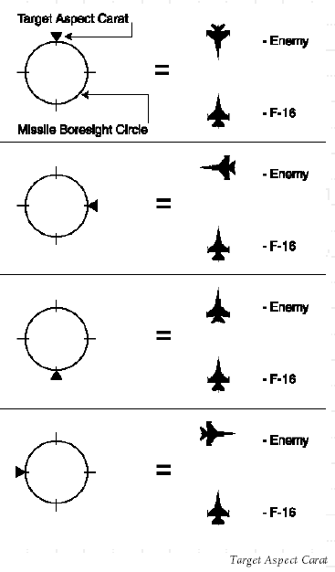

Wind Velocity Meter
Displays the current velocity of the wind relative to the aircraft's flight. This data is particularly important for landing and takeoff procedures.

Waypoint Identifier
The waypoint identifier is present only when the HUD is in NAV mode. It informs the pilot which waypoint the pipper is directing him towards. If you fly to a waypoint then the navigation system will automatically switch to the next waypoint if one is available.

Waypoint Distance
Similar in all aspects to the waypoint identifier, this informs the pilot of the distance from the selected waypoint measured in nautical miles.

Pipper
The pipper consists of 2 parts, the relative approach line position, represented by the position of the circle on the HUD and the approach heading indicator, represented by the line emanating from the centre of the pipper. The approach line is defined by the previous and current waypoints. You are flying along the correct approach line when the pipper is in the centre of the HUD and the heading indicator points straight up. If you are not on the approach line, steering the aircraft so that the line is always vertical will return you to the correct approach line with the correct heading.
In this position the pipper will guide you along the best approach line, according to the waypoints, whereas the compass carat and heading indicator will guide you straight to the selected waypoint irrespective of the approach line.

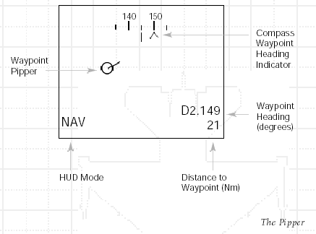

Specific HUD modes
The different HUD modes fall into two basic categories. Those that are dedicated to flight and navigation and those that are dedicated combat modes. Of the ten HUD modes two are concerned with flight and navigation and the other eight are combat modes.

Flight and Navigation Modes

Navigation (NAV) HUD Mode
This mode is used to guide the pilot towards the selected pre-designated waypoints. The current waypoint number is indicated at the bottom right of the HUD.

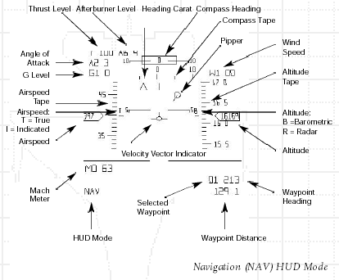

Landing (LND) HUD Mode
Used specifically when landing, this mode provides information dedicated to factors that will affect the landing procedure. This is the only mode in which the HUD displays the ILS deviation bars that are essential for a safe landing procedure. Landing mode is automatically selected when the landing gear is lowered.

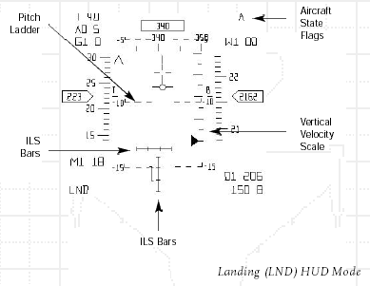

Combat Modes
The combat modes of the HUD are divided between the two different areas of combat. There are three modes for air-to-air combat and five modes dedicated to ground attack. In air-to-air combat the modes basically relate to the use of missiles, cannon and a combination of the two. With ground attack, two of the modes are for different types of missile, two modes are for different bombs i.e. guided and unguided and the last mode is used when firing rockets or cannon, both of these weapons being unguided.
N.B. In all combat modes the HUD will display a large X symbol if you attempt to use a weapon on a target that is either out of range or that is too close to the F-16 for an effective launch.

Air-to-air Combat

Missiles (MSLS) HUD Mode

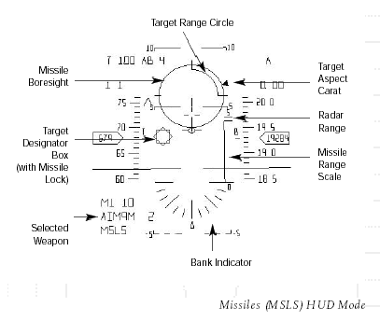

Used to arm and launch air-to-air missiles. All the necessary information, related to missile launch, is present in this mode.

Lead Computed Optical Sight (LCOS) HUD Mode

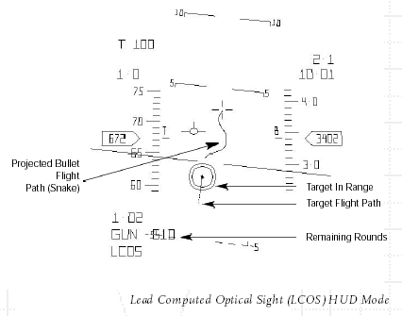

The LCOS mode gives an optical trail that portrays the projected bullet flight path of the F-16's internal cannon rounds. This avoids the waste of precious ammunition as the pilot can gauge accurately when a hostile plane will be in his sights. LCOS also superimposes a dashed trail on the target displaying its previous flight path.

Dogfight (DGFT) HUD Mode

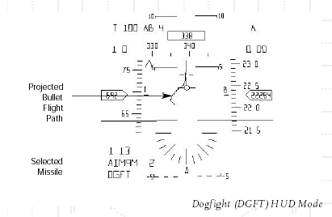

A combination of MSLS and LCOS, the DGFT mode is specifically designed to help the pilot in close combat situations. It enables the aiming and firing of air-to-air missiles as well as providing a constant projected bullet flight path for cannon firing.

Air-to ground Combat

Continuously Computed Impact Point (CCIP)
Pre-designate HUD Mode

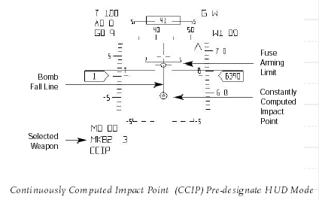

This mode is used to aim 'dumb' air-to-ground weapons like unguided bombs e.g. 2000lb iron bomb. The CCIP mode shows a 'bomb fall line' and computed impact point. Pinpoint accuracy is required for accurate delivery. The Fuse Arming Limit must be below the Computed Impact Point at the time of weapon release. This is to ensure that the aircraft is not damaged from bomb explosion or debris.

Continuously Computed Impact Point (CCIP)
Post-designate HUD Mode

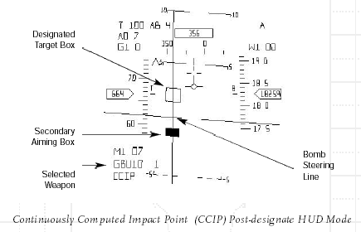

Used only in conjunction with guided and laser guided bombs such as the GBU-10. Here the HUD mode displays a vertical bomb 'steering line'. A primary designated target box is displayed, along with a secondary box, that represents the CCIP. Ensure the steering line intersects the designated target box. The secondary box will appear to climb the steering line. Hold down the fire button and when the two boxes are aligned the selected weapon is automatically released guaranteeing accurate delivery.

Electro Optical (EO) HUD Mode

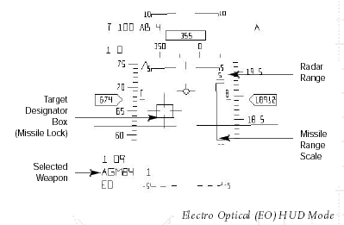

This is the primary ground attack mode used for launching guided air-to-ground missiles such as the AGM-65 Maverick. Electro Optical, as a term, refers to the way in which the air-to-ground missile is guided. All types of air-to-ground missile, with the exception of anti-radiation missiles fall into this category. When missile lock is achieved the missile crosshair, displayed on the HUD, snaps onto the target designator box. Launch can be initiated at any subsequent point providing the target is in range.

Anti-Radiation Missile (ARM) HUD Mode

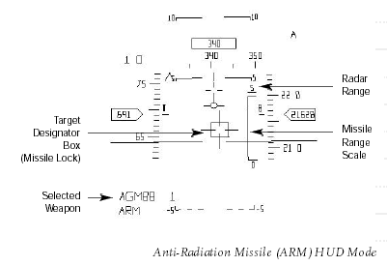

Used only when launching an anti-radiation missile e.g. AGM-88 radar seeking missile. This mode duplicates the information provided in EO that is required for a ground attack missile launch. Missile launch will only be possible when a strong radar-emitting source, such as a SAM radar site or a ship, is in the vicinity. Otherwise the missile will be unable to lock on to a target, as it cannot detect targets that are not emitting radar waves. These missiles can be used even if the F-16's radar is damaged or switched off as they track radar sources as opposed to using radar as guidance.

Strafe HUD Mode

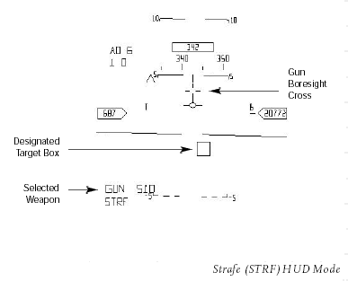

Used when firing either guns or rockets at ground targets. Though STRF mode provides a target designator box, it is only a visual guide to aid the pilot as there is no lock available with unguided rockets. Aim to place the Gun Boresight Cross over the target designator box to increase accuracy.

HUD Summary

Mode ...... .Name Use

NAV Navigation.............................................Waypoint navigation
LND Landing..................................................Landing
MSLS Missiles...................................................Air-to-air missile launch
LCOS Lead Computed Optical Sight................Cannon fire
DGFT Dogfight.................................................Air-to-air missile launch / cannon fire
CCIP CCIP Pre.................................................Dumb / unguided bomb launch
CCIP CCIP Post................................................Guided bomb launch
EO Electro Optical........................................Air-to-ground guided missile launch
ARM Anti Radiation Missile............................Air-to-ground anti-radiation missile launch
STRF Strafe.......................................................Cannon / rocket fire at ground target

The Multifunction Display (MFD)
The two multifunction displays can be used to access various elements of the F-16's radar and computer systems.

The Multifunction Display does not intrude on the pilot's line of sight and is invaluable in every combat situation. There are several different modes available via the MFD and these are described below. The current mode of each MFD is shown in the top left corner.

Navigation (NAV) MFD Mode

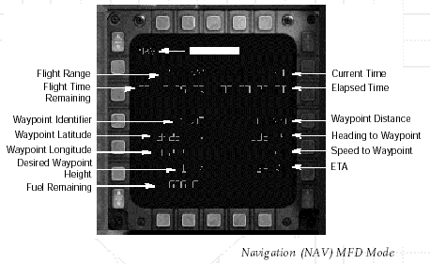

The NAV or Navigation mode of the MFD supplies all the necessary information for in-flight navigation. The on board computer constantly monitors fuel consumption and predicts the amount of fuel remaining and the amount of flight time remaining based on the current fuel consumption of the aircraft. This of course is determined by the percentage of throttle used. It is here that you witness just how much fuel the afterburner uses. Try turning the afterburner up to maximum and watch the remaining fuel gauge reduce significantly.
The NAV mode also gives all the relevant data regarding selected waypoints. Longitude, latitude and the desired approach height for the selected waypoint are shown. So also are the waypoint distance, heading, speed and ETA (Estimated Time of Arrival). Mission time and current time displays are also included in NAV mode.

Damage (DMG) MFD Mode

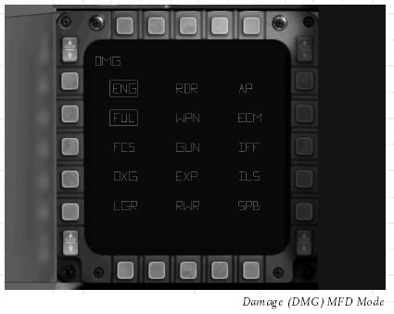

Damage mode monitors the integrity of the aircraft and its systems. When a section of the display is illuminated that system is damaged or destroyed.

ENG Engine
RDR Radar
AP Auto-Pilot
FUL Fuel
WPN Weapons
ECM Electronic Counter Measures
FCS Flight Control Systems
GUN Guns
IFF Identifier Friend/Foe
OXG Oxygen
EXP Expendables (Chaff/Flare)
ILS Instrument Landing System
LGR Landing Gear
RWR Radar Warning Reciever
SPB Speed Brake

Armaments (ARM) MFD Mode

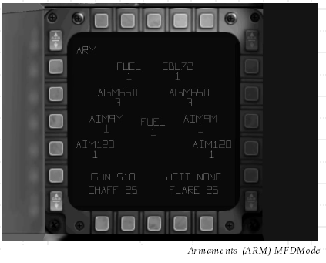

Armament mode displays the F-16's weapon management system. This shows the type, quantity and placement of the F-16's payload. The display also indicates the number of rounds the internal cannon has remaining as well as the number of chaff and flares.

Satellite (SAT) MFD Mode

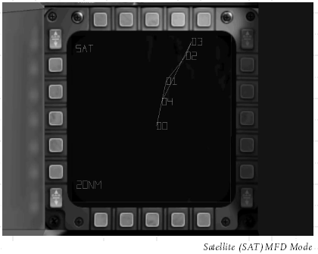

The Satellite mode shows an aerial representation of the ground the F-16 is flying over. This includes the mission waypoints, which are joined by computed lines indicating the correct approach line.

Air-to-air Radar (JTIDS) MFD Mode

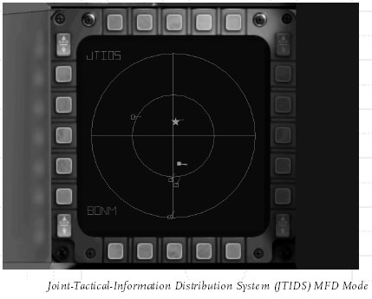

Joint-Tactical-Information Distribution System. JTIDS is the F-16's air-to-air radar. It operates either by itself or in conjunction with friendly AWACS aircraft that are in the area. If the F-16 is not receiving support from an AWACS, the radar range is limited to 120° field of view in front of the aircraft. If an AWACS is supplying enhanced radar information to the F-16 it has a complete 360° radar coverage. The radar range can be enlarged or reduced using the Insert/Delete keys. The radar range varies between 5-80 Nm. It is impossible for the F-16 to gain missile lock on a Friendly Aircraft as long as the lock safety mechanism is engaged.

JTIDS Symbols

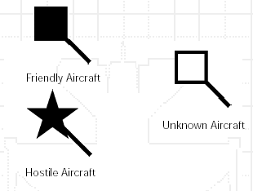

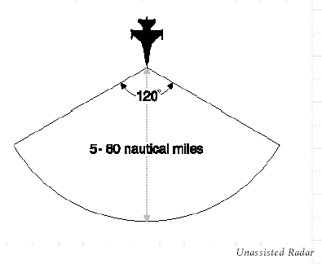

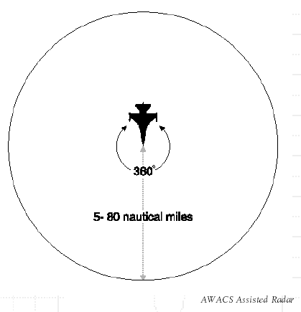

Ground Map (GM) MFD Mode

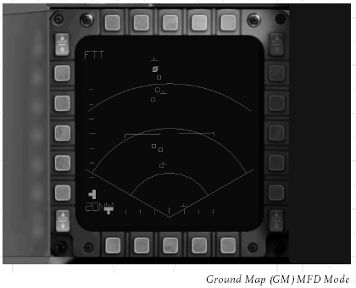

This is the primary air-to-ground radar mode of the F-16. The GM mode consists of a 120° field of view forward of the F-16. In this mode all ground targets that are in range are displayed. The range of the radar is 5 Nm - 80 Nm. Once you have target lock you can then choose to select the Fixed Target Tracking mode or FTT on the Multifunction Display.

Fixed Target Tracking (FTT) MFD Mode

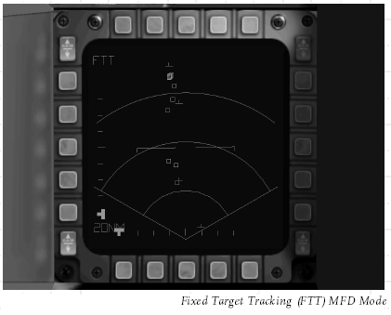

Fixed Target Tracking is the F-16's second air-to-ground radar mode. After the pilot has selected a target in GM mode he can then switch to FTT. This strips the radar display of unnecessary information making it easier for the pilot to read. FTT will then continually track the ground target even if the target subsequently becomes mobile.

Symbols

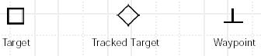

Threat Warning Indicator

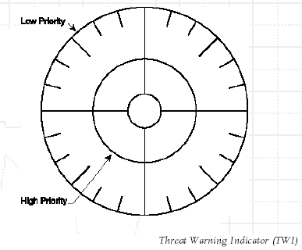

The F-16C has an ALR-64 radar-warning receiver that alerts the pilot to other radar sources.

The F-16 has antennae on each side of the fuselage which detect radar waves. These radar waves could be coming from either an enemy plane or SAM sight or a missile that has been targeted at the F-16 and has achieved missile 'lock'. As soon as the F-16's systems realise that the aircraft is being illuminated by radar emissions the Threat Warning Indicator alerts the pilot. It displays the direction and priority of the threat. It also determines the origin of the radar waves and uses different symbols to represent the different types of hostile unit.

When the F-16 has been locked onto, a warning sound is emitted within the cockpit. This increases in pitch and frequency as the danger increases. If there are multiple threats present, the highest priority is displayed as a multiple threat symbol. Initial priority is allocated to any threat that has the capacity to launch against you. Higher priority is given to threats that are recognised to be in firing mode.

Enlarged representations of air / ground radar symbols.
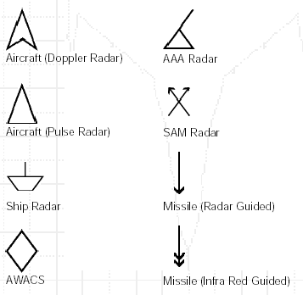

Bitching Betty
The technical term for Betty is the voice warning reproducer. It is an on board system that is linked to the F-16's instruments and monitors the status of the aircraft. The Bitching Betty system alerts the pilot to a variety of dangers and situations from missile lock to altitude and fuel warnings. When the defence industry researched this system pilots were exposed to a variety of alerts and their responses recorded. The majority of pilots responded more rapidly to a female voice, perhaps because pilots are generally male. Bitching Betty was born.

Integrated Control Panel (ICP)
The Integrated Control Panel (ICP) is the primary interface to the aircraft’s systems. The Data Entry Display (DED) tracks system status, Fire Control Computer (FCC) settings, and facilitates data entry. The side-consoles are back up systems in the event the ICP fails.

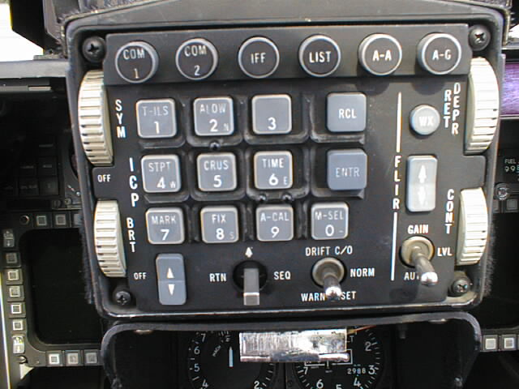
Fig ICP

Backup Switch
In the event of a primary system failure, the BACKUP switch on the AUX COMM panel is used to divert control from the ICP to backup controls. When switched to backup, the TACAN channels and other systems are accessed through the AUX COMM panel. When the BACKUP switch is restored to the UFC position, the settings from the ICP override any entries made using the AUX COMM panel.

Master Modes
The master modes simultaneously set several functions and configure the cockpit and it's display devices for a particular mission activity. There are two types of master modes. The first set is for weapon delivery:
- Air-to-Air (A-A)
- Air-to-Ground (A-G)
- Dogfight (DGFT)
- Missile Override (MSL OVRD)
Air-to-Air and Air-to-Ground master modes are selected using the appropriately labeled buttons on the ICP.
The other master modes are:
- Navigation (NAV) is the default mode and is automatically selected when no other MASTER mode is selected.
- Selective Jettison (S-J) may be accessed from either MFD using the Stores Management System (SMS) page.
- Emergency Jettison (E-J) is shown while the Emergency Jettison button is pressed.

Override Modes
COMM1, COMM2, IFF, LIST and F-ACK buttons are Override modes. Pressing any of these buttons usually provides immediate access to the functions of the corresponding button. Override modes are a toggle function. Return to the previous mode by pressing the same Override button a second time.
The RESET function is a special Override mode that brings up the Communication, Navigation, Identification (CNI) page from any mode or display combination. It is accessed using the Data Command Switch (DCS).

ICP Functions and Usage
They are labeled with a four-letter abbreviation if they directly access a subpage.

Scratchpad
Two asterisks surround the data entry section of the DED known as the Scratchpad. Wherever you see two asterisks, you’re allowed to make manual input using the Secondary buttons (there are a few exceptions).
To change a value, such as the TACAN channel for example, access the appropriate page (such as the T-ILS page) and type in your new channel. You’ll notice that the text between the asterisks will be drawn with light text on a dark background when starting to input data. After pushing the button, the input is checked for validity. If valid, the system will use the new settings and clear the Scratchpad. If the input is not valid (entering a nonexistent TACAN channel), the DED will flash.

Data Command Switch (DCS)
The Data Command Switch (DCS) is the four-way switch below the ICP. Its four labeled positions and corresponding functions are:

Label | Direction | Function
RTN | Left | Reset
UP | Up | Cycle through the editable options forward
SEQ | Right | Cycle through subpages and options
DOWN | Down | Cycle through the editable options backwards

CLEAR button
This button will clear the last two data entries. If pushed twice, the entire input is cleared.

Communication, Navigation, and Identification (CNI) Page
The Communication, Navigation, and Identification (CNI) page is the default page displayed on the DED after powering up the Up Front Control panel (UFC). The CNI page displays information about your communications channel, steerpoint, IFF response, and TACAN channel settings. The active communications channel is written on the 1 st row of the DED.

Instrument Landing System page (ILS or 1 button)
The T-ILS Button makes the FCC enter into one of the two following modes:

1. Instrument Landing System (ILS) mode is entered if the Instrument mode (INSTR MODE) switch (beside the HSI) is in the appropriate position (TCN/ILS or NAV/ILS).

2. The FCC defaults to NAV mode when the INSTR MODE is set to NAV or TCN.
- Input any new TACAN channel using the Secondary buttons. A valid channel must be between 1 and 126. To cycle through the TACAN BAND, input 0 into your Scratchpad and push ENTR. The DED readout shows your active TACAN channel. The FREQ readout shows a bogus ILS frequency if your TACAN channel is set to an airbase.
- Use the SEQ button to toggle the TACAN domain.
- The CRS readout shows your selected HSI course.
- To activate the reception of the ILS signal, you must first call the Tower using the "Inbound" radio command.
- For a perfect ILS approach, work with the Command Steering mode: While receiving an ILS signal, use the DCS to get to the CMD STRG section, then press Mode-Select (M-SEL0) to activate Command Steering. This will put your ILS in CMD STRG mode, with the tadpole in the HUD indicating an 45° intercept path to the ILS approach path. Just put the FPM onto the tadpole and follow this direction. Then, as soon as you are within 3° of the approach path, the ILS will switch to the usual approach mode.
Two things to keep in mind: The 45° intercept doesn't consider your relative position to the
runway (so if you are outside of +/-45° horizontal cone extending from the runway threshold,
the intercept will falsely lead you to a position which is actually behind runway). In addition, if
you overfly the runway, command steering will not lead you back towards ILS approach.

Altitude Low page (ALOW or 2 button)
Increment or decrement the low altitude alarm using the Secondary buttons. By default, your Minimum Safe Level (MSL) floor is set to 10,000ft. Should the aircraft enter that area during a descent "Bitchin' Betty" will call out "Altitude" twice.
NOTE:
- The MSL floor setting is RALT independent!
- Terrain Following Advisory (TF ADV) is not implemented at this time.

Steerpoint page (STPT or 4 button)
Provides the GPS coordinates of the selected steerpoint. Choose the steerpoint to be displayed on the DED with the PREV/NEXT buttons. Pushing any of the Secondary buttons will change to the Destination (DEST) page (see below). Press RTN to return to CNI page (required before accessing any other page).
Use the SEQ function to cycle between AUTO and MANUAL options. If you’ve selected AUTO, your steerpoint will cycle automatically to the next when you’re within 2 miles of the currently selected steerpoint. AutoSteerpoint only works when the FCC is not in A-G mode.

Cruise page (CRUS or 5 button)
There are 4 sub pages:
RNG
Shows the current waypoint, how much fuel you will approximately have when you reach it, and wind information.
HOME
Shows the same info as the RNG page plus the optimum cruise altitude for your HOME waypoint.
EDR (Endurance)
Shows your current waypoint, how much time left until you reach your bingo level (see below) plus optimum cruise altitude, and wind information.
TOS
Shows your current waypoint, system (or, if running, HACK) time (see below), time left until reaching the current waypoint, estimated waypoint arrival time, and the required (approximate) ground speed to reach the waypoint on time.
Push either the SEQ button, or a Secondary button (1-9 only) to cycle through the pages.
Press RTN to return to CNI page (required before accessing any other page).

TIME page (6 button)
Shows the current system time. Also contains a stopwatch that can be started/stopped using the PREV/NEXT buttons. Push NEXT once to start it, a second time to freeze it (while the timer is still running in the background), and a third time to update the display again. Use the PREV button to clear the HACK clock. If the HACK time is running, it will show up on the CNI and the CRUS TOS pages. For example, there is a given station time on a BARCAP mission. When arriving at the first BARCAP steerpoint, start the HACK time. This will give an indication of time on station as it runs. Then wait until the HACK time has almost exceeded the station time, then cross reference destination time on station with your ETA. As an example, by Falcon4 default a full 15 minutes is required in the BARCAP area, so a safe bet is to let HACK time run a minute or two over, then apply a little more power to meet the speed/time requirements to get to the next NAV steerpoint.

MARK page (7 button)
Shows info on the MARK points. Press RTN to return to CNI page (required before accessing any other page).

FIX page (8 button)
Permits selection of sensors to update INS position (N/I).

A-CAL page (9 button)
Used to update system altitude and/or INS position (N/I).

Identify Friend or Foe (IFF )
Displays some info about your IFF settings. IFF is not implemented.

LIST page
Used to access various additional subpages:

Destination page (DEST)
Displays the GPS coordinates of the selected steerpoint (see STPT page above). Use the PREV or NEXT button to change the selected steerpoint. The waypoint coordinates may be changed using the Secondary buttons. Enter the GPS coordinates of the new waypoint destination and press ENTR to implement the change.
For the target waypoint (needs to be the currently selected waypoint), up to two Offset Aimpoints (OA) may be entered: Use the sequence button to cycle between the two OA and DEST, then input an OA by entering it's bearing and distance relative to the target waypoint.

BINGO page
Sets the BINGO Fuel warning level. It can be set using the Secondary buttons. Push the ENTR button to implement the changed warning level.

Visual Initial Point page (VIP)
Set location information for the Visual Initial Point (VIP). Enter a Visual Initial Waypoint for the target waypoint (the target waypoint needs to be the active waypoint).

Navigation page (NAV)
Displays and controls FCC NAV Filter operation and some GPS functions. Not implemented.

Manual Gun Funnel Adjustment page (MAN)
Set the manual ballistics for the gun using the DED scratchpad. Valid data entries change the size of the gun funnel to match the wingspan of known threats. The default is 35 feet, an effective setting for small to medium fighters (e.g. MiG-29).

Inertial Navigation System page (INS)
The first line displays the align time/status, RDY mnemonic, and steerpoint. The other lines display your current GPS coordinates, heading and groundspeed. Use this page to set your current reference coordinates before aligning the INS.

Electronic Warfare System page (EWS)
Control page for the Electronic Warfare System. Toggling the REQJAM option to ON automatically turns the radar jammer on when the RWR system detects a radar spike. Set the warning level for expendables by toggling BINGO to ON, then manually set chaff and flare low warning levels. When BINGO is ON, Bitchin’ Betty will call out “Low” when your chaff/flare level reaches the alarm level set. REQJAM and BINGO options are toggled with any of the Secondary buttons.
To create your own chaff/flare programs, use the SEQ button to access the programming mode (you need to set the EWS mode switch to STBY before).The PREV/NEXT button then switches between four different default programs.

EWS CHAFF | PGM
Burst Quantity (BQ) | 4
Burst Interval (BI) | 0.500
Salvo Quantity (SQ) | 3
Salvo Interval (SI) | 1.5

Master Mode page (MODE)
The current master mode may be changed through this page should the master mode buttons on the ICP become inoperative. Use the SEQ button to choose the mode you want to change to, then press the 0 button to select it (You can only choose between A-A and A-G master modes). The active mode is drawn color inverted. Pushing 0 on a selected mode will change the FCC into NAV mode.

Visual Reference Point page (VRP)
Set location information for Visual Reference Point (VRP). Enter a VRP for the target waypoint (Target waypoint needs to be the active waypoint).

Interrogation page (INTG)
Check or set AIFF modes and code for interrogation (N/I).

Data Link page (DLNK)
Display data link target information (N/I).

Miscellaneous page (MISC)
Gives you access to miscellaneous subpages:

Correction page (CORR)
Allows checking/input of the correction coefficient for the HUD, CTVS, CAMERA and left and right hardpoints (N/I).

Magnetic Variation page (MAGV)
Displays the actual magnetic variation of the aircraft’s location. This value is displayed on the DED. This info would be used to correct the INS for positional errors in the real aircraft (N/I).

Operational Flight Program page (OFP)
The Operational Flight Program (OFP) page shows the program numbers for the UFC, FCR, MFDs, FCC, SMS and DTE (N/I).

Inertial Navigation System Memory page (INSM)
This is the place where INS parameters like drift errors, maintenance data and manufacturer codes are stored (N/I).

Laser page (LASR)
Page for setting the targeting pod laser pulse code (N/I) and lasing timer (default setting: lasing begins 8 seconds before impact).

Global Positioning System page (GPS)
Displays information about the GPS system (N/I).

DRNG page
Set manual correction to a consistent A-G miss distance (N/I).

BULL page
Select Bullseye mode.
Toggle with ICP button 0 while inside this subpage.
If selected, Bullseye information is displayed. If the aircraft is further than 99 miles away from Bullseye, the Bullseye circle is empty. Otherwise the actual distance is displayed. When the target is in STT, the Cursor-Bullseye readout changes to Target-Bullseye distance/bearing.
If not selected (default), an aircraft reference symbol is displayed in the FCR and HSD screens. It's bearing/distance readout depends on current master mode:
A-A: Bearing to the collision point (with a locked target only)
A-G: Air-to-Ground bearing
NAV: Bearing to current system waypoint

In this screenshot (right), the current systém waypoint is the one fully right. Therefore, the vertical line in the aircraft reference symbol is also shifted to the right, displaying the bearing to this current waypoint.

WPT page
Info and settings for Harpoon missile operation (N/I).
HARM page
Verify/modify HARM threat table data (N/I).

Horizontal Situation Indicator
The horizontal situation indicator is basically a very precise compass which provides additional information on navigation.
The horizontal situation indicator guides the pilot to the selected waypoint. Whichever waypoint is selected you must fly the plane so that the needle is pointing in a directly vertical position. When this is the case you will be heading towards the waypoint. The central portion may be displaced to either the left or right of the main body of the needle. This will indicate that although you are heading towards the waypoint you not following the correct approach line. You will be flying to either the left or right of the correct approach line respectively. Waypoint heading is measured in degrees and waypoint distance is measured in nautical miles.
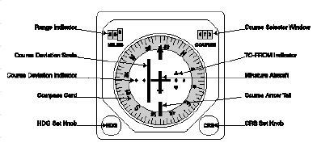

Fuel Flow Indicator
Displays the burn rate or fuel consumption in lbs/per mins. The actual amount of fuel remaining is displayed on the MFD in NAV mode.

Data Entry Display
Conveys information to the pilot such as target identification and damaged systems.

Angle of Attack (AoA) Indexer
Instrument dedicated to landing.

Master Warning Indicator
If any aircraft system is damaged this instrument will illuminate. The specific system can then be identified on the MFD in Damage mode, see later section on MFD.

NOS POS
Indicates the afterburner nozzle position, i.e. the degree to which it is open or closed.

APG-68 Radar System
The radar MFDs have been improved to reflect improved realism and enhancements to the HUD and the Non-Cooperative Target Recognition.

Air-to-Air Radar Modes
Long Range Scan (LRS)
The LRS mode is functionally identical to the RWS mode. It is however designed to operate in the 80-160nm range, and is intended to detect large objects at distant ranges. The LRS mode is also slower than the RWS mode and increases your chances of being detected by enemy radar warning receivers.
The real use of LRS is to detect enemy strategic bombers when flying DCA or BARCAP missions: Using LRS alerts you to their approach at a much longer range, allowing you to plan the intercept early on. As LRS only detects large planes, it can also be used to find and attack enemy early warning aircraft (AWACS), transporters and other support aircraft.

Range While Search (RWS)
When using the AIM-120, some of the major HUD elements are now also displayed in the FCR:
This includes the Allowable Steering Error Cue (ASEC), the Dynamic Launch Zone (DLZ) brackets and the LOSE cue.
The above pictures show (from left to right) the display changes upon AIM-120 engagement:
- A bugged target (depicted as a yellow triangle) well inside the DLZ.
- The same target (now in RED), moments after a missile was launched against it.
- The target after estimated impact (based upon FCR missile flight time estimation): yellow
triangle marked with red cross.

Non-cooperative Target Recognition (NCTR)
As soon as you lock up a radar contact in TWS or STT mode, the NCTR system will try to identify the target by analyzing radar signature details. During this process, "WAIT" will be displayed in the top middle of the FCR.
If NCTR is successful, it will then display the actual target ID (e.g. "MG25") in the FCR. If NCTR fails, it will display UNKN ("unknown") instead.
Success for NCTR depends very much on the aspect to target, as it relies heavily on radar returns from the engine compressor blades and air intakes. Therefore, NCTR must be able to "see into" the engines of the target; this means that your plane must point towards the target and be inside a 25° cone in front of it.
The NCTR range depends on the radar mode: in TWS, it's only about 70% of what it is in STT.

Track While Scan (TWS)
TWS now has an EXP mode, expanding the field of view by 4:1 around a bugged target (or the current cursor position if no target is bugged). With no target bugged, the expansion box can be slewed around the screen with the radar cursor keys.
This EXP function enables you to split out targets flying in close formation (No special radar modes are used here; EXP is simply magnifying the existing display).
To toggle between the Expanded (EXP) and Normal (NRML) views, use OSB3 or the SOI FOV keyboard shortcut [v]. The EXP mnemonic under OSB 3 will flash when the function is enabled. Also note the following changes to the TWS:
- Track Files are now displayed as hollow polygons.
- Track Files display a tail if an AMRAAM has been fired at it. The tail flashes when the missile goes active.
- At the calculated impact time, an X is imposed over the Track file. This happens regardless of actual impact or not. The X is steady for 5 seconds before it flashes and disappears. If the radar lock is lost due to target disintegration after impact, the Track Files will vanish as usual.
- The radar will not scan while the aircraft is on the ground.

Azimuth Step
The Azimuth scan width step can also be changed between 60 and 30 degrees using the radar cursor: Slewing it to one side of the display toggles an Azimuth step change and moves the radar cursor back in range on the MFD.

ACM modes
ACM submodes are accessible via OSBs on the MFD by cycling through the A-A radar modes. Direct access to individual submodes is possible through keyboard shortcuts or by switching to dogfight master mode.

Air-to-Ground Radar Modes
Air-to-Ground Ranging (AGR)
The Air-to-Ground Ranging mode is automatically selected during continuously-computed impact point (CCIP) and dive-toss attacks.
It is used by the FCC to generate the slant range measurement to a designated surface location. This means that the radar basically "looks" through the CCIP pipper to provide the fire control computer with the range and elevation of the target. The FCC then makes its calculations and releases the bombs as soon as you press the pickle button.
If you push the pickle button while the plane is still a bit too far away for the bombs to reach the target, the usual CCRP solution cue comes up in the HUD. Once the solution cue drops and meets the flightpath marker (while you are on the CCRP steering line), the bombs will be released (just as in normal CCRP mode).

Ground Map (GM) / Ground Moving Target (GMT)
With SP3, GMT is now only showing targets that are actually moving (and not all vehicles, regardless of their speed, as it did in all previous versions of Falcon). If a contact is moving slower than 5 kts or faster than 100 kts, it will therefore not show up on the scope.
All targets that are not moving will instead show up on GM (not just buildings as it did before). So if you have a tank column that is speeding towards it's destination, they will show up on GMT.
When they arrive in their destination area, they will move slower. Then, as soon as they move at less than 5 kts, they will disappear from GMT. Finally, once the have stopped completely, they will show up again on the GM scope.
Furthermore, Soldiers will not show up on any radar mode anymore: Since these troops don't really have a radar signature, they simply can't be detected by the APG-66.
If you want your wingman to attack an infantry target that doesn't show up on the radar, just padlock the target visually (you can use the new Padlock AG keys), then issue the "Attack Targets" radio command. This is also a neat trick when flying the A-10, as the Warthog doesn't feature an AG radar!
Once you designate a target in either GM or GMT, the radar displays a cross and dot symbol over the target location as the radar enters a stabilized ranging and tracking mode similar to A-A STT mode and stops sweeping the entire selected azimuth. The moment you undesignate the target, the A/G radar returns to the usual azimuth sweep display.

Auto/Manual ranging
Auto and Manual ranging has been implemented. This option can be toggled through OSB2. What it does is rather simple: In Auto mode, you can use the cursor to bump the radar range up and down - just move it to the top or bottom of the display. In Manual mode, the bump will not happen and you will have to change the radar range through the OSB keys

Azimuth Step
The other thing added is that the azimuth sweep of the radar can now be set just like it can for the A-A radar. Pushing the OSB that is labeled with "A" and a number will change between 60,30 and 10 degrees sweep.
This is useful if you only need a specific patch of ground map updated (where your target is). When reducing the azimuth scan, you'll get faster target updates.

Radar map gain
In GM and GMT modes, adjusting the radar gain can improve the picture quality of the display, thereby providing more details and better information about the target and it's surroundings (like displaying hills, valleys, rivers and roads. To help you taking advantage of this, the default gain settings have been adjusted.

Electronic Warfare System
The EWS allows for automatic countermeasures upon missile launch detection by the RWR. This includes the release of pre-programmed sequences of Flares and/or Chaff and the ability to turn on the Jammer automatically.
The EWS is controlled by a number of switches on the main EWS panel found on the left-hand front panel.

MODE
Select the EWS main mode:
- OFF: The system is switched off completely. No Flare/Chaff release is possible.
- STBY: To manually re-program one of the default programs through the ICP, switch the EWS to standby mode.
- MAN: To manually launch the selected Flare/Chaff program.
- SEMI: When a radar spike is detected by the RWR, Betty calls out "Jammer" to ask you if you want to turn the Jammer on (only if the REQJMR Option in the ICP is set to ON). If so, turn it on manually. When a missile launch is detected by the RWR, Chaff/Flares are automatically released according to the currently selected program on the PRGM switch.
- AUTO: When a radar spike is detected by the RWR, the Jammer is turned on automatically (only if the REQJMR Option in the ICP is set to ON). When a missile launch is detected by the RWR, Chaff/Flares are released automatically according to the currently selected PRGM.

PRGM
The program selector controls which one of four pre-programmed counter-measure programs will be used in SEMI and AUTO mode. The default program is #1, a chaff-only sequence for medium and high altitude SAM evasion.
The pilot can choose between 4 different programs, each optimized for a certain task. By default, the 4 programs are defined as follows
Program #1 - High-Med Altitude SAM Evasion
This program is optimized to deal with RDR launches from SAMS and SARH missiles. The 3 Chaff drop every 2 seconds gives the pilot a maneuver time between salvos to jink and change heading.
Chaff BQ: 3 Flare BQ: 0
BI: 0 .5 BI: 0
SQ: 3 SQ: 0
SI: 2 SI: 0

Program #2 - Merge program against enemy with IR missiles
This is optimized to deal with the Archer-HMS combo. At the first turn, the Pilot dispenses this program (8 flares in 2.5 seconds per program launch)
Chaff BQ: 1 Flare BQ: 4
BI : 0.5 BI: 0.25
SQ: 3 SQ: 2
SI : 3 SI: 1

Program #3 - Popup AG sequence, Chaff only
To confuse enemy radar, as the ingressing fighter begins his pull-up into the SAM envelopes this program dumps 8 bundles of chaff.
Chaff BQ: 2 Flare BQ: 0
BI : 0.5 BI: 0
SQ: 4 SQ: 0
SI : 3 SI: 0

Program #4 - Popup AG sequence, Chaff-Flare
With the possibility of SA7 or SA8 over the target area, this sequence adds in the protective measure of 6 flares.
Chaff BQ: 2 Flare BQ: 2
BI : 0.5 BI: 0.5
SQ: 4 SQ: 3
SI : 3 SI: 3

The EWS system is closely related to the ICP. The pilot can change each program as he/ she likes. To do so, the pilot accesses the “LIST” page, switches to the “EWS” selection and enters the Chaff and Flare program pages. The pilot can change the various values from there. Remember: To manually re-program the default programs the MODE switch of the EWS must be in STBY MODE.

RWR
This switch controls whether or not the EWS system receives RWR data. Switch it to ON to use SEMI and AUTO modes –otherwise the EWS doesn't get launch warnings from the RWR.

JMR
SEMI and AUTO Jammer operations only work if this switch is set to the ON position.

Chaff / Flare
Chaff and Flares are only released in SEMI or AUTO when these switches are in the ON position. Manual Chaff/Flare program release does not depend on the state of these switches.

Chaff / Flare release keys
If the avionics are setup as "Realistic", pressing the keystrokes for manual Chaff or Flare release will instead start the selected program.

VMS Calls
New VMS ("Bitchin' Betty") calls are "Chaff/Flare", "Chaff/Flare LOW", and "Chaff/Flare OUT".

Fault and Warning System
There are two types of indications that the pilot can get from this system: warnings and cautions.
Note: The Voice Management System (Bitchin’ Betty) is disabled when on the ground.

Warnings and Warning Lights
Warning lights are attached to the glare shield, and are red in color. The "T/O LDG CFG" (Take-Off Landing Configuration) light is a warning light. If the pilot flies slower then 190 kts, descending at more than 250 ft/min, and is below 10,000 ft. with gear up, this warning light illuminates. A typical warning consist of a "WARN" indication on the HUD when a light is illuminated. Five beeps followed by “Warning, warning!" from the VMS (Betty) follows 1.5 seconds after a warning light illuminates.
There are two ways to clear a warning:
- Use the WARN RESET switch located on the ICP. The "WARN" indication in the HUD will be removed, and the VMS will stop. However, the warning light will remain on.
- Change the situation that caused the warning. In the above example, accelerate to a speed above 190 kts, descend slower, or lower the landing gear. The HUD "WARN" indication will be removed, the warning light will extinguish, and Betty will quit shouting.
This is the same with all warning lights. Clear by getting out of the condition that caused the warning (if possible), or use the WARN reset switch.

Cautions and Caution Lights
Cautions work basically the same as Warnings, but the Master Caution light illuminates instead of the HUD "WARN" indication. Seven seconds after the caution light illuminates, Betty calls "Caution, caution". Pressing the Master Caution button during the seven-second interval avoids the VMS call. Removing the condition causing the warning will clear the warning.
Example: selecting CAT I when the aircraft is limited to CAT III will generate a Master Caution, a Betty call and a Stores Config caution light. Changing the switch back to CAT III will extinguish the caution lights and there will be no VMS messages. Also after expending all A-G ordnance, the Master Caution and Stores Config lights will be on and Betty calls. This is because CAT III isn't necessary any longer, as no A-G ordnance hangs under the pylons anymore. Simply switch back to CAT I to solve the problem!

Pilot Fault Display
The Pilot Fault Display (PFD) is located just above the caution lights panel on the right auxiliary console. This display is accessed via the F-ACK button on the left side of the glare shield. If the button is pressed and there are no system faults then "No FAULTS, ALL SYS OK" will be displayed. Pushing the F-ACK button a second time will turn the display off.
When the "AVIONICS FAULT" caution light is illuminated the pilot will get a Pilot Fault List (PFL) and Master Caution will illuminate as it does for all cautions. Pushing the F-ACK button will bring up the first fault the system detected. Use the F-ACK button to cycle through all system faults (You can also click directly on the PFD to switch through the messages). When the last fault in the list has been displayed, another push on the F-ACK button will turn the display off. The "AVIONICS FAULT" light will be turned off once the pilot has cycled through all faults.
The PFL can also be accessed through the DED: If the DED Data switch is set to PFL data, the F-ACK button steps through the individual faults, just like the PFD display.

Warn Reset
The Warning Reset switch is located on your UFC and is used to acknowledge warning indications when they appear on your HUD. For example, should a warning indication for Bingo Fuel occur, the Master Caution light illuminates and "WARN" is displayed in your HUD. Pressing the Master Caution button will reset the warning system and extinguish the Master Caution light, but will not remove the "WARN" indication on the HUD. Use the Warn Reset switch to reset and remove that indication. The Warn Reset resets the MaxG readout the pilot sees on the HUD to 1.

Inertial Navigation System
The INS uses gyroscopes and other electronic tracking systems to detect acceleration and deceleration of the airplane. With this data, the INS computes the aircraft's position in latitude and longitude. As the INS is aligned on the ground before take-off, it's accuracy declines on long flights. In modern jets, the INS is coupled with the GPS to gain additional precision.
INS is implemented:
- When doing a ramp start, the INS must be aligned. (Full alignment takes 8 minutes, but INS will be useable after 90 seconds of alignment).
- Wrongly entered INS coordinates will result in waypoint offset (coordinates are automatically preset upon start – but can be changed manually through the DED)
- The INS drifts if GPS is turned off (HUD waypoint and HSD stuff drifts). Drift depends on alignment time. The longer aligned, the smaller the drift will be:
With full alignment, INS drifts 1 NM per hour, with minimum alignment, INS drifts 10% more.
- The jet may not be moved during alignment, or alignment will stop (it continues once the jet stops again). If the plane moves faster than 60kts on ground and in Align mode, INS has to be shut down before it can be aligned again.
- Pitch ladder and heading tape numbers aren't shown when the INS is powered off or not aligned

How to Use the INS
- To align the INS, the UFC must be turned on. Then, switch the INS knob on the right panel to ALIGN NORM. Alignment will now begin.
- The alignment status is shown in the HUD and on the INS DED page:
- During alignment, ALIGN is displayed in the HUD and flashes after full alignment.
- On the DED, the 1 st line shows RDY as soon as the INS is useable (after 90 seconds). When the INS is fully aligned (after about 8 minutes), this RDY indicator will flash.
- The timer on the INS DED page will count on after 8 minutes, but status won't go below 10.
- If coordinates are entered in the DED after 2 minutes of alignment, alignment starts anew.
- Should you have a total power loss in flight or switch the INS to OFF, turn the INS knob to IN FLT ALIGN. The INS will then use GPS information to re-align itself

Other Switches

Avionics Power
The main power switch on the left console needs to be set to BATT for engine startup and to MAIN PWR when the engine is running.
The other power switches are on the right side panels:
FCC Fire Control Computer
HSD display on the MFD
SMS Stores Management System
MFD Main MFD
UFC Up Front Controls, DED, and ICP
MAP Unknown (N/I)
DL Data link (required to datalink wingman positional data and JSTAR updates)
GPS GPS power
INS Inertial Navigation System
- Inflight/Aligned: NAV
- Ramp/Aligning: ALIGN NORM
FCR Fire Control Radar, powers up the radar systems
LEFT/RIGHT
HDPT
Powers the fuselage hardpoints (normally targeting or navigation pods)

Radar Altimeter (RALT)
This is a three-position power switch. Positions are OFF, STANDBY, and ON. Only the ON position provides A-LOW warnings. The altimeter takes time to cool down before it functions. In realistic avionics, the RALT will only work if the aircraft’s parameters are within following limits:

Altitude (ft) | Roll (+/-) | Pitch (+/-)
< 3000 | 60° | 30°
> 3000 <= 5000 | 30° | 30°
> 5000 <= 10000 | 25° | 25°
>10000 <= 25000 | 15° | 15°
>25000 <= 50000 | 10° | 10°

Parking Brake
The parking brake switch applies the brakes permanently. As its name implies, it is used to park the aircraft. The parking brake may be released with the parking brake switch or by applying 83% or greater engine RPM.

Landing Light
Toggles the landing/taxi light on or off.

Exterior Lightning
Used to toggle the jet's position and anti-collision lights.
MASTER Set to NORM
ANTI COLLISION Toggle the anti-collision light (on the tail)
POSITION Switch to BRT to turn on the position lights on the wings and choose FLASH or STEADY.

Interior Cockpit Flood Lighting Rheostat
This rheostat on the right console controls the interior flood lighting of the cockpit. Please note that enabling this causes a framerate hit.

Kneepad
The kneepad has a third page listing the original waypoints from Falcon’s planning page. The pages can be cycled with the command.

Seat Arm Switch
This switch can be found on the left front of the ACES II Ejection seat, just below the pilot’s kneepad and the landing gear handle. When the switch is in the UP (SAFE) position, the seat is NOT armed and the SEAT NOT ARMED caution light will illuminate. Ejection is NOT possible. Moving the switch down (ARMED) allows normal operation of the ejection seat. Changing the seat from ARM to SAFE will illuminate the caution light and a Master Caution will be displayed.

Tail Hook Switch
For carrier landings, the aircraft's tailhook must be deployed. Upon landing, the hook catches one of several arresting wires stretched across the landing deck of the carrier, bringing the plane to a stop.

Alternate Gear Deploy / Reset
If hydraulics fail, this handle engages the alternate gear deployment. The center white button resets the alt gear deployment and re-enables normal hydraulic gear deployment.

Speed Brakes
In the air and with the gear retracted, the speed brake operates through its full range. However, if the landing gear is lowered, the speed brake opening is limited to 43°. If necessary, the pilot can override this limitation by holding the speed brake actuator in the "open" position. On the ground, there is no need to hold the key in the open position after the nose wheel is on the ground. The speed brake will remain in the position the pilot set before.

Drag Chute
Use a cockpit switch to deploy the chute when you have slowed to about 160 kts (do not deploy while faster - it may get detached!). After slowing down, press the switch a second time to detach the chute (before turning from the runway onto the taxiway).

Laser Arm
Found just below the RF Switch, the Laser Arm switch turns on the Forward Looking InfraRed (FLIR) pod’s targeting laser. Laser Guided Bombs (LGB) require that the laser illuminates the target until impact. Should the laser stop illuminating the target, or should the lock be broken during the LGB’s time of flight (TOF), the weapons will follow a ballistic trajectory. LGBs can be assigned new targets while in flight.

RF Switch
The RF switch is located on the left side of the cockpit, just above the Laser Arm switch. This switch is used to cut radar emissions quickly and completely. When entering into enemy territory with the desire to be undetected (perhaps using Terrain Following Radar navigation or just NOE ingressing) use this switch. This switch has three positions:
- NORM: Normal operation
- QUIET: Radar emissions reduced, and the AGP-68 radar is put into Standby
- SILENT: ALL radar emissions are silenced (i.e. no RADAR, no CARA (RALT), and no TFR, the system will indicate a TF failure and generate a TF FAIL light and WARN indication)

Ground Jettison Enable Switch
Enables stores jettison while still on the ground (in case of Emergency).

Emergency Jettison Button
Pressing this button for more than one second will jettison all Air-to-Ground weapons (Air-to-Air missiles will stay onboard). While the Emergency Jettison button is hold, the Emergency Jettison page will be displayed in the MFD.

Stores Config Switch
This switch toggles the stores configuration. Also known as the CAT switch, it restores maneuverability to the aircraft after the loadout is released or jettisoned.

Trim Panel
Use the manual trim knobs to correct problems with airplane stability (e.g. after being hit by AAA or SAM). The gauges show the level of currently applied trim. TRIM/AP DISC switch: Set to DISC to disable trim through the stick or autopilot.

Flight Control
As the F-16's flaps are controlled by the FLCS, no pilot input is needed. However, if the FLCS is damaged, you can manually access the flaps by using the FLT CONTROL panel:
LE FLAPS AUTO: Leading edge flaps controlled by the FLCS

AVTR Switch
The Airborne Videotape Recorder is used to record ACMIs:
- Switching to ON starts recording.
- Switching to AUTO enables automatic recording. In this mode, the AVTR starts recording whenever the 1 st trigger detent or the pickle button are pressed. It then keeps recording for at least 30 seconds or until recording is stopped.

Audio Volume
Use the knob on the main AUDIO panel to regulate the sound volume of the missile seeker heads (MSL), the threat warnings (THREAT) and the two (voice) comms channels.

Test Panel
Set the Test switch from NORM to TEST to check malfunction and indicator lights.

Airframe

Airframe Overstress
Extreme levels of airframe overstress or overspeed during flight will damage the hardpoints.
Damaged stations will not be able to release weapons.
Noise inside the airframe will warn you of increased airframe stress.

Fuel
The F-16 Fuel system is based on the Forward/ Right Left/Aft layout. The fuel is divided into two systems, the F/R and L/A, and is fed from both systems to the engine. In this way balance is maintained and the aircraft does not become too nose or tail heavy or have a tendency to roll.
The fuel storage system is composed of the following:
- Two Reservoir tanks, these hold 480lbs of fuel each and feed the engine directly. One reservoir is for the F/R and the other L/A system.
- Forward and aft fuel tanks hold the bulk of the internal fuel. They feed into the appropriate reservoir tanks.
- The wing tanks which feed the forward and aft tanks, the left wing tank feeding the aft main tank, and the right feeding the forward tank. These tanks hold 550lbs of fuel each.
- External tanks feed into the wing main tanks. The wing externals feed into the appropriate wing tank, and the centerline feed into both. Capacity is dependent on the tank size loaded.
The fuel is transferred from the reservoirs to the engine. There are fuel pumps that are normally activated to aid the transfer, but the main transfer mechanism is gravity and siphoning between tanks. The fuel then goes through the Fuel Flow Proportioner (FFP). It adjusts flow rates from the two systems to maintain the balance of fuel between F/R and L/A systems to maintain the aircraft’s center of gravity. Should the FFP fail (it is part of the ‘A’ hydraulic system) then erratic distribution may occur leading to a center of gravity imbalance.
The fuel then goes through the main fuel valve to the engine (where it burns!). The amount of fuel in the F/R and L/A is shown on the fuel gauge. More important is the ratio of the fuel in the tanks. If the difference is too large, a center of gravity imbalance will occur. Attention to the fuel gauge indicators is important beyond just assessing remaining fuel.

The fuel readout knob has 6 settings - which alter what is shown on the gauge. In all positions except TEST, the digits in the display show the total fuel.
The positions have the following functions:
- TEST: Digits should show 6000lbs of fuel, and both dial indicators should point to 2000lbs.
- NORM: One gauge indicates the F/R amount, and the other the L/A quantity of internal fuel (total amount stored in reservoirs, Fwd/Aft tanks and internal wing tanks for each system).
- RESV: Shows the amounts in the Fwd/Aft reservoirs.
- INT WING: Shows the amount of fuel in the Right/Left internal wing tanks.
- EXT WING: Shows the amount of fuel stored in any external wing tanks.
- EXT CENTER: Shows the amount of fuel stored in any centerline tanks.
The normal fuel transfer procedure from external to internal is to transfer fuel from the centerline tank first, then from the external wing tanks. However, this may be overridden by setting the fuel transfer switch to WING FIRST.
The left console has the protected fuel master switch. This controls the main fuel valve. In the off position, no fuel will get to the engine.
Next to it is the fuel pumps control switch. This has 4 positions:
- OFF: All fuel pumps are off. Fuel will still transfer using gravity and siphon feeds, but you will encounter problems in negative G maneuvers with the engine being fuel starved.
- NORM: Normal position - all fuel pumps on.
- AFT: Fuel is transferred from the L/A system only .
- FWD: Fuel is transferred from the F/R system only.
These last two positions allow a fuel imbalance to be corrected manually.
The switch for the aerial refueling door opens and closes the air-refueling door. The air-refueling door must be opened before attempting in-flight refueling.

Finally, there is the air source control switch on the right console. This controls pressurization of the cockpit and the fuel tanks. The external fuel tanks require pressurizing to allow the transfer system to work.
This knob has four settings:
- OFF: no air control.
- NORM: normal position for pressurizing the cockpit and the external fuel tanks.
- DUMP: dumps cockpit pressure, but still pressurizes the external fuel tanks.
- RAM: external tanks are not pressurized.
The external tanks are pressurized when switch is in the NORM or DUMP. In other positions the tanks are not pressurized and external fuel flow will not occur. If this happens for too long, you may get a FUEL TRAPPED warning on the HUD indicating fuel flow problems.
To dump fuel, use the keyboard shortcut. On every key press, about 7% of the available fuel is dumped (with a minimum of 100 pounds per key press).
About fuel management, warnings and radio calls:
- "Joker" is called at 50% of internal fuel,
- "Bingo" at 20% of internal fuel,
- "Fumes" at 7% of internal fuel.

Engine

Definitions And Terminology
The jet engine system in the F-16 consists of several engines actually. There is the main engine, and a small jet engine known as the Jet Fuel Starter (JFS). This engine is used to bootstrap the main engine to life by spinning up the main engine to an adequate RPM where the fuel can be fed and ignited. What spins up the JFS engine to a point where it can light? Hydraulic power, stored in two hydraulic pressure accumulators, is used to accomplish this.
When you start the JFS, hydraulic accumulators discharge through the JFS to spin it up to starting speed. Once running, the JFS can then start the main engine. The JFS accumulators are a one-shot process. Once the accumulators are discharged (one JFS start attempt), they must be recharged before another attempt can be made. Running the engine at greater than 12% RPM about one minute is enough to charge the accumulators.
Power to move the control surfaces and other parts is supplied through the ‘ A’ and ‘B’ hydraulic systems. These are pressurized from pumps driven by the main engine.
When all other systems fail, and the aircraft is in the air, the Emergency Power Unit (EPU) starts up automatically. The EPU has ten (10) minutes of fuel, total. When the engine is offline, the secondary hydraulic system, Hydraulic B, fails. The primary hydraulic system, Hydraulic A, fails when the EPU shuts down. None of the aircraft control surfaces function when both systems are down. This is a good time to leave the cockpit.
If the EPU switch is in the NORMAL position during flight, the EPU will start and run automatically. In the OFF position, the EPU doesn't run. In the ON position, the EPU runs regardless of the main engine status. The EPU can be set manually.
Switching the EPU to ON has no noticeable effect if the engine RPM is above 80%, as it will simply derive power from the main engine. However, as soon as RPM drops below 80%, the EPU will start to burn EPU fuel.
The throttle on the F-16 has various stops where the normal sliding motion stops (called detents). The throttle must either be lifted or an interlock lever pulled to move it further. One of these detent settings stops the throttle before it moves into afterburner position, so the pilot has feedback that he is about to go into afterburner. There is another position at the other end of the throttle travel that stops the throttle from moving below the idle setting to the cut-off setting (which avoids accidental shutdowns). In the F-16, a small lever must be engaged to move the throttle below idle and shut down the engine: Use the throttle idle detent to cut-off the fuel flow to the engine.

Functions and Usage

To shut down the engine
- Set throttle position to idle.
- Engage the idle detent switch. This is equivalent to pressing the lever that allows the throttle to travel fully back, and then pulling back the throttle.
- Engine will now spool down (to 0% on the ground or between 5%-10% in the air, depending on speed).
In flight, the EPU will start and run automatically as soon as the rpm drops below 80% (The EPU has a 10 minute fuel supply to power flight systems, then a total flight control system failure will happen).

The Hydraulic B system will fail as soon as the engine is shut down. The most important effect of this is that the landing gear cannot be lowered normally. Instead you’ll have to use the Alternate Gear Extension to lower the gear. You will not be able to retract it unless the main engine is restarted. To retract after an engine restart, toggle the Alternate Gear Reset switch to reset the system.

To start the jet engine
- Set throttle position to idle.
- Start the Jet Fuel Starter. Engine will spool up to a maximum of 25% rpm.
- When the RPMs are greater than 20% advance the throttle above idle.
- Press the idle detent switch.
Engine should now start and spool up to over 70%. The JFS will automatically disengage when the engine RPM gets above 50%.

Details
The JFS will fail to start the main engine if the aircraft is higher than 20,000 ft barometric or moving at greater than 400 Knots. There is an increasing probability of failure at higher altitudes or speed. Unfortunately, the JFS accumulator will still discharge during an attempted restart!
Once discharged, the JFS accumulator will not function without recharging the pressure accumulators. If at sufficient altitude, diving the aircraft to get 12% or better RPM on the inlet turbine will recharge the JFS accumulators in about one minute.
When the ‘B’ hydraulic system fails the following systems will fail:
- landing gear
- nose wheel steering
- drag chute system
- gun
- air refueling
- wheel brakes
- JFS recharge
When the ‘A’ hydraulic system fails the following systems will fail:
- speed brakes
- fuel flow proportioner
All other systems are served by both A and B.

Electrical Systems
The F-16 has several electrical systems and generators. The main sources of electrical power are in rough preference of use:
- Main Generator
- Standby Generator
- Emergency Power Unit (EPU)
- Battery
The main generator is powered by the engine and is sufficient to power all the aircraft’s systems. The standby generator is powered by the main engine and has adequate output to power most of the essential systems. The emergency power unit is an independent system that can provide power in the absence of the main generators. The batteries provide minimal power to certain systems only.
Attached to each generator is a power bus, which is designed to allow degrading of the power systems. These are:
- Battery bus
- Emergency power bus
- Essential power bus
- Non essential power bus
Thus, the main generator provides power to all busses, the standby generator provides power to all but the non-essential power bus, and so on. Without the engine, both the standby and main generators are inoperative, which is why the EPU is an independent system used for power during an engine failure.

Lights
There are numerous lights associated with the electrical system. The main one is the ELEC SYS caution light. This illuminates when there are any electrical problems identified and is a cue to check for other problems. There are two lights on the electrical panel, showing the status of the main and standby generator. These are illuminated when there is a problem with the generators. FLCS RLY and TO FLCS indicate problems with power to the FLCS. This usually indicates that the FLCS is not getting power from all possible power sources (The FLCS gets power from every system as it is the most critical system in flight). The battery light illuminates when there is a problem charging the batteries, or problems with the battery voltage. The EPU has two lights to show that it is working (in addition to the main EPU run light): The first one is an AIR light that indicates that the EPU is running. The other one, labeled HYDRAZINE, indicates that the EPU is consuming Hydrazine fuel (rather than running off engine pressure). This means there are less than ten (10) minutes of reserve power!

Waepon Systems

In this chapter, basic combat procedure is outlined for both air-to-air and air-to-ground combat. One of the training missions is designed to teach you these concepts. It's wise to take the time to practise these before starting the campaigns. You'll almost certainly stay alive longer if you do. Basic combat procedure is a term for a number of fundamental actions a pilot will have to perform in order to engage specific hostile units. As you gain experience these procedures will become automatic but meanwhile it is useful to have a step by step approach to follow. Most of the missions you fly will include both aerial and ground threats. You will have to decide which constitutes the greater danger in any given situation. The ability to monitor, alternate between and respond to different types of danger cannot be underestimated. By definition the first rule of engagement is to remember that there will be multiple threats, so cover your back. There is a basic protocol that can be followed for air-to-air and air-to-ground combat. The vital issue is not to forget that you are constantly vulnerable to attack from both areas.

Targeting Pod
The AN/AAQ-14 Targeting Pod contains a high-resolution, forward-looking infrared sensor (which displays an infrared image of the target to the pilot), a laser designator-rangefinder for precise delivery of laser-guided munitions, a missile boresight correlator for automatic lock-on of AGM-65D imaging infrared Maverick missiles, and software for automatic target tracking. These features simplify the functions of target detection, recognition and attack and permit pilots of single-seat fighters to attack targets with precision-guided weapons on a single pass.
As soon as right hardpoint power is turned on, the pod begins to cool. This will take 7-15 minutes. During cooling, "NOT TIMED OUT" will be displayed on the TGP page.
FOV adjusted to real world values (6° in Wide View, 1.7° in Narrow View). EXP mode modeled, providing 2:1 expansion over narrow view. The box around the crosshair is the narrow FOV indicator.
The Pinky switch toggles FOV.
If the TGP is SOI and not ground stabilized, it will use the Radar slewing speed. If it is ground stabilized, it will use it's own (slower) slewing speed.
The laser will only fire if armed (LASER ARM switch!). It keeps firing until 4 sec. after impact. OVRD (OSB 4) inhibits the laser from firing. If the laser hasn't been fired manually (1 st trigger detent) and a bomb is in the air, the laser will automatically fire at the target using the LASER ST TIME entered on the UFC (MISC page 5) if the calculated impact time is greater than the entered time. LASER ST TIME can be 176 seconds at maximum. Using manual lasing overrides this setting- the laser will not lase automatically anymore during this bomb drop!
Laser status displayed: Steady L means laser armed, flashing L means Laser is firing.
Time to Impact displayed: Laser and passive ranging added: The TGP image shows the range to target. When the laser is firing, an L is displayed in front of the readout. Without the laser firing , a T is displayed meaning that the range value is coming from the targeting pod itself.
RALT readout is displayed (if enabled). TMS-Left toggles display polarity between BHOT and WHOT (N/I)

Weapon Summary

Air-to-air: Unguided
Internal 20mm cannon

Air-to-air: Guided
AIM-7D Sparrow
AIM-7E Sparrow
AIM-7F Sparrow
AIM-7P Sparrow
AIM-9BSidewinder
AIM-9E Sidewinder
AIM-9J Sidewinder
AIM-9L Sidewinder
AIM-9M Sidewinder
AIM-120 AMRAAM

Air-to-ground: Unguided
Internal 20mm cannon
LAU-3A Hydra Rocket Pod
MK82 500lb Iron Bomb
MK83 1000lb Iron Bomb
MK84 2000lb Iron Bomb
CBU-72 Fuel Air Bomb
CBU-87 Cluster Bomb

Air-to-ground: Guided
AGM-65G Maverick
GBU-10 Paveway 2000lb Laser Guided Bomb
GBU-12 Paveway 500lb Laser Guided Bomb
GBU-16 Paveway 1000lb Laser Guided Bomb

Anti-runway
BLU-107 Durandal

Anti-Radiation
AGM-45 Shrike
AGM-88 HARM

Anti-Ship
AGM-84 Harpoon
AGM-119A Penguin

Air-to-air Combat
There are two types of weapon that can be used, the F-16's internal 20mm cannon or air-to-air missiles. Missiles are always preferable as they can be launched from a greater distance and are much more accurate. Using missiles also provides an increased amount of time to react to any offensive manoeuvres initiated by the enemy.

The majority of air-to-air missiles use a solid propellant rocket to achieve the high speeds necessary to intercept their targets (between three and four times the speed of sound). Once an air-to-air missile has been launched it rapidly accelerates to its maximum speed. As the fuel burns off, the missile glides in towards its target. In order to track the target perfectly the missile makes constant minor adjustments to its flight path, which leads to aerodynamic drag. Missiles lose speed as a result of gravity and aerodynamic drag. As the missile speed reduces so does the missile's ability to manoeuvre and this is vital to the strike success rate. That is why you are advised to wait until targets are well within range before launching.

The altitude of the launch aircraft will affect a missile's range. A missile launched at high altitude won't lose its speed as rapidly as one launched close to sea level. This is because at higher altitudes the air is not as dense and so the drag is reduced. Vice-versa missiles launched close to sea level will have a significantly reduced range.
The aspect of the target is also relevant to missile launch. This is the direction the target is flying in relative to your own aircraft. If the target is flying towards you, the missile and the target will be flying at one another. Therefore you could launch the missile at an increased range and the two will still meet. If you are firing on a retreating target make sure that it is well within range. Otherwise the probability of the missile catching the target over a long distance, even with its superior speed, will be small. If the target is crossing your flight path the missile will be constantly turning to track it, therefore increasing its aerodynamic drag and losing speed and therefore range and effectiveness continuously. In conclusion, the range and speed of any AAM missile depends on the altitude and heading of the plane it is fired from.

Air-to-air Missile
Upon perceiving an aerial threat:
Select JTIDS mode on the MFD if it's not already selected. (Use [ ] to cycle through MFD display options). Alter radar range to the desired choice using the INS/DEL keys. Select missiles mode on the HUD (mode 5). This enables you to arm an AA missile.

If there are multiple targets cycle through them on radar using the TAB key.

Use the I key to identify any selected target. The target description will appear on screen and on the computer read out (Cockpit view 9). Decide which target you wish to designate. JTIDS will automatically

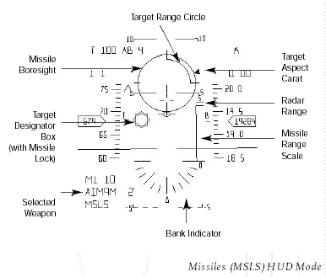

designate a target if there is one available. The designator box will appear on the HUD in the position that the target will appear when it is in visual range. Decide which type of missile you wish to use if there is an option. Use the ENTER key to alter weapon selection. Missiles have different ranges illustrated on the HUD by the missile range scale, so select the most appropriate one if there is a choice. This scale also has a sliding pointer denoting the target's range. Identify the aspect of the target by observing the target aspect carat revolving around the missile boresight symbol. A head-on or tail-on shot is preferable for tracking purposes. Check that you are in range, which can be determined by using the range to target scale on the HUD. As you close on the target the circle will unwind counter clockwise. After it has reached the three o'clock position your target is within optimum range. This scale is only present when using short range AAM's where range is critical. With medium range AAM's the missile range scale provides enough accuracy for an effective launch. Wait until the missile achieves lock. Missile lock is displayed on the HUD as a diamond superimposed over the target designator box. The Bitching Betty cockpit system will confirm missile lock. Fire when ready.

Your actions after firing depend on the type of missile you have launched. If you can afford to purchase advanced missiles like the AIM-120 AMRAAM 'fire and forget' missile you can turn away and immediately begin tracking another target. If the missile is not of the 'fire and forget' variety you may have to maintain missile lock until the missile has made impact. To do this you must keep the target in your field of vision until missile impact. This will certainly be the case if you have launched a missile like the AIM-7 Sparrow. See Chapter 22.1, weapons specifications.

Air-to-air Cannon
The dogfight is perhaps the most difficult and in its own way the most sophisticated type of aerial combat to engage in. Because of range limitations use of the cannon dictates that you will be quite close to the enemy. This being the case it is counter-productive to be flying at speeds in excess of 250-300 knots. Any faster and your turning rate will be reduced thus giving the enemy an advantage. Shooting at high speed targets, in relatively close quarters with no form of computer guidance, would be futile. Therefore if you have to use your cannon against an opponent select the LCOS (Lead Computed Optical Sight) mode of the HUD (mode 6). LCOS gives an optical trail that portrays the projected bullet flight path of the cannon rounds as well as the targets previous flight path.
Should you find yourself in close proximity to a hostile aircraft and have the choice of using missiles or cannon select the Dogfight or DGFT mode of the HUD (mode 9). This will provide the option of launching a missile under the same constraints as MSLS mode. DGFT also supplies a constant LCOS (see above) so that if at any point a hostile aircraft is directly in your sights you can switch to cannons without having to alter the HUD mode.

Air-to-ground Combat

Air-to-ground combat is entirely dependent on aircraft payload and mission objectives etc. In some missions you may not be expected to designate any ground targets though ground threats will probably exist. In others your payload could include a range of air-to-ground missiles and guided/unguided bombs. Air-to-ground combat is generally pre-planned in relation to the mission that you are flying. This will dictate to some extent which weapons are chosen. The combat procedure for ground attack tends to reflect this. The weapons that are used are more specific and therefore require more specific launch conditions. We will cover the deployment procedure for each variety of air-to-ground weapon.

Air-to-ground Missiles
To launch standard air-to-ground missiles such as any missile in the Maverick family, you must first select Electro Optical (EO) HUD
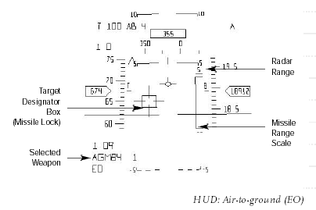

mode (mode 4). This is the primary ground attack mode of the HUD. You must also be monitoring possible targets using radar. Select GM (ground map) radar mode on the multifunction display. Alter the range using the INS/DEL keys. This will display all the available ground targets in your radar range and scope. To cycle through available targets use the TAB key. As in air-to-air combat you can identify the target by pressing the I key. This will provide a description of the target on screen as well as on the computer read-out. Once you have selected your target you may choose to switch the multifunction display to FTT or fixed target tracking. This will enable you to follow the target even if it subsequently becomes mobile. It also reduces the amount of information on the MFD making it easier to monitor. Weapon range is displayed on the HUD. A target designator box will appear as you approach the target. The missile boresight, portrayed as cross-hairs on the HUD, will drift towards the designator box as the missile acquires lock. When missile lock is achieved the cross-hairs will snap onto the designator box and lock will be confirmed by the Bitching Betty cockpit system. Once you are in range you can launch the missile at any time.

Anti Radiation Missiles
When launching anti-radiation missiles the ARM mode of the HUD must be selected (mode 8). Follow the same procedure used for launching traditional air-to-ground missiles but remember that antiradiation missiles will only lock on to targets that are emitting radar waves. Even if an enemy radar site is in the vicinity it must be at least partially active for an anti-radiation missile to track it.

Air-to-ground Bombs (Unguided)
Using 'dumb' or unguided bombs requires precise accuracy by the pilot. They are relatively cheap but quite difficult to use successfully. Unless you are very confident or experienced it is wise to approach potential targets at low altitude, 1000ft or lower, and reduced air speed. This in turn makes you an easy target for nearby anti-aircraft guns or mobile missile launchers, so be wary. Choose your target using the GM radar mode on the MFD as above. Select the Continuously Computed Impact Point (CCIP) Pre-designate mode of the HUD (mode 2). This mode is only used for unguided bombs. It shows a 'bomb fall line' and computed impact point. Wait until impact point covers the target and then release the bomb. To check if the target has been destroyed use the camera views e.g. last weapon fired view or present target view (F6 and F7 keys respectively).

Air-to-ground Bombs (Guided)
These bombs are much easier to use and have a greatly increased strike rate due to their guidance systems. It is much easier to guarantee accuracy even at increased speeds and higher altitudes. When using guided and laser guided bombs such as the GBU-10, select Continuously Computed Impact Point (CCIP) Post-designate HUD mode (mode 3). Select the desired target as above, cycling through potential targets on radar. When a target is chosen the CCIP displays a 'bomb steering line' with a primary, designated target box, which covers the target and a secondary box. You must fly the F-16 so that the steering line dissects the designated target box. The secondary box slowly climbs towards the target box. Hold down the fire button and when the two are perfectly aligned the weapon is released automatically.

Rockets and Cannon
When firing either rockets or cannon at ground targets select STRF mode (mode 7). You can use the radar to specify a certain target but although the HUD provides a target designator box over the chosen target, it is only a visual guide to aid the pilot. This is because there is no lock available with unguided weapons like rockets and cannon fire. When the gun boresight cross on the HUD covers the target designator box open fire. Effective rocket and cannon range is estimated at just under 1Nm.

Weapon Selection and Related HUD Summary

Aerial Combat
Air-to-air missiles HUD mode: MSLS
Cannon HUD mode: LCOS
A-A missiles and cannon HUD mode: DGFT

Ground attack
Air-to-ground missiles HUD mode: EO
Anti-radiation missiles HUD mode: ARM
Unguided bombs HUD mode: CCIP (Pre)
Guided bombs HUD mode: CCIP (Post)
Rockets and Cannon HUD mode: STRF

19.5 Counter Measures

Chaff and Flares
The F-16 is equipped with an internal ALE-40 chaff and flare dispenser. The number of chaff and flare rounds available is displayed on the MFD in weapons management mode. Chaff is made up of radar reflecting strips. These are released into the air so as to confuse enemy radar positions and radar guided missiles. Flares are decoys used against heat seeking missiles that will follow the heat trail of the F-16's engines. There are 25 rounds of each loaded onto the aircraft but each round will only be effective for a short amount of time. Releasing them is a skill in itself. If they are released too soon the incoming missile will quickly re-orient itself on your position. Releasing them too late will unfortunately be much too late! The best tactic is to perform an aggressive turn, dive or climb immediately after releasing the decoy, therefore hopefully escaping the missile's field of view once it attempts to resume its search.

SPECIFICATIONS

Weapons

All specifications for weapons utilised by the F-16 Aggressor Unit are as follows:

AIM-7D SPARROW
WEIGHT 200KG RANGE 20NM
The AIM-7D Sparrow is an all aspect semi-active, radar guided, medium range air-to-air missile. It requires a constant radar lock to be maintained on the target during flight. The Sparrow missiles are effective against all air targets, however they are quite susceptible to countermeasures.

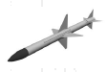

AIM-7E SPARROW
WEIGHT 205KG RANGE 20NM
The AIM-7E Sparrow is an improvement on the earlier D variant being more manoeuvrable and having a generally superior warhead.

AIM-7F SPARROW
WEIGHT 230KG RANGE 43NM
The AIM-7F Sparrow is again an improvement on the earlier D and E variants. An enhanced warhead which is faster, more manoeuvrable and more reliable.

AIM-7P SPARROW
WEIGHT 250KG RANGE 43NM
The AIM-7P Sparrow is an all aspect semi active, radar guided, medium range air-to-air missile. It requires a constant radar lock to be maintained on the target during flight. The AIM-7P Sparrow is a further improvement on the F variant with better tracking.

AIM-7P SPARROW
WEIGHT 250KG RANGE 43NM
The AIM-7P Sparrow is an all aspect semi active, radar guided, medium range air-to-air missile. It requires a constant radar lock to be maintained on the target during flight. The AIM-7P Sparrow is a further improvement on the F variant with better tracking.

AIM-9B SIDEWINDER
WEIGHT 70.4KG RANGE 1.5NM
The AIM-9B Sidewinder is a fire and forget, rear aspect, infrared guided air-to-air missile. It must be fired at the rear of enemy planes from a 60 degree field of view. It is less manoeuvrable and less reliable than later models.
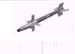

AIM-9E SIDEWINDER
WEIGHT 74.5KG RANGE 2.5NM
The AIM-9E Sidewinder is a fire and forget rear aspect infrared guided air-to-air missile. It must be fired at the rear of enemy planes from a 80 degree field of view. Although an improvement over the AIM-9B, it remains less manoeuvrable and reliable than later models.

AIM-9J SIDEWINDER
WEIGHT 78KG RANGE 8NM
The AIM-9J Sidewinder is a fire and forget rear aspect infrared guided air-to-air missile. It can be fired anywhere at the rear of enemy planes. The AIM-9J is a modern missile and a great improvement over the earlier B and E variants.
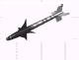

AIM-9L SIDEWINDER
WEIGHT 85.3KG RANGE 9.5NM
The AIM-9L Sidewinder is a fire and forget all aspect infrared guided air-to-air missile. The L Sidewinder can be fired at the target from any angle. Slightly more manoeuvrable and reliable than the J variant, its all aspect capability is a great advantage.

AIM-9M SIDEWINDER
WEIGHT 86KG RANGE 9.5NM
The AIM-9M Sidewinder is a fire and forget all aspect infrared guided air-to-air missile. The M Sidewinder can be fired at the target from any angle. It is more manoeuvrable and reliable than the L variant and has a reduced smoke motor.

AIM-120 AMRAAM
WEIGHT 150KG RANGE 21.5NM
The AIM-120 Advanced Medium Range Air-to-air Missile, is a fire and forget all aspect, active radar, guided air-to-air missile. The AMRAAM is effective against all air targets and is fitted with the latest anti-countermeasures system making it the most lethal air-to-air missile in our arsenal.

AGM-45 SHRIKE
WEIGHT 177KG RANGE 15NM
The AGM-45 Shrike is a fire and forget radar signal seeking air-to-ground missile. The Shrike is effective against ground radar stations and vehicles but can be easily countered if the target turns off their radar signal.

AGM-88 HARM (D)
WEIGHT 362KG RANGE 26NM
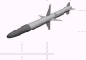
The AGM-88 High speed Anti Radiation Missile is a fire and forget radar signal seeking air-to-ground missile. The HARM is effective against ground radar stations and vehicles and is difficult to counter as it 'remembers' the target location even if the radar signal is turned off.

AGM-65G MAVERICK
WEIGHT 302KG RANGE 6.5NM
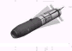
The AGM-65G Maverick is a fire and forget infrared guided air to ground missile. The Maverick is a versatile weapon, it is effective against all types of vehicle, small buildings and hardened bunkers and can even be used against ships at sea.

AGM-84 HARPOON
WEIGHT 555KG RANGE 43NM
The AGM-84 Harpoon is a fire and forget active radar guided air to ship missile. The Harpoon is effective against all types of sea vessel and its large warhead is particularly good when used against larger classes of ship.
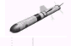

AGM-119A PENGUIN
WEIGHT 384KG RANGE 21.5NM
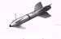
The AGM-119A Penguin is a fire and forget anti-ship missile. Primary guidance is followed by terminal infrared guidance. The Penguin is suitable against all small and medium class ships and submarines.

LAU-3A HYDRA ROCKET POD
WEIGHT 245KG
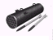
The LAU-3A Hydra Rocket Pod carries 19 unguided 2.75inch rockets containing a mixture of M151 high explosive and M247 anti tank warheads. Hydra Rockets are effective against all ground targets except hardened bunkers and are particularly useful against large concentrations of mixed targets. Their low accuracy makes them of little use beyond 1Nm.

MK82 500LB IRON BOMB
WEIGHT 241KG
The MK82 500lb Iron Bomb is an unguided, general purpose, free fall bomb. The MK82 is effective against all ground targets except the most hardened bunker. With their lack of guidance, the MK82 must be delivered with pinpoint accuracy.
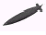

MK83 1000LB IRON BOMB
WEIGHT 447KG
The MK83 1000lb iron bomb is similar in all aspects to the smaller MK82.
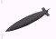

MK84 2000LB IRON BOMB
WEIGHT 894KG
The MK84 2000lb iron bomb is similar in all aspects to the smaller MK82.
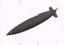

CBU-72 (FUEL/AIR BOMB)
WEIGHT 890KG
The CBU-72 is a Fuel/Air Bomb is a devastating ground attack weapon. After the weapon is released an initial detonation distributes highly explosive liquid droplets into the surrounding air. A secondary detonation then ignites these droplets causing a huge explosion.
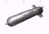

CBU-87 (CLUSTER BOMB)
WEIGHT 431KG
The CBU-87 Cluster Bomb Unit spreads hundreds of small bomblets over an area of 300ft by 600 ft. Half the bomblets penetrate the ground and explode beneath the surface, while the remainder detonate on impact with the surface therefore causing maximum damage.
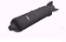

BLU-107 DURANDAL
WEIGHT 204KG
The BLU-107 Durandal is an unguided runway cratering bomb. The Durandal is designed for one target only and will cause extensive damage to any runway.
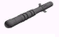

GBU-10 2000LB BOMB
WEIGHT 944KG
The GBU-10 Paveway 2000lb Laser Guided Bomb is a variant of the MK84 2000lb Iron Bomb fitted with a laser guidance system for increased accuracy. The Paveway is effective against all ground targets. With its pinpoint accuracy, it is most suited for targets that require a direct hit such as hardened bunkers.
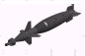

GBU-12 500LB BOMB
WEIGHT 255KG
The GBU-12 Paveway 500lb Laser Guided Bomb is a variant of the MK82 500lb Iron Bomb fitted with a laser guidance system for increased accuracy.

GBU-16 1000LB BOMB
WEIGHT 474KG
The GBU-16 Paveway 1000lb Laser Guided Bomb is a variant of the MK83 1000lb Iron Bomb fitted with a laser guidance system for increased accuracy.

FUEL POD (WING)
WEIGHT 943KG
The fuel pods carry any extra fuel that the F-16 requires in order to increase its air time or flight range.
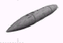

FUEL POD (FUSELAGE)
WEIGHT 943KG
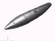

Database
Table shows, how the database will be fullfilled.

Name | What to do (happen) | Pilot’s reaction | Where | Comment
prepare for engine startup |  | set the parking brake | C
 |  | set the switch to MAIN PWR | ELEC panel | power the system
 | warning lights: ELEC SYS, SEC ON, SEAT NOT ARMED | ignore | warning panel (D)
 | warning light: HYD OIL ON | ignore | eyebrow panel (D)
 |  | set the master switch to NORM | external ligths panel (B)
 |  | turn anti-collision lights to ON | external ligths panel (B)
 |  | switch the position lights on Wing Trail and Fuselage to BRT and set them to FLASH. | external ligths panel (B)
 |  | set MASTER FUEL to ON | B
 |  | set ENG FEED to NORM | B
 | EPU switch is set to NORMAL | check | B
 | Fuel Readout Switch (FUEL QTY SEL) is set to NORM | check | E
 |  | set the AIR SOURCE to NORM | G
start the jet engine |  | set throttle position to idle | throttle
 |  | set the JFS to START2 | B | engine will spool up to a maximum of 25% RPM
 | the RPMs are greater than 20% | advance the throttle above idle | D
 |  | press the idle detent switch | C | engine should now start and spool up to over 70%
 | the JFS will automatically switch OFF | check | B | when the engine RPM gets above 50%
 | the HYD OIL warning light has switched off between 25% and 70% RPM | check | D
power up the avionics |  | turn on FCC, SMS, UFC, MFD, GPS and DL | G | with the engine running at idle
 |  | Set the INS to ALIGN NORM. | G | the gyroscopes will begin to spin up, the INS will be fully aligned after about 8 minutes.
 |  | power on the left and right hardpoints | F
 |  | turn on the FCR and set RDR ALT to STBY | F
 |  | enable the flight path marker by setting the ATT/FPM switch from OFF to FPM. | F
 |  | turn on the HUD using the SYM knob | D | press multiple times to increase brightness
 | the INS status in the DED: | observe | D | the first line shows status and remaining time, starting at "0.0/99". It will be fully aligned when the status reaches "10.0".
 | no flags are shown anymore on the ADI, VVI or AOA displays | check | E
 | TRIM is reset. | check | A
 |  | adjust audio volumes for COMM1, COMM2, MSL and THREAT audio | B
 |  | power the EWS: Set THREAT WARN AUX, EWS PWR, EWS JMR, EWS CHAFF, EWS FLARES to ON | C
 |  | switch EWS MODE to MAN | C
 |  | arm the ejection seat | C
 | INS is fully aligned, | enable it by switching to NAV on the avionics power panel | G
 |  | set RDR ALT to ON | F
 |  | switch the landing lights ON | C
 |  | switch the PARKING BRAKE to OFF | C
 |  | enable nose-wheel steering, NWS
shut down the engine |  | set throttle position to idle | trottle
 |  | engage the idle detent switch |  | engine will now spool down (to 0% on the ground or between 5%-10% in the air, depending on speed)
 | in flight, the EPU will start and run automatically as soon as the rpm drops below 80%

Appendix A

Acronyms

A/C Lights Anti Collision Lights
A-A Air to Air
AAM Air to Air Missile
AAM Air to Air Missile
AAR Air to Air Refueling
AB Afterburner
ACE Adaptive Cockpit Environment
ACES Advanced Concept Ejection Seat
ACM Air Combat Maneuvring / Air Combat Mode
AD Air Defense
AEW Airborne Early Warning
A-G Air to Ground
AGL Air Ground Level
AGM Air to Ground Missile
AHC Aircraft Handling Characteristics
AIM Air Intercept Missile
A-LOW Automatic Altitude Low Warning
AMRAAM Advanced Medium Range Air to Air Missile
AOA Angle Of Attack
AP Auto-Pilot
AR Air Refueling
ARM Anti Radiation Missile
ASAP As Soon As Possible
ATC Air Combat Tactics
ATT Attitude
AVTR Airborne Video Tape Recorder
AWACS Airborne Warning And Control System
BCN Beacon mode
BFM Basic Fighter Maneuvers
BSGT Boresight
BULL Bulleye
CAP Combat Air Patrol
CCIP Continuously Computed Impact Point
CCRP Continuously Computed Release Point
DACT Defensive Air Combat Tactics
DBFM Defensive Basic Fighter Maneuvers
DBS Doppler Beam Sharpenning
DED Data Entry Display
DGFT Dogfight
DISC Light Disconnet light
DL Data Link
DTE Data Terminal Entry
DTOS Dive Toss
ECM Electronic Counter Measures
EEGS Enhanced Envelope Gun Sight
E-J Emergency Jettison
EPU Emergency Power Unit
EWS Electronic Warfare Systém
F-ACK Fault Acknowlegment
FBW Fly By Wire
FCC Fire Control Computer
FCR Fire Control Radar
FCS Flight Control System
FLIR Forward Looking Infra Red
FOV Field of View
FPM Flight Path Marker
FTT Fixed Target Track
GBU Guided Bomb Unit
GCA Ground Controlled Approach
GCI Ground Controlled Intercept
GM Ground Map
GMT Ground Moving Target
GPS Global Positioning System
HARM High-speed Anti Radiation Missile
HSD Horizontal Situation Display
HSI Horizontal Situation Indikator
HTS HARM Targeting System
HUD Head Up Display
IADS Integrated Air Defence System
ICAO International Civil Aviation Organization
ICP Instrument Control Panel
IFF Identification Friend / Foe
ILS Instrument Landing Systém
INS Inertial Navigation Systém
INSTR Mode Instrument mode
IP Initial Point
IR Infra Red
JFS Jet Fuel Starter
JMR Jammer
KCAS Knots Calibrated Airspeed
KIAS Knots Indicated Airspeed
KTAS Knots True Airspeed
LADD Low Altitude Drogue Delivery
LANTRIN Low Altitude Navigation and Targeting Infrared for Night
LCOS Lead Computed Optical Sight
LGB Laser Guided Bomb
LGR Landing Gear
LND Landing
LOS Line of Sight
LRS Long Range Scan
MFD Multi Function Display
MIL Military Power
ML Missile Launch
MLU Mid Life Update
MPO Manual Pitch Override
MRM Medium Range Missile
MSL Mean Sea Level / Missile
MSL OVRD Missile Override
MSLS Missiles
NWG Night vision Goggles
NWS Nose Wheel Steering
OFP Operationnal Flight Program
Ops Operational
PFD Pilot Fault Display
PFL Pilot Fault List
PWR Power
RALT Radar Altimeter
RCKT Air to Ground Rocket
RDR Radar
RDY Light Ready light
RP Release point
RPM Rotation Per Minute
RTB Return To Base
RWR Radar Warning Reveiver
RWS Range While Search
S-J Stores Jettison
SLW Slewable mode
SMS Stores Management System
SNAP Snapshoot Sight
SOP Standard Operating Procedures
SPB Speed Brake
STBY Standby
STPT Steerpoint
STT Single Target Track
TACAN Tactical Air Navigation
TARS Tactical Aerial Reconnaissance System
TBD To Be Determined
TCN Tactical Air Navigation
TD Target Designator
TFR Terrain Following Radar
TGP Targeting Pod
TGT Target
TOF Time Of Flight
TOS Time On Steerpoint
TSFC Fuel Flow
TWD Threat Warning Display
TWS Track While Scan / Threat Warning System
UFC Up Front Controls
VID Visual Identification
VIP Visual Initial Point
VRP Visual Release Point
VS Velocity Search
VVI Vertical Velocity Indicator
WPN Weapon
WPT Way PoinT

Literature

[1] Multi-Command Instruction 11-F16, (PACAF) Volume 3, 21. April 1995.
[2] Multi-Command Handbook 11-F16, Volume 5, 10. May 1996.
[3] Falcon Unified Team, Falcon 4, Superpak 2, User Manual, Infogrames Inc.
[4] Falcon Unified Team, Falcon 4, Superpak 3, User Manual, Infogrames Inc.
[5] F-16 Aggressor, User Manual, General Simulations Incorporated Ltd., 1998.
[6] Microprose, Falcon 4.0, Flight Handbook, Microprose, 1998.
[7] FALCON 4.0, Trainink mission, Czech version.

