The Intelligent Cockpit Environment Project
(Draft version)

Ehlert, Patrick  Rothkrantz, Leon  Research Report DKS03-04 / ICE 04  Version 0.3, July 2026  Mediamatics / Data and Knowledge Systems group  Faculty of Electrical Engineering, Mathematics, and  Computer Science  Delft University of Technology, The Netherlands | 
Ehlert, Patrick A.M. (P.A.M.Ehlert@its.tudelft.nl)
Rothkrantz, Leon J.M. (L.J.M.Rothkrantz@cs.tudelft.nl)

“The Intelligent Cockpit Environment Project”
Draft version

Research Report DKS03-04 / ICE 04

Mediamatics / Data and Knowledge Systems group

http://www.kbs.twi.tudelft.nl/Research/Projects/ICE

Keywords: | intelligent user interfaces, situation awareness, human-computer interaction, workload assessment, situation assessment, intelligent agents, adaptive interfaces, artificial intelligence

Preface
This report describes the research that has been done until now in the Intelligent Cockpit Environment (ICE) project

Summary
Here comes the summary

Used abbreviations

AI | Artificial Intelligence
ANN | Artificial Neural Network
BBN | Bayesian Belief Network
CAS | Crew Assistance System
CIM | Cockpit Information Manager
FMS | Flight Management System
ICE | Intelligent Cockpit Environment
IFR | Instrumental Flight Rules
MFD | Multi-Function Display
PA | Pilot’s Associate
PVI | Pilot-Vehicle Interface
SA | Situation Awareness

Table of Contents
Preface I
Summary III
Used abbreviations V
Chapter 1: Introduction 1
1.1 Problem setting 1
1.2 Situation awareness 1
1.3 Automation in aviation 2
1.3.1 Traditional automation 2
1.3.2 Human-centered automation 2
1.4 The intelligent cockpit environment 3
1.5 Report overview 4
Chapter 2: Crew assistance systems 5
2.1 Introduction 5
2.1.1 Data fusion 6
2.1.2 Situation assessment 6
2.1.3 Decision-making 7
2.1.4 Presentation and control management 7
2.1.5 System management 7
2.2 Artificial intelligence 7
Rule-based reasoning 8
Model-based reasoning 8
Case-based reasoning 8
Constraint-based reasoning 8
Probabilistic reasoning and Bayesian belief networks 8
Artificial neural networks 8
2.3 Pilot tasks and information needs 9
2.4 Existing systems and research 9
2.4.1 Pilot’s Associate 9
2.4.2 Rotorcraft Pilot’s Associate 11
2.4.3 Copilote Electronique 12
2.4.4 CASSY 12
2.4.5 CAMA 13
2.4.6 Other projects 14
Power and Power II 14
MMA (TACAID) 14
Delphins 14
Cogpit 14
Flight Deck 2020 14
2.5 Conclusions 14
2.5.1 Support system functionality 15
Information needs 15
Workload 15
2.5.2 Design issues 16
Artificial intelligence 16
Encountered problems/risks 16
Chapter 3: The ICE architecture 17
3.1 Important entities 17
3.1.1 The pilot 17
3.1.2 The aircraft 17
3.1.3 The environment 17
3.1.4 The mission/flightplan and its progress 17
3.2 The ICE system 17
3.3 The situation awareness module 18
3.4 Pilot workload module 18
3.5 Planners 18
3.6 Decision module 18
3.6.1 Goals 18
3.6.2 Missing and uncertain information 18
3.7 Management modules 18
3.7.1 Aircraft control manager 18
3.7.2 Cockpit information manager 18
3.7.3 System manager 18
Chapter 4: Designing and testing 19
4.1 Simulation environments 19
4.1.1 Flightgear 19
4.1.2 Flight Simulator 2002 19
Chapter 5: Situation recognition 21
5.1 Introduction 21
5.2 The artificial neural network approach 21
5.3 The rule-based approach 21
5.3.1 Flightgear Monitor: a simple hard-coded expert system 21
5.3.2 The JESS Pilot prototype 22
5.4 Using probabilities 22
5.5 Related work 23
Chapter 6: Workload assessment 25
6.1 The need for pilot workload assessment 25
6.2 Design 25
6.3 The workload assessment toolkit program 25
6.3.1 Physical workload 25
6.3.2 Cognitive workload 25
Chapter 7: Decision-making and reasoning 27
7.1 Introduction 27
7.2 Flight plan 27
7.3 Automated dog-fight 28
Chapter 8: Future work 29
Bibliography 30
Appendix A: 32

Introduction
In this chapter we will give an introduction to the ICE project. First, in section 1.1 we will outline the problem that we are trying to solve. Then in section 1.2 we will explain an important concept in the ICE project, which is situation awareness. Next, in section 1.3 we will again look at our problem and show the need for a situation-aware intelligent cockpit system, which is the focus of the ICE project. A short description of the ICE project and its goals is given in section 1.4.We end with a short overview of the remaining chapters in this report in section 1.5

Problem setting
Ever since the first airplane was built by the Wright brothers the capabilities of aircraft have continuously been improved. For example, the maximum speed of the average military fighter plane has gone from approximately 100 Mph in 1920 to over 1500 Mph currently. These high speeds are responsible for the little time available to fighter pilots to process information and make decisions. In addition, the improved weapons range in military aircraft (missiles can be fired from 20 km away) reduces the pilot’s decision time even more.
Commercial aircraft have been improved as well. Where early planes only had a few meters, modern commercial aircraft have several hundreds of meters or information displays, providing the pilot with a wealth of information. With the growth of information sources, the complexity of the available information has increased also. Research has shown that flight performance is correlated to the complexity of the presented information [Svensson et al 1997]. Performance is constant up to a certain complexity level (in Svensson’s research complexity was defined as the number of displayed items) and deteriorates when the information complexity increases beyond this point. It is expected that future developments in aviation, such as “free flight” [RTCA 1995], will further increase information complexity in the cockpit.
Combining the increase in aircraft capabilities and information complexity, it is clear that pilots run the risk of information overload. To help a pilot deal with information processing and decision-making, avoid information overload, and optimize flight performance, a Crew-Assistant System (CAS) or intelligent pilot-vehicle interface (PVI) has been proposed [Mulgund and Zacharias 1996], [Abeloos et al 2000], [NLR 2000]. The idea is that the assistant-system presents relevant information to the pilot at the right moment and in the appropriate format, depending on the situation, the status of the aircraft, and the workload of the pilot. The intelligent interface should help to improve the pilot’s situation awareness and reduce his workload. As a result the survivability of the pilot and plane, and the effectiveness of the flight or mission will be improved.

Situation awareness
Having a high level of situation awareness (SA), sometimes also called situational awareness, is generally seen as one of the most critical aspects for achieving successful performance in aviation. Several definitions of SA exists, but the one from Mica Endsley [1995a p.36] seems to be the most cited:

“Situation awareness is the perception of elements in the environment within a volume of time and space, the comprehension of their meaning, and the projection of their status in the near future.”

Endsley refers to “perception of elements” as level 1 SA, “comprehension of the situation” as level 2 SA, and “projection of future status” as level 3 SA. Having a good SA means that the pilot is able to perceive and understand his situation and can predict the future situation. Basically a pilot builds SA by integrating the different sources of information to one mental situation model of the world. Pilots usually sample the available information sources briefly, following a pattern that is learned from experience. The information in the mental model is updated constantly by continuously sampling and processing new information. To some extent, more experience leads to faster information processing. Information is processed quicker when its content is as expected, but people are more likely to make mistakes if it is not. Important aspects that affect a person’s situation awareness are among others; workload (overload/underload situations), system design (how is the information presented), system complexity (how complex is the information) and the level of automation (whether the pilot is in or out the control loop).
Research has suggested that many human errors in (military) aviation are caused by lack of SA. Most errors in aviation can be attributed to failures in level 1 SA. Not observing the available information (e.g. due to high workload and/or distractions) has been determined to be the largest single causal factor for these level 1 SA failures [Endsley 1995b]. By understanding why SA problems occur, it is possible to design an interface or system to prevent many of these problems. Designing such a system would require [Endsley 1999]:
- An analysis of SA requirements; e.g. through expert elicitation, observing operator performance, questionnaires.
- Using design guidelines for enhancing SA; e.g. always provide goal-oriented information, remove extraneous information, support parallel processing.
- Evaluation during the design process; make sure the system does indeed improve SA.

Evaluation of situation awareness is usually done by observing test subjects and/or asking questions about their knowledge, actions, and assumptions. Examination is done either during a specific test scenario or after performing the scenario. Examples of SA evaluation techniques are SAGAT [Endsley 2000] and SART [Taylor 1990].

Automation in aviation
In order to reduce human errors and increase pilot task performance it seems logical to automate the process of flying an aircraft as much as possible. This is exactly what we can see in aviation in the last decades.

Traditional automation
Using a technology-driven approach, many of the simpler aircraft systems have been automated. Automation focused mainly on sensors (e.g. Flight Management System) and actuator systems (e.g. auto-pilot) that were fairly easy to implement. Recently, attention has been given to more advanced systems. Although current cockpit automation systems have been reported to improve accident rates, they also have their drawbacks:
- Automated systems add to the total system complexity of the cockpit.
- Automation shifts the pilot’s workload from manual to mental workload, which is more difficult. The (commercial) pilot has become a passive systems monitor instead of actively controlling the system.
- Placing the pilot out of the control loop leads to degradation of pilot skills and poorer system understanding. This makes building SA more difficult for the pilot, especially during critical situations where this awareness is the most important.
- Pilots may rely on automation too much and become overconfident. It has been known that some commercial pilots doze off during a flight, letting the plane fly itself.
For an extensive list of other reported automation drawbacks we refer to [Funk et al 1997].

Human-centered automation
We feel that it is very unlikely that in the foreseeable future human pilots will be completely replaced by automated systems. First of all, automated systems are very suitable in well-known and predictable situations, but cannot deal with unexpected events. It is often very difficult for an automated system to deal with failures and breakdowns, therefore a pilot still needs to be present to solve problems. Second, people do not feel comfortable in an airplane if they know that is only controlled by a computer without human supervision, so for now, in most cases, the pilot needs to remain in the cockpit.
It has been suggested that the new generation of intelligent cockpit systems needs to take a human-centered design approach, helping the pilot with decision-making, and building and maintaining SA [Billings 1997]. These systems need to complement the human pilot rather than automate manual tasks. Paul Schutte from NASA Langley Research Centre has proposed a complete redesign of the existing flight deck [Schutte 2002]. This new flight deck should help the pilot with monitoring and diagnostics, and leave simple but meaningful tasks to the pilot in order to keep him in the loop and maintain the pilot’s SA. The flight deck will help the pilot with achieving a good level of SA by providing relevant information and taking over system monitoring, and it is the pilot’s job to deal with unexpected situations.
When designing intelligent human-support systems, SA is just as important for the system as it is for the human crew. The intelligent system’s SA forms the basis for its reasoning and decision-making processes. To help the crew properly, the system’s SA should at least be of the same order as that of the crew. This system SA does not only include understanding and predicting the status of the aircraft systems and environment, but also of the pilot and his mission. Workload and other pilot specific performance measures can be used by the system to adapt to the pilot’s capabilities. Russell, Wilson and Monett [1996] have even stated that “accurate and reliable assessment of operator state is the key to successful implementation of adaptive automation”.
The most challenging aspects of intelligent context and user-aware systems are: obtaining the necessary data, fusing data from multiple sensors, and accurately determining the pilots’ state. Within the boundaries of aviation regulations, each pilot has its own way of flying. Therefore, the system needs to have knowledge on normative pilot behavior as well as individual pilots’ preferences. This means that either the system should be able to learn from a pilot’s actions or the individual preferences of the pilot should be entered into the system in advance.

The intelligent cockpit environment
The intelligent cockpit environment (ICE) project is a project of the Knowledge Based Systems group of Delft University of Technology in the Netherlands. The goal of the ICE project is to design, test, and evaluate computational techniques that can be used in the development of intelligent situation-aware crew assistance systems. Using methods from artificial intelligence, ICE focuses primarily on the data fusion, data processing and reasoning part of these systems. Special issues addressed in the ICE project are:
- Situation recognition
- Mission or flight plan monitoring
- Attack management
- Pilot workload monitoring
The ICE project is a follow-up of a similar project called ACE [NLR 2000] that unfortunately was cancelled. Whereas the ACE project only focused on adaptive interface techniques for the F-16, the ICE project is much broader. ICE looks at common intelligent techniques for all types of planes, both commercial and military. However, since there are many different types of aircraft, with each aircraft having its own characteristics, we currently have limited ourselves to two aircraft which are the Cessna 172, a small two-seater airplane, and the F-16C Falcon, a military multi-purpose fighter aircraft. The Cessna is a fairly simple and easy to fly aircraft and allows us to create and test new prototypes quickly. The F-16C is used to test the more difficult and advanced reasoning techniques necessary in a support system for military aviation. Note, that the developed techniques in ICE can also be used for developing support systems for other aircraft. However, this would require gathering and implementing data on the specifics of each particular aircraft.
The techniques that are being developed in the ICE project can be used for future intelligent crew assistance systems. It paves the way for augmented reality systems using 3D vision and sound feedback that has been suggested for future pilot interface systems [Furness 1986]. The ICE techniques can also be applied to human support systems in other complex and dynamic environments such as car-driving and industrial process control.

Report overview
In chapter 2 we will provide an overview of existing research and applications related to the ICE project that was found in literature. This chapter also contains an overview of the conclusions that were drawn from this literature study. Then in chapter 3, we will present our ICE system architecture. This chapter presents a global picture of the system’s design.
{need to add other chapter’s description}

Crew assistance systems
{summary}

Introduction
A Crew Assistance System (CAS), also called Associate system, is a system that assists the crew in performing their task in the aircraft. The main task of a CAS is to reduce the workload of the crew and increase their situation awareness. This is done by providing them with important information or by taking over (some of) their tasks so the crew can perform other tasks and concentrate on their mission. Basically, a CAS can be seen as a future version of the Flight Management System (FMS) that is currently in use in many commercial aircraft. However, pilots need to enter almost all information into a FMS by hand, whereas a CAS can figure things out by itself. In order to do this a CAS has knowledge about how to perform the tasks of the pilot. With this knowledge, an intelligent CAS can give situation-specific advice or solutions.
All CASs follow the same basic principles. The system first gathers data from the aircraft’s systems and possibly also from sensors monitoring the pilot and other crewmembers. Then, based on the gathered data, it makes an assessment of the current situation. Often, possible future situations need to be predicted by the system as well. Then, the CAS has to reason about what action to perform. Finally, the system acts on the decision that was made. System output is given via the various cockpit display devices. Some CASs may take over tasks from the crew, others are more passive and only monitor and inform the crew. It usually is possible for the crew to alter certain settings of the CAS, for example setting the current automation level of the CAS. An overview of a generic CAS is show below in Figure 1. There are four basic modules in a generic CAS; a system’s management module, a decision-making module, a situation assessment module and a data fusion module. The exact role of these modules will be discussed at the end of this chapter.

Figure 1: Generic crew assistance system
Often a CAS is multi-dimensional or layered. One (sub-)system is created for one particular application. Example applications are: following mission progress, weapons selection, or threat assessment. This way the entire system is constructed by joining all the subsystems together. However, this design method introduces the need for explicit coordination between the subsystems in order to resolve conflict. In Figure 2 we show a more elaborate picture of a generic CAS framework that consists of subsystems and includes coordination mechanisms in the form of a presentation management and a control management module. The job of both modules is to coordinate which subsystem is allowed to send its output to the pilot or aircraft.

Figure 2: Generic crew assistance system consisting of subsystems and management modules
The two management modules are not needed in all cases. Sometimes, coordination is done implicitly in the reasoning process of the CAS. Usually, the subsystems can communicate with each other at the decision-making stage. Note that the CAS needs to be informed of the crew’s commands that are sent to the aircraft. In the figure above we assume that the crew’s commands are received by the CAS via the aircraft’s sensors, so the decision-making process can take pilot actions into account.

Data fusion
Data fusion is the seamless integration of data from different sources. In this case, sensors are used to gather data online and in real-time. Usually this data comes from the aircraft’s own systems, but other additional sensors can also be used, for example heart-rate sensors to determine the state of the pilot. Data fusion is needed for several reasons: to derive “higher-level” data by combining data from different sensors and to limit the amount of data that needs to be processed by the system. Also, data fusion can reduce uncertainty that is associated with single sensors.

Situation assessment
Situation assessment is basically the system’s way of achieving situation awareness (see also 1.2). The situation assessment module tries to determine the current situation of the aircraft, the crew, their surroundings, and the mission. Many CASs define separate submodules to assess the status of each of these entities. Situation assessment also includes predicting future situations. To be able to do this, the situation assessment module needs to interpret past and current data from the data fusion process.

Decision-making
Decision-making is a reasoning process that occurs based on the system’s situation assessment. The result of the decision-making process is the action that should be taken by the CAS. However, decision-making costs time which is very limited in a CAS. Therefore, high-priority events have to be recognized and processed first. Then, other less time demanding data can be processed. Decision-making does not only include what action to take, but also how to do it. For example, if it is decided to present the crew some important information, the CAS also has to decide on the best method to do this, for example displaying it on a multi-function display (MFD), sounding an alarm, turning on warning lights etc.

Presentation and control management
The presentation and control management modules coordinate the output of the reasoning processes of the CAS subsystems. In some CASs both modules are combined into a single module or even joint with the decision-making module, but usually they can be separated into separate modules.
When multiple messages need to be sent to the pilot, the presentation coordination module can filter out less important messages to avoid information overload. Also, the presentation coordination module might decide on an alternative method to present the information.
The control management module checks for conflicting actions and may coordinate the system’s actions with the actions taken by the pilot.

System management
It is desirable that the crew is in complete control of the aircraft. Therefore the crew must have a method to regulate the CAS. The system management module functions as an interface between the CAS and the crew. It allows to crew to set a certain level of control and override the CAS. The levels of control of a CAS may vary from complete control (pilot override) to advisory function only.

Artificial intelligence
Artificial Intelligence (AI) techniques play an important role in CASs. They are necessary for a CAS to perform reasoning, which is required in most of the modules describe in the previous section. In addition, AI techniques allow CASs to learn, for example a pilot’s preferences. Veldman [1999] has identified several important evaluation criteria for AI techniques to be used in a CAS:
- Functionality: the technique should be able express the problem and its solution in its representation and should be able to solve the problem.
- Clearness: the applied technique (reasoning process) should be clear and understandable
- Reliability: the technique should function correctly under difficult circumstances, e.g. uncertain or incorrect data.
- Performance: the technique is able to provide a satisfactory solution in real-time.
- Scalability: the technique or system that uses it should be modular to allow expansion and scaling up to larger and more complex applications.
- Maintainability: the used system or database should be maintainable by the end-user. Maintenance usually consists of small adjustments to the system.
- Integratability: it should be possible to integrate the technique with other non-AI techniques.

Below we provide a list and short explanation of the AI techniques that can currently be found in existing CASs or are expected to be useful in future CASs. The basis of the list was formed by the AI techniques described in [Veldman 1999].

Rule-based reasoning
Rule-based reasoning systems, also called production systems, use IF-THEN rules to describe what to do in certain predetermined situations. The IF-THEN rules are fairly easy to understand, especially when fuzzy linguistic variables are used. In addition rule-based reasoning is transparent and new knowledge can be added easily. These advantages are probably the reason that rule-based reasoning has become one of the most popular forms of declarative knowledge representations in AI. Depending on the amount of rules real-time use of rule-based systems is possible.
A disadvantage is that rule-based systems require knowledge to be made explicit and modeled as IF-THEN rules, which can be very difficult and time-consuming. Also, adjusting existing knowledge bases containing the rules can be cumbersome.

Model-based reasoning
Model-based reasoning uses representations or models of a real-life system. Generally, model-based reasoning is clear and understandable, although more complex than rule-based reasoning. Not all model-based reasoning systems allow real-time performance. Also, scalability or maintainability can be a problem.

Case-based reasoning
Case-based learning organizes experiences and stores them in a structure. Each new experience (case) is compared with the known and stored cases. The solution used for the most similar case is then adapted to this new case. The new solution is then applied and results are evaluated. The combination of the new case and solution is stored for future reference.
The advantage of case-based reasoning is that it is able to learn from experience and handle (a limit amount of) uncertainty. Real-time performance can only be achieved if similar cases are already stored, since adapting to completely new cases takes a lot of time.

Constraint-based reasoning
A constraint represents a relation that should be maintained. Constraint-based reasoning uses search techniques but sets constraints to limit the search space. The main advantage is that it can be very fast, depending on the amount of constraints and the size of the search space. However, a time-limit or real-time performance cannot always be guaranteed and not all problems allow this method of reasoning. Constraint-based reasoning can be used to complement rule-based reasoning, especially in the area of planning and scheduling.

Probabilistic reasoning and Bayesian belief networks
Probabilistic reasoning is used to reason with uncertain variables. The most popular method of probabilistic reasoning is Bayesian belief networks. A Bayesian Belief Network (BBN), also called causal network or probabilistic network, is a directed acyclic graph in which nodes stand for propositional variables and edges for the probabilistic relation between them. A BBN represents knowledge in its nodes and links and can modify information propagated among the nodes. The knowledge stored in the network can be specified a priori or learned from examples. The main disadvantage of BBNs of is that a lot of data is needed to accurately set the network’s probabilities.

Artificial neural networks
An Artificial Neural Network (ANN) consists of nodes, connected by links that have a certain weight. Learning in artificial neural networks occurs through the adjustment of synaptic weights by an error minimization procedure. By increasing the synaptic strength along the neural pathways that are associated with a stimulus and a correct response, frequently used paths are strengthened.
The advantage of ANNs is the fact that the network does not need to have specific properties for specific problems and no explicit knowledge has to be modeled. The system tries to learn these properties itself by adjusting link weights. However, it is necessary provide the system examples and train it, which can take a long time. “Reasoning” in an ANN is not transparent and the network is not adjustable by the user. Also, it does not guarantee an optimal solution.

For more information on the described AI techniques, the reader is referred to [Russell and Norvig 1995].

Pilot tasks and information needs
A pilot’s job basically consists of gathering information from several (partly) automated systems, evaluating the importance and reliability of the information, combining it with other information sources, and finally making a decision based on the result. All this needs to be done fast, often under high pressure, under high G-forces, using uncertain and sometimes unreliable information sources. The functionality of a CAS is driven by the information needs of a pilot. Below we sum up the general tasks that are performed by a pilot:
- Flight control: keep the aircraft in the air and flying safely. This task includes manipulating stick, throttle, flaps, etc. The necessary information of a pilot comes from his main instruments and HUD (if available).
- Monitoring aircraft systems: the pilot needs to check regularly if the aircraft and its systems are performing normally. The used information is gathered from diverse sources; not only from the pilot’s instruments, but also from auditive, visual and tacticle feedback (e.g. warning signals, strange engine sounds, warning lights, aircraft vibrations).
- Navigation: keeping the aircraft on course and monitoring flightplan progress. Navigation is mainly a cognitive task and requires heading, location, speed and altitude information.
- Communications: sending information to or receiving it from air traffic control or possibly other aircraft.

The three tasks described above are performed by all pilots. For military pilot we can add the following two tasks:
- Identification: related to the navigation and communications task, identification consists of recognizing and determining specific targets. Identification can be done visual or via advanced onboard systems.
- Engaging in combat: combat can be either bombing a specific target (air-to-ground attack), engaging in a dog-fight (air-to-air combat), or performing evasive maneuvers to avoid a missile. Information needed by the pilot include the location, heading, and speed of a target, available weapons and electronic countermeasures.

Existing systems and research
The first efforts to design a crew assistance system date back to the mid 1980s. Although today, several prototype CASs exist and a lot of (theoretical) research has been done in this area, in practice there has been little success. In this section, we will discuss some of the more important (large) CAS projects, but note that this list is far from complete. Also, note that not all described systems were implemented and tested.

Pilot’s Associate
The Pilot’s Associate is a program initiated by the United States Air Force’s Wright Laboratory and the Defense Advanced Research Projects Agency (DARPA) in 1986. It is the first known attempt to design a decision support system for military pilots. The goal of the PA project was to enhance a military fighter pilot’s situation awareness, enabling him to make better decisions. The Pilot’s Associate (PA) architecture basically consists of a set of cooperating knowledge-based subsystems, communicating via a blackboard and developed using the rapid prototyping design approach. The knowledge-based subsystems are described in the paper of Banks and Lizza [1991]. Below we give a short summary:

- The Situation Assessor supports the pilot and system planners by determining the (high-level) state of the outside world. It manages uncertainty and threat intent using General Electric’s Reasoning with Uncertainty Module (RUM). During the first experiments with the PA the assessor functioned based on perfect data, later simulated sensor data was used.

- The System Status Assessor determines the state of the aircraft’s systems and helps the pilot determining the source of malfunctions when they arise. The system mainly uses parametric limit checks and focuses on engine status. The engine was chosen primarily because much knowledge in that particular area was available. The system status assessor also provides data on the aircraft’s capabilities to other systems.

- The Tactic Planner reasons about immediate threats, targets for attack or evasion, countermeasures, communication support, and weapons support. The planner helps the pilot by recommending one of the pre-programmed tactics. Furthermore, the planner has a limited sensor-management capability. Kadet, a Lisp-based planning tool and reasoning engine developed by a company called ISX, is used to reason about particular domains. The domains are organized as a hierarchical tree consisting of plan elements.

- The Mission Planner looks at the effect of actions on the mission plan that was entered before flight. Basically, the mission planner consists of a dynamic programming algorithm for route planning implemented in Lisp (which was later rewritten in C), and some additional heuristic control and evaluation functions implemented in Fortran.

- The Pilot-Vehicle Interface is the link between the pilot and the rest of the PA system. It selects the form, content, modality, and placement of information in the cockpit (presentation management). In addition, the interface is able to recognize pilot intentions and identify errors. The inputs of a pilot (switch activations, stick movements etc.) are translated by an input decoder. A plan-and-goal-graph implemented with IF-THEN rules uses these inputs to infer the pilot’s intent. Inferences are made by an expert system and inference engine called Opal [Rouse et al 1990]. The pilot’s intent is then checked by the error monitor. Identified errors are reported to the pilot via the adaptive aider module. The interface manager decides on the format of the message and a pilot resource model predicts whether the aider can safely bother the pilot with this message, or has to wait until the pilot is less occupied.
Before the mission, pilots can customize many aspects of the interface and set automation levels, which includes approving the system in advance to take action in specific cases. The functional design of the pilot-vehicle interface is shown in Figure 3.

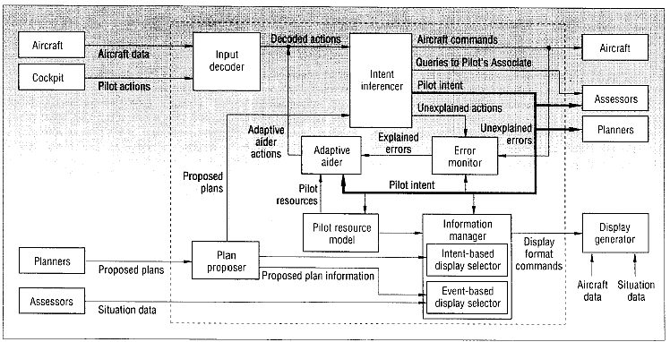
Figure 3: The functional design of the pilot-vehicle interface [Banks and Lizza 1991]
Large aircraft construction companies such as Boeing, McDonnell and Lockheed were responsible for different parts of the project, but other companies such as General Electric and Texas Instruments were involved as well. The first phase of the PA project was done by two consortia. A team led by McDonnell focused on air-to-ground missions, whereas the other team lead by Lockheed investigated air-to-air missions. Using a top-down hierarchical task analysis approach, knowledge acquisition was done by interviewing pilots and other experts. The knowledge was implemented as expert systems and specialized methods were added to integrate knowledge from the separate systems. Two large demonstrations (simulated) were held during the first phase, but neither of them functioned in real-time. The second phase of the project investigated real-time aspects. After this phase, research shifted towards a more practical approach, which was to develop software for a next-generation fighter aircraft.
The PA project was a very ambitious and large program. Although, the concept was considered successful, the implementation was not. Since several partners were responsible for developing different modules over a period of 8 years, the integration of the modules was a problem. Different knowledge representations describing the same knowledge were used for different modules. Lisp was used to implement most of the modules, but Fortran and C were also used. Although it was claimed that the project was successful, real-time performance proved to be a large bottleneck. Other encountered problems are knowledge acquisition, knowledge base updating and knowledge base validation. Although pilot intent inferencing was not perfect, the system was reported to be working satisfactorily by test pilots. However, the idea that workload would be reduced when the system takes over tasks proved to be false. During air-to-air combat changing assignments actually raised the pilot’s workload.

Rotorcraft Pilot’s Associate
The Rotorcraft Pilot’s Associate (RPA) is a five-year program of the US Army Aviation Applied Technology Directorate. Its foundation is formed by the Pilot’s Associate project described in section 2.4.1. RPA extends the Pilot’ Associate system and applies it to an attack/scout helicopter instead of a jet aircraft. The goal of the RPA system is to manage the information available in future helicopter operations. The RPA architecture is separated into two parts, dividing the “traditional” automation systems from the more intelligent Cognitive Decision Aiding part of the system (CDAS). The CDAS consists of six modules as is shown in Figure 4 [Miller and Hannen 1999a and 1999b]:
- The Data fusion module turns multiple information streams into one unified information stream.
- The External situation assessment module reasons about potential targets and the significance of external conditions to the mission goals.
- The Internal situation assessment module checks the aircraft’s status and its monitoring equipment.
- A set of real-time planners uses data from the assessment modules to offer suggestions to help reach the mission goals. Each planner focuses on a particular domain, e.g. route planning, survivability, communications, sensor management etc.
- The Cockpit Information Manager (CIM) regulates the interface to the pilots and deals with the pilot intent estimation, task allocation, page selection, window declutter, window placement, and window pan and zoom.
- The Controls and displays and mission processing logic module is responsible for issuing the low-level avionics commands to achieve automation tasks and cockpit configurations commanded by the CIM.

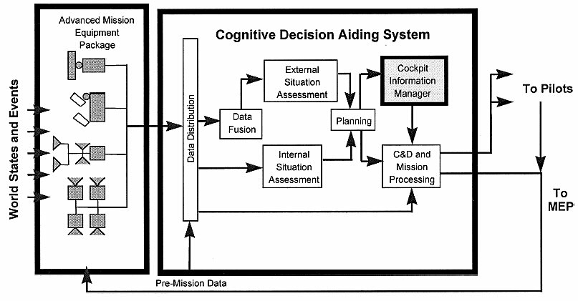
Figure 4: Functional architecture of the RPA [Miller and Hannen 1999]
Simulations studies with the RPA CIM have showed that even though the system is not always correct in its assessments, when giving a choice the test pilot’s prefer flying with all the CIM’s features turned on.

Copilote Electronique
Unlike the Pilot’s Associate and Rotorcraft projects technology-driven design approach, the Copilote Electronique project focused on cognitive processing of pilots. The basis of the Copilote Electronique is a cognitive model that describes how the pilot manages his resources in a low-level air-to-ground mission under pressure of time. The system focuses on support for situation assessment and does not include planning support or taking over tasks.

The cognitive model was designed after extensive cognitive processing and pilot activity analysis. It explains how a pilot uses important information, assesses the situation, and tries to reduce uncertainties during his mission. It also takes the limited cognitive resources of a pilot into account.
The model was implemented in a computer simulation and tested for validation. Two levels were implemented, one for short-term navigation and one for long-term anticipation and situation adjustment.

CASSY
CASSY is a crew assistance system developed by the Flight Mechanics and Flight Guidance group of the University of the German Armed Forces in Munich Germany, in cooperation with the Dornier company. The purpose of CASSY is to guide the pilot with the objectively most urgent task or subtask, while avoiding overload of the crew in planning, decision-making and execution. CASSY primarily focuses on flight planning and pilot error detection in civil (transport) aircraft under instrumental flight rules (IFR). The system permanently shows its assessed situation to the crew and only becomes active when problems are detected. The structure of CASSY is shown below in Figure 5. It includes [Onken 1997]:
- An automatic flight planner that generates a 3D/4D flight plan either autonomously or interactively with the crew. The planner is capable of re-planning during flight if necessary.
- A monitoring module that monitors all pilot actions, aircraft configuration, and violations of specific danger boundaries, such as minimum safe altitudes, stall and maximum operating speeds and thrust limits.
- A piloting expert that checks the expected pilot behavior based on the pilot’s current actions
- A pilot intent and error recognition module that compares the expected behavior of the piloting expert with the crew’s actual behavior and identifies the differences.
- A dialogue manager to perform speech recognition and provide synthesized speech output.

Figure 5: Structure of CASSY [Onken 1997]
A working prototype of CASSY has been tested in-flight in a civil transport airplane. About 10 hours of flight has been recorded. An amount of 100 recorded warnings has been evaluated and in 72% of the time CASSY properly detected a pilot error. In 20% of the time CASSY was wrong, warning the pilot unnecessarily. About half of these errors have been attributed to an incomplete knowledge base. The responses of the test pilots were very positive, even though only a part of the system was functional [Onken 1997].

CAMA
CAMA which stands for Crew Assistant Military Aircraft, is basically the CASSY system, but then adapted to be used in military transport aircraft. The CAMA project was initiated in 1992 by the German Ministry of Defense and the system was based on the experiences with CASSY. CAMA has been developed by the same group that built CASSY, in close cooperation with DaimlerChrysler Aerospace, Elektronik System GmbH (ESG), and the Deutsches Zentrum für Luft- und Raumfahrt (DLR). The architecture of CAMA is based on CORBA and allows applications to communicate with each other no matter where they are located or who has designed them. CORBA servers provide the knowledge that is being processed by CORBA clients that form the “cognitive” tasks [Onken and Walsdorf 2001]. A picture of is shown below in Figure 6.

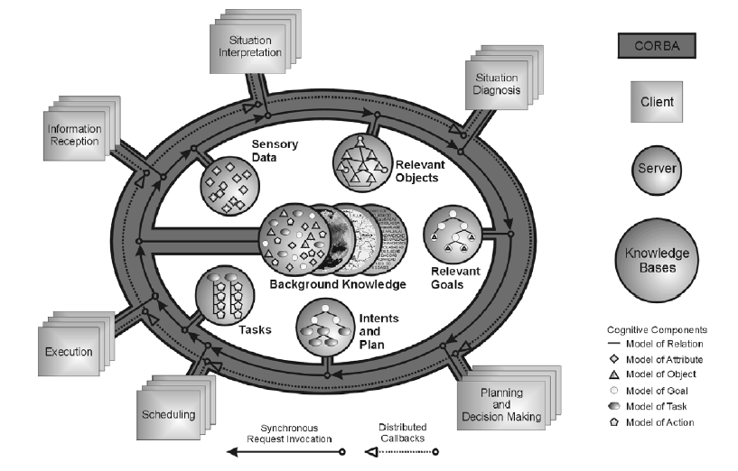
Figure 6: Architecture of CAMA [Onken and Walsdorf 2001]
CAMA uses a state-based approach (Petri-nets) to model the normative pilot actions that follow from the regulations in the aviation handbooks. Case-based reasoning is used to evaluate the pilot’s actual actions and to adapt state-transitions so individual pilot’s differences can be learned [Stütz and Onken 2001].
In 1997 and 1998 the first flight simulator test runs with CAMA were performed. In 2000 four separate pilots performed five real life test flights. Results appeared to be successful.

Other projects
Smaller less important research project include:

Power and Power II

MMA (TACAID)

Delphins

Cogpit

Flight Deck 2020

Conclusions
Most crew assistance systems seem to focus on military aircraft (e.g. PA, RPA, CAMA). Overall, less attention is given to commercial aviation (e.g. CASSY). We can think of several reasons for this. First of all, practical applications are still a long way off. Funding of CAS research is mostly supplied by the Departments of Defense in several countries, who are less reluctant to invest in this kind of long-term research than commercial companies. Second, a military pilot has more to gain from a CAS than a commercial pilot, since their task is much more difficult and dynamic.

Support system functionality
All CAS try to support the pilot by providing specific information and some (PA, RPA) can take over specific tasks. CAS subsystems usually focus on specific task areas. The goals of the described CASs is the same, improving pilot performance and mission effectiveness, but the way they try to achieve this differs. The Copilot Electronique, for example, focused on supporting the pilot with his situation assessment. The PA on the other hand tried to help the pilot in the whole process of processing information, planning, making decisions and taking action. In their review of both systems, Svenmarck and Dekker [2003] argue that the Copilote Electronique project better matches the idea that the user makes the decisions and the system criticizes them, unlike a rule-based system like PA that tries to make its own decisions. On the other hand, the approach taken in the Copilote Electronique project is more difficult because it requires extensive activity analysis and the transition for domain knowledge to system implementation is much more difficult.

Information needs
Depending on the specific goal and method of the supporting system, the information needs of a CAS are approximately the same as that of the pilot. By using at least the same information that is available to the pilot, the CAS can function as a co-pilot. However, the system needs some additional knowledge. Below we some up the basic information needs of a CASs:
- Situation awareness
  - What is going on?
  - What is the pilot doing (tasks, workload)?
- Task knowledge
  - How to use sensor information to identify an ongoing task (pilot intent)
  - How should a task normally be performed
  - What are possible alternative task strategies
- Pilot information requirements [from miller and hannen 1999]
  - What information does the pilot need during a particular task
  - What is importance of each information item
  - What is the scope of information
  - Which resolution (level of detail) is required
- Display knowledge
  - What are the possible methods to provide information to the pilot
- Evaluation knowledge
  - Was the decision/output of the system correct?

Workload
Although almost all CASs project descriptions mention that they try to reduce a pilot’s workload, the determination of the workload has not been given much attention. Some systems like the Rotorcraft PA have a taskload estimator, but this only uses the task models and expected taskload. As far as we know, real-time workload assessment has not been used in any CAS. Veldman [1999] discusses expert information on several areas in which the pilot risks suffering high workload:
- Aircraft systems
- Malfunctions / warnings
- Communications management
- Threat management
- Attack management
- Weapons management
- Mission plan / navigation
- Situational awareness

Design issues
A loosely-coupled system design seems to be a popular in designing a CAS (Pilot’s Associate and CAMA). This is probably because this allows different groups to focus on particular subsystems. Much knowledge is needed for each subsystem, so this makes it difficult if not impossible for small group to built an usable CAS. The disadvantage of this approach is that the overhead. Often the same knowledge in different knowledge bases and in different forms is used by separate subsystems. Also coordination between modules becomes very important.

Artificial intelligence

Encountered problems/risks

The ICE architecture

Important entities

The pilot

The aircraft

The environment

The mission/flightplan and its progress

The ICE system

The situation awareness module

Pilot workload module

Planners

Decision module

Goals

Missing and uncertain information

Management modules

Aircraft control manager

Cockpit information manager

System manager

Designing and testing

Simulation environments
All subsystems in the ICE project were developed to work in a simulated flight environment. Two different flight simulators were used for this; the open-source Flightgear simulator and Microsoft’s Flight Simulator 2002.

Flightgear
Many sophisticated flight simulator software packages are available on the market, but most programs are commercial software that cannot be extended.

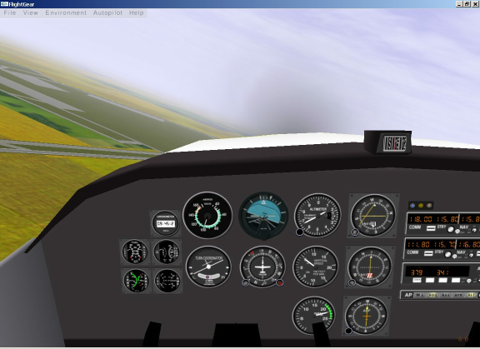
Figure 7: Screen shot of the FlightGear program (version 0.8.2)
The FlightGear flight simulator is an open-source, multi-platform, cooperative flight simulator. The idea for FlightGear was born out of dissatisfaction with current commercial available PC flight simulators. The goal of the FlightGear project is to create a sophisticated flight simulator framework for use in research or academic environments, for the development and pursuit of other interesting flight simulation ideas, and as an end-user application. The FlightGear platform is open to be expanded and improved upon by anyone interested in contributing. [Flightgear 2003][Perry and Olson 2001].
The main advantages of the FlightGear simulator is that is open-source, has an active user-support mailing list, and many options and settings can be modified using the property tree and/or XML files. However, the simulator is constructed entirely by volunteers and is continuously being expanded and improved. Unfortunately, this method of working regularly introduces bugs. For example, the Telnet interface, used by one of our prototype programs to read flight variables, has stopped working properly since version 0.8.0. Although this problem was reported to the FlightGear community, the problem has persisted despite several attempts to solve it.

Flight Simulator 2002

Situation recognition

Introduction
Several studies were done that investigated situation recognition [Mouthaan et al 2002]. The first study included capturing data from a flight simulator, an analysis of the data, and using a neural network to detect certain state during a flight. The second study consisted of using a rule-based system to determine a particular state. This work was used continued in another direction to include probabilities that specific situations were started of finished. Below we give a short description of the three projects.

The artificial neural network approach
The first attempt to design a system for situation recognition focused on artificial neural networks. Data was captured using the default Cessna airplane of the FlightGear simulator and this data was labelled with one of 7 situations (going up, going down, turning left, turning right, regular flight, standing on the ground and taxiing). In an explorative data study it was found that, using a PCA projection, it is possible to cluster variables and identify these situations (see Figure 8).
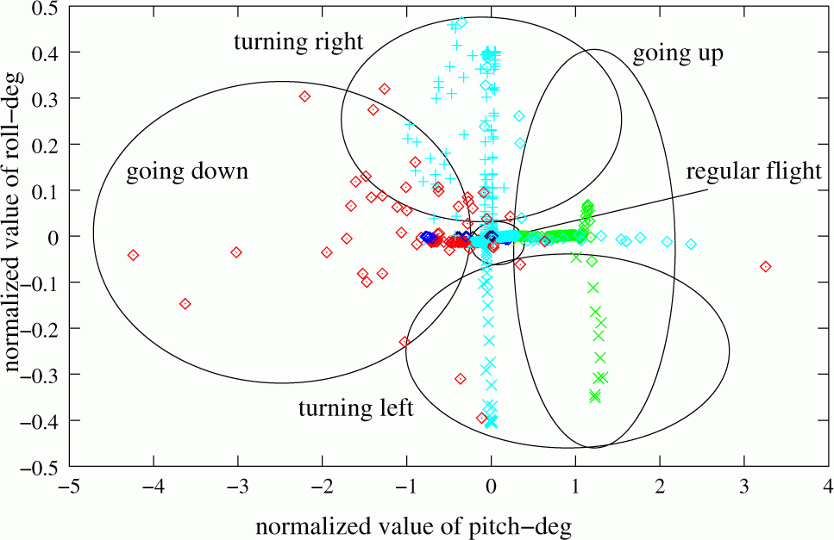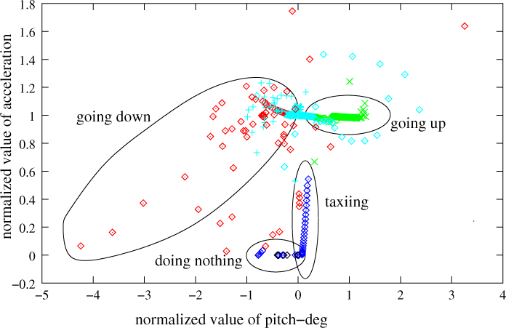
Figure 8: Two projections of flight data: roll and acceleration vs. pitch
An partially recurrent Elman neural network with 2 hidden layers was used to recognize the state of the aircraft. More details about the explorative data analysis and using neural networks for situation recognition can be found in [Čapková et al. 2002].
Artificial neural networks provide a fairly accurate way to recognize and even predict high-level situations. However, there are some important disadvantages. First of all, data is required to train the network and for each type of aircraft data has to be recorded. Second, when small modifications are made to the aircraft configuration or the simulator, the network needs to be retrained. This makes ANN less suitable for rapid prototyping. Third, since an ANN functions as a black box, it is unclear how the network comes to a conclusion. For a CAS, it is desirable that the system can explain its output.

The rule-based approach
After the first attempts to use an ANN to perform situation recognition, we decided to look at an expert-systems approach. The main advantages of expert systems are the clarity of reasoning and the ability to quickly make changes to the used rules. So far, we have experimented with three different expert-system approaches.

Flightgear Monitor: a simple hard-coded expert system
The first expert system prototype that was developed was part of the “FlightGear Monitor” program. FlightGear monitor makes a connection to a running FlightGear program so it can read all the flight data variables. IF-THEN statements about situation changes were hard-coded into the program, based on a state-transition diagram (see Appendix A). A small part of the code is shown below.

procedure TFormSimpleSAR.StateTaxiing;
begin
if (Airspeed <= MAX_SPEED_STANDSTILL) then
State := sHoldShort
else if (Airspeed > MAX_SPEED_TAXIING) OR (Throttle >= FULL_THROTTLE) then
State := sTakeOff
end;

It was found that it is fairly easy to implement a set of rules to detect situations and changes in situations. The accuracy of the system was reasonably good. The program only had some difficulty with detection landing situations. Using hard-coded rules has as an advantage that reasoning can be done very fast (little overhead compared to a rule-based system such as CLIPS). However, it can be difficult to alter rules or add new rules, especially in large rule-bases.

The JESS Pilot prototype
The second expert-system prototype called “Pilot” was constructed with the help of JESS. The purpose of this Java program was merely to show how to perform reasoning with the help of JESS (Java Expert System Shell). Below, in Figure 9, we show the architecture of the pilot application.

Figure 9: architecture of the Pilot application
The Pilot class is the main program. It shows the user interface and reads input data from XML files. The Sampler class runs a loop that continuously reads input (flight simulator) data. The values of these controls are stored in a States object. For each control, the XML code indicates the possible values. For the states a window size is defined that indicates how many past state vectors will be stored and can be used by the knowledge rules. For example, a window state of 5 means that the rules will use the values of the past 5 state vectors. This way, we can define rules that detect transitions of control values. The Sampler uses the data in the States object to reason about the current situation of the pilot. The derived situations are stored in a Situations object. Reasoning occurs based on knowledge rules stored in JESS which can be read via the Jess Communicator [Van der Poel 2003].
Although the Pilot prototype showed the flexibility of using JESS and its ability to link simulator variables directly to JESS facts with JavaBeans, the way the program was constructed made it difficult to expand.

Using probabilities
[quint’s work]

Related work
Zhang and Hill [2000] have created a situation awareness system for a virtual helicopter pilot in a military training simulator. They used trees to represent (groups of) entities that were observed by the virtual pilot and used this to set its focus of attention and level of detail in order to reduce its perceptual processing. Might be interesting for our own work. If information is missing then focus on that particular entity

Workload assessment

The need for pilot workload assessment

Design
[see also Technical Report DKS03-02 / ACE 03]

The workload assessment toolkit program
The current prototype of the Workload Assessment toolkit (WAToolkit) distinguishes between physical and cognitive workload. Physical workload consists of all “manual” actions performed by the user and cognitive workload consists of mental tasks that are carried out.

Physical workload
To determine physical workload the WAToolkit program connects to a separate logging program called Log User Interaction (LUI) [Ehlert 2003]. This LUI program records all the joystick, keyboard and mouse actions of the user and sends this data to the WAToolkit program. The program assigns a value to specific properties of the detected actions such as the user’s typing speed or whether or not the user is moving the joystick.

Cognitive workload
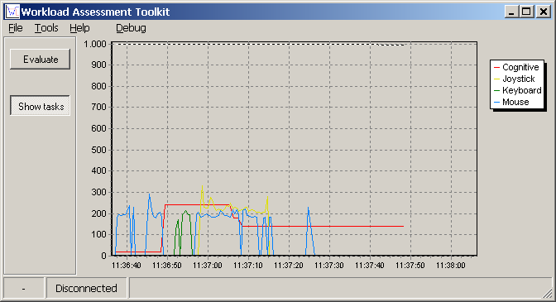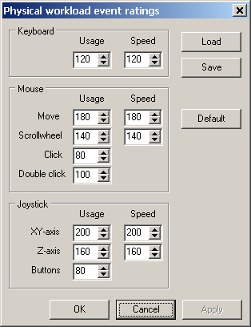
Figure 10: Screen shots of the Workload Assessment Toolkit program
The cognitive workload in the WAToolkit program is determined by specifying cognitive tasks and/or making them active or inactive. The total cognitive load, which is the sum of all active tasks including the always-present base load and coordination task, is calculated regularly and shown on the screen.
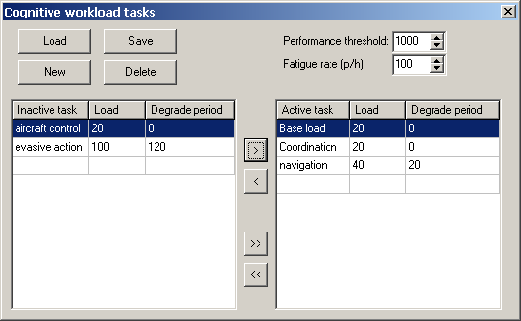
Figure 11: The cognitive tasks panel of the WAToolkit program

Decision-making and reasoning
[summary]

Introduction
Looking back at the ICE system proposed in chapter 3, first data has to be gathered and processed and then the decision-making process can start. The ultimate goal of this decision-making process is to provide useful and relevant feedback to a pilot.
Two subprojects in the ICE project have dealt with decision-making. The goal of the first project was to create an artificial pilot that is able to fly an aircraft given a flight plan. The second project concentrated on designing a bot for automatically intercepting an aircraft. Although both projects are not directly applicable to the ICE system, the knowledge and experience gathered in these subprojects is expected to be very useful.

Flight plan
Originally the idea behind the “Flight plan”-project performed by Tamerius [2003] was to create a flight-bot that was able to fly the route describe in a given flight-plan by itself. The basic design of such a flight-bot is shown in Error: Reference source not found. After the flight-plan is give to the bot, it generates a flight script that contains the manoeuvres and actions that should be performed during the flight. The script is analysed for consistency and errors. During a flight, the bot checks whether everything is still going according to plan (situation assessment) and if changes to the original script are necessary.

Figure 12: the three layers of the flight plan bot

Automated dog-fight
The goal of the automated dog-fight bot was to design an artificial pilot that is able to intercept an enemy aircraft. After a literature survey on the manoeuvres that pilot perform during a dog-fight, the project focussed mainly on choosing the right manoeuvres. The dog-fight bot uses decision trees to come up with a basic strategy (see also Figure 13). Then the exact values for the manoeuvres of this strategy are determined

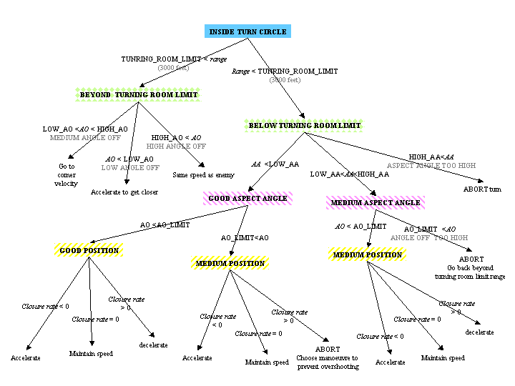
Figure 13: The pursuit decision tree of the dog-fight bot

Future work

Bibliography
Abeloos, A.L.M., Mulder, M., and Van Paassen, M.M. (2000) “The applicability of an adaptive human-machine interface in the cockpit”, in Proceedings of the 19th European Annual Conference on Human Decision Making and Manual Control (EAM 2000), June 26-28, Ispra, Italy.
Andriambololona, A. and Lefeuvre, P. (2003) “Implementing a dogfight artificial pilot”, ”, Research report DKS03-07/ICE 07, Knowledge Based Systems group, Delft University of Technology, The Netherlands.
Banks, S.B and Lizza, C.S. (1991) “ Pilot’s Associate: a cooperative, knowledge-based system application”, in IEEEE Intelligent Systems, Vol. 6, No. 3, pp. 18-29, June 1991.
Billings, C.E. (1997) “Aviation automation: the search for a human-centered approach”, Lawrence Erlbaum Associates Inc, Mahwah, NJ, USA.
Čapková, I., Jůza, M., Zimmerman, K. and Ehlert, P.A.M. (2002) “Explorative data analysis of flight behaviour”, Research report DKS02-04/ACE 02, Knowledge Based Systems group, Delft University of Technology, The Netherlands.
Ehlert, P.A.M. (2003) “Design and implementation of an interaction logging tool: source documentation of the LUI program”, Technical report, Knowledge Based Systems group, Delft University of Technology, forthcoming.
Endsley, M.R. (1995a) “Toward a theory of situation awareness in dynamic systems”, in Human Factors, Vol. 37, No. 1, pp 32-64
Endsley, M.R. (1995b) “A taxonomy of situation awareness errors”, in Human factors in aviation operations, pp. 287-292, Fuller, R. Johnston, N. and McDonald, N. eds. , Ashgate Publishing Ltd.
Endsley, M.R. (1999b) “Situation awareness and human error: designing to suppport human performance”, in Proceedings of the High Consequence Systems Surety Conference, Alburquerque, NM, USA. http://www.satechnologies.com/Papers/pdf/Sandia99-safety.pdf (Jan 8, 2003)
Endsley, M.R. (2000) “Direct measurement of situation awareness: validity and use of SAGAT”, in Situation Awareness Analysis and Measurement, Endley, M.R. and Garland, D.J. eds, Lawrence Erlbaum Associates Inc., Mahwah, NJ, USA.
Flightgear (2003) http://www.flightgear.org (July 17, 2003)
Furness, T.A. (1986) “The super cockpit and human factors challenges”, in Proceedings of Human Factors Society 30th Annual Meeting, Ung, M. (Ed.), pp. 48-52. Also http://www.hitl.washington.edu/publications/m-86-1 (June 6, 2003)
Funk, H. and Miller, C. (2001) “User acceptance and plan recognition: why even perfect intent inferencing might not be good enough”, in Proceedings of the AAAI Fall Symposium on Intent Inference for Collaborative Tasks, November 2-4, 2001, North Falmouth, MA, USA. http://www.siftech.com/English/publications/AAAI-FS-01.pdf (April 10, 2003)
Funk, K. Lyall, B., Suroteguh, C., Owen, G., Sukhia, C., Kurup, R., Wilson, R., Wilson, J., Niemczyk, M. and Vint, R. (1997) “Flight deck automation issues home page”, http://www.flightdeckautomation.com/issues.html (April 7, 2003)
Miller, C.A. and Hannen, M.D. (1999a) “The Rotorcraft Pilot’s Associate: design and evaluation of an intelligent user interface for cockpit information management”, in Knowledge Based Systems, Vol. 12, pp. 443-456.
Miller, C.A. and Hannen, M.D. (1999b) “User acceptance of an intelligent user interface: a Rotorcraft Pilot’s Associate example”, in Proceedings of the international conference on Inteligent User Interfaces (IUI), Redonde Beach, CA, USA.
Mouthaan, M.M., Ehlert, P.A.M. and Rothkrantz, L.J.M. (2002) “Recognising situations in a flight simulator environment”, in Mehdi, Q., Gough, N. and Cavazza, M. (Eds.), Proceedings of 3rd Int. Conference on Intelligent Games and Simulation (GAME- ON 2002), November 2002, London, Great Britain
Mulgund, S.S. and Zacharias, G.L. (1996) “A situation-driven adaptive pilot/vehicle interface”, in Proceedings of the Human Interaction with Complex Systems Symposium, Dayton, OH, August 1996.
Neerinx, M.A. (2002) “Cognitive task load analysis: allocating tasks and designing support”, in Handbook of Cognitive task design, Hollnagel, E (editor). Lawrence Erlbaum Associates, Inc. (forthcoming)
NLR (2000) “Adaptive Cockpit Environment”, memorandum VE-2000-002, Version 1.1, Nationaal Lucht-en Ruimtevaartlaboratorium, The Netherlands.
Onken, R. and Walsdorf, A. (2001) “ Assistant systems for aircraft guidance: cognitive man-machine cooperation”, in Aerospace Science and Technology 5, pp. 511-520, December 2001.
Onken, R. (1997) “The cockpit assistant system CASSY as an on-board player in the ATM environment”, paper presented at 1st U.S.A/Europe Air Traffic Management R&D Seminar, Saclay, France, June 1997. http://atm-seminar-97.eurocontrol.fr (April 14, 2003)
Perry, A.R. and Olson, C. (2001) “The FlightGear flight simulator: history, status and future”, LinuxTag July 2001, Stuttgart, Germany.
Rouse, W.B., Geddes, N.D. and Hammer, J.M. (1990) “Computer-aided fighter pilots”, in IEEE Spectrum Vol. 27, No. 3, pp. 38-41, March 1990.
RTCA (1995) “Final Report of RTCA Task Force 3 Free Flight Implementation”, Radio Technical Commission for Aeronautics, Inc., Washington DC, USA.
Russell, S. and Norvig, P. (1995) “Artificial Intelligence: a modern approach”. Prenctice-Hall International, Inc.
Schutte, P.C. (2000) “Better machines or better humans?”, in IFALPA Interpilot Magazine 2000, No.2 http://www.ifalpa.org/Interpilot/BetterMachines_00_02.pdf (Oct 31, 2002)
Stütz, P. and Onken, R. (2001) “Adaptive pilot modeling for cockpit crew assistance: concept, realisation and results”, in Proceedings of the 8th European Conference on Cognitive Science Approaches to Process Control (CSAPC’01), September 2001, Munich, Germany.
Svenmarck, P. and Dekker, S. (2003) “Decision support in fighter aircraft.”, in Behaviour and Information Technology, Vol.22., No.3, May/June 2003, pp. 175-184.
Svensson, E., Angelborg-Thanderz, M., Sjoberg, L. and Olsson, S. (1997) “Information complexity-mental workload and performance in combat aircraft” in Ergonomics, Vol 40, No.3, pages 362-380, March 1997, Taylor and Francis Ltd.
Tamerius, M.S. (2003) “Automating the cockpit: constructing an autonomous, human-like flight bot in a simulated environment”, Technical report DKS03-05/ICE 05, Knowledge Based Systems, Delft University of Technology, The Netherlands.
Taylor, R.M. (1990) “Situational awareness rating technique (SART): the development of a tool for aircrew systems design”, in Situational awareness in aerospace operations (AGARD-CP-478), pp. 3-1 / 3-17, Neuilly Sur Seine.
Van der Poel, B.P.I. (2003) “JESS Pilot, prototype reasoning logic”, Software documentation, internal report, Knowledge Based Systems, Delft University of Technology, The Netherlands.
Veldman, H.E. (1999) “The electronic crewmember, volume 1: survey of previous research”, MSc. thesis, Knowledge Based Systems group, Delft University of Technology, The Netherlands.
Wiener, E.L. and Curry, R.E. (1980) “Flight-deck automation: promises and problems”, in Ergonomics, Vol.23, No.10, pp. 995-1011
Zhang, W. and Hill, R.W. (2000) “A template-based and pattern-driven approach to situation awareness and assessment in virtual humans”, in Proceedings of the 4th int. conference on autonomous agents, pp. 116-123, June 2000, Barcelona, Spain.

Figure 14: The state-transition diagram that was used in one of the first prototypes to detect changes in situations for a Cessna

