The Intelligent Cockpit Environment Project
(Draft version)

Ehlert, Patrick  Rothkrantz, Leon  Research Report DKS03-04 / ICE 04  Version 0.27, July 2026  Mediamatics / Data and Knowledge Engineering group  Faculty of Electrical Engineering, Mathematics, and Computer Science  Delft University of Technology, The Netherlands | 
Ehlert, Patrick A.M. (P.A.M.Ehlert@its.tudelft.nl)
Rothkrantz, Leon J.M. (L.J.M.Rothkrantz@cs.tudelft.nl)

“The Intelligent Cockpit Environment”
Draft version

Research Report DKS03-04 / ICE 04

Mediamatics / Data and Knowledge Engineering group

http://www.kbs.twi.tudelft.nl/Research/Projects/ICE

Keywords: | intelligent user interfaces, situation awareness, human-computer interaction, workload assessment, situation assessment, intelligent agents, adaptive interfaces, artificial intelligence

Preface
This report describes the research that has been done until now in the Intelligent Cockpit Environment (ICE) project

Summary

Used abbreviations

AI | Artificial Intelligence
CAS | Crew Assistance System
CIM | Cockpit Information Manager
FMS | Flight Management System
ICE | Intelligent Cockpit Environment
IFR | Instrumental Flight Rules
MFD | Multi-Function Display
PA | Pilot’s Associate
PVI | Pilot-Vehicle Interface
SA | Situation Awareness

Table of Contents
Preface I
Summary III
Used abbreviations V
Chapter 1: Introduction 1
1.1 Problem setting 1
1.2 Situation awareness 1
1.3 Automation in aviation 2
1.3.1 Traditional automation 2
1.3.2 Human-centered automation 2
1.4 The intelligent cockpit environment 3
1.5 Report overview 3
Chapter 2: Crew assistance systems 5
2.1 Introduction 5
2.1.1 Data fusion 6
2.1.2 Situation assessment 6
2.1.3 Decision-making 7
2.1.4 Presentation and control management 7
2.1.5 System management 7
2.2 Artificial intelligence techniques 7
Rule-based reasoning 7
Model-based reasoning 8
Case-based reasoning 8
Constraint-based reasoning 8
Artificial neural networks 8
Bayesian belief networks 8
2.3 Pilot tasks and information needs 9
2.4 Existing systems and research 9
2.4.1 Pilot’s Associate 9
2.4.2 Rotorcraft Pilot’s Associate 11
2.4.3 Copilote Electronique 12
2.4.4 CASSY 12
2.4.5 CAMA 13
2.4.6 Other projects 14
Delphins 14
Power 14
Cogpit 14
Flight Deck 2020 14
2.5 Conclusions 14
2.5.1 CAS functionality 15
2.5.2 Design issues 15
Chapter 3: The ICE architecture 17
Chapter 4: Situation recognition 19
4.2 The artificial neural network approach 19
Chapter 5: The Pilot Workload Module 21
Bibliography 22

Introduction
In this chapter we will give an introduction to the ICE project. First, in section 1.2 we will outline the problem that we are trying to solve. Then in section 1.3 we will explain an important concept in the ICE project, which is situation awareness. Next, in section 1.4 we will again look at our problem and show the need for a situation-aware intelligent cockpit system, which is the goal of the ICE project. A further description of the ICE project and its goals is given in section 1.5.We end with a short overview of the remaining chapters in this report in section 1.6

Problem setting
Ever since the first airplane was built by the Wright brothers the capabilities of aircraft have continuously been improved. For example, the maximum speed of the average military fighter plane has gone from approximately 100 Mph in 1920 to over 1500 Mph currently. These high speeds are responsible for the little time available to fighter pilots to process information and make decisions. In addition, the improved weapons range in military aircraft (missiles can be fired from 20 km away) reduces the pilot’s decision time even more.
Commercial aircraft have been improved as well. Where early planes only had a few meters, modern commercial aircraft have several hundreds of meters or information displays, providing the pilot with a wealth of information. With the growth of information sources, the complexity of the available information has increased also. Research has shown that flight performance is correlated to the complexity of the presented information [Svensson et al 1997]. Performance is constant up to a certain complexity level (in Svensson’s research complexity was defined as the number of displayed items) and deteriorates when the information complexity increases beyond this point.
Combining the increase in aircraft capabilities and information complexity, it is clear that pilots run the risk of information overload. To help a pilot deal with information processing and decision-making, avoid information overload, and optimize flight performance, a Crew-Assistant System (CAS) or intelligent pilot-vehicle interface (PVI) has been proposed [Mulgund and Zacharias 1996], [Abeloos et al 2000], [NLR 2000]. The idea is that the assistant-system presents relevant information to the pilot at the right moment and in the appropriate format, depending on the situation, the status of the aircraft, and the workload of the pilot. The intelligent interface should help to improve the pilot’s situation awareness and reduce his workload. As a result the survivability of the pilot and plane, and the effectiveness of the flight or mission will be improved.

Situation awareness
Having a high level of situation awareness (SA), sometimes also called situational awareness, is generally seen as one of the most critical aspects for achieving successful performance in aviation. Several definitions of SA exists, but the one from Mica Endsley [1995a p.36] seems to be the most cited:

“Situation awareness is the perception of elements in the environment within a volume of time and space, the comprehension of their meaning, and the projection of their status in the near future.”

Endsley refers to “perception of elements” as level 1 SA, “comprehension of the situation” as level 2 SA, and “projection of future status” as level 3 SA. Having a good SA means that the pilot is able to perceive and understand his situation and can predict the future situation. Basically a pilot builds SA by integrating the different sources of information to one mental situation model of the world. Pilots usually sample the available information sources briefly, following a pattern that is learned from experience. The information in the mental model is updated constantly by continuously sampling and processing new information. To some extent, more experience leads to faster information processing. Information will be processed quicker when the contents of the information is as expected, but people are more likely to make mistakes if it is not. Important aspects that affect a person’s situation awareness are among others; workload (overload/underload situations), system design (how is the information presented), system complexity (how complex is the information) and the level of automation (whether the pilot is in or out the control loop).
Research has suggested that many human errors in (military) aviation are caused by lack of SA. Most errors in aviation can be attributed to failures in level 1 SA. Not observing the available information (e.g. due to high workload and/or distractions) has been determined to be the largest single causal factor for these level 1 SA failures [Endsley 1995b]. By understanding why SA problems occur, it is possible to design an interface or system to prevent many of these problems. Designing such a system would require [Endsley 1999]:
- An analysis of SA requirements; e.g. through expert elicitation, observing operator performance, questionnaires.
- Using design guidelines for enhancing SA; e.g. always provide goal-oriented information, remove extraneous information, support parallel processing.
- Evaluation during the design process; make sure the system does indeed improve SA.

Evaluation of situation awareness is usually done by observing test subjects and/or asking questions about their knowledge, actions and assumptions. Examination is done either during a specific test scenario or after performing the scenario. Examples of SA evaluation techniques are SAGAT [Endsley 2000] and SART [Taylor 1990].

Automation in aviation
In order to reduce human errors and increase pilot task performance it seems logical to automate the process of flying an aircraft as much as possible. This is exactly what we can see in aviation in the last decades. Using a technology-driven approach, many of the simpler aircraft systems were automated. Automation focused mainly on sensors (e.g. Flight Management System) and actuator systems (e.g. auto-pilot) that were fairly easy to implement. Recently more attention has been given to more advanced cooperating systems.

Traditional automation
Although cockpit automation systems have been reported to improve accident rates, they also have their drawbacks. First of all, automation is very suitable in well-known predictable situations, but cannot deal with unexpected events. Therefore, the pilot still needs to be present in the cockpit to solve problems. In addition, people do not feel comfortable flying in an airplane if they know that is only controlled by a computer without human supervision. Another drawback is that automation has shifted pilot workload from manual to mental workload. The (commercial) pilot has become a passive systems monitor instead of actively controlling the system. This makes building SA more difficult for the pilot, especially during critical situations where this awareness is the most important. Also, placing the pilot out of the control loop may lead to degradation of pilot skills and poorer system understanding. Third, pilots can rely on automation too much and become overconfident. It has been known that many commercial pilots doze off during a flight, letting the plane fly itself. For an extensive list of other reported automation drawbacks we refer to [Funk et al 1997].

Human-centered automation
It has been suggested that the new generation of intelligent cockpit systems needs to take a human-centered design approach, helping the pilot with decision-making and building and maintaining SA. These systems need to complement the human pilot rather than automate manual tasks. Paul Schutte from NASA Langley Research Centre has proposed a complete redesign of the existing flight deck. This new flight deck should help the pilot with monitoring and diagnostics, but leave simple manual tasks to the pilot in order to keep him in the loop and maintain the pilot’s SA. The flight deck will help the pilot with his SA by providing relevant information and system monitoring, and it is the pilot’s job to deal with unexpected situations. [Schutte 2002].
When designing human-support systems, SA is just as important for the system as it is for the human crew. To help the crew properly, the system’s SA should be at least as good as that of the crew. This system SA does not only include understanding and predicting the status of the aircraft systems and environment, but also of the pilot and his mission. Russell, Wilson and Monett [1996] have even stated that “accurate and reliable assessment of operator state is the key to successful implementation of adaptive automation”. The most difficult aspects of these context and user-aware systems are: obtaining the necessary data reliably, fusing data from multiple sensors, and accurately determining the pilots’ state. Individual pilots have individual performance and preferences. Therefore, the system needs to have knowledge on normative pilot behavior as well as an individual pilots’ behavior. This means that either the system should be able to learn from a pilot’s actions or the individual preferences of the pilot should be entered into the system in advance.

The intelligent cockpit environment
The intelligent cockpit environment (ICE) project is a project of the Knowledge Based Systems group of Delft University of Technology in the Netherlands. The goal of the ICE project is to design, test, and evaluate computational techniques that can be used in the development of intelligent situation-aware crew assistance systems. Using methods from artificial intelligence, ICE focuses primarily on the data fusion, data processing and reasoning part of these systems. Special issues addressed in the ICE project are:
- Situation recognition
- Mission or flightplan monitoring
- Attack management
- Pilot workload monitoring
The ICE project is a follow-up of a similar project called ACE that unfortunately was cancelled [NLR 2000]. Whereas the ACE project only focused on adaptive interface techniques for the F-16, the ICE project is much broader. ICE looks at common intelligent techniques for all types of planes, both commercial and military. However, since there are many different types of aircraft, with each aircraft having its own characteristics, we currently have limited ourselves to two aircraft which are the Cessna 172, a small two-seater airplane, and the F-16C Falcon, a military multi-purpose fighter aircraft. The Cessna is a fairly simple and easy to fly aircraft and allows us to create and test new prototypes quickly. The F-16C is used to test the more difficult and advanced reasoning techniques necessary in a support system for military aviation. Note, that the developed techniques in ICE can also be used for developing support systems for other aircraft. However, this would require gathering and implementing data on the specifics of each particular aircraft.

Report overview
In chapter 2 we will provide an overview of existing research and applications related to the ICE project that was found in literature. This chapter also contains an overview of the conclusions that were drawn from this literature study. Then in chapter 3, we will present our ICE system architecture. This chapter presents a global picture of the system’s design.

Crew assistance systems

Introduction
A Crew Assistance System (CAS), also called Pilot’s Associate or Electronic Co-pilot, is a system that assists the crew in performing their task in the aircraft. The main task of a CAS is to reduce the workload of the crew and increase their situation awareness. This is done by providing them with important information or by taking over (some of) their tasks so the crew can perform other tasks and concentrate on their mission. Basically, a CAS can be seen as a future version of the Flight Management System (FMS) that is currently in use in many commercial aircraft. However, pilots need to enter almost all information into a FMS by hand, whereas a CAS can figure things out by itself. In order to do this a CAS has knowledge about how to perform the tasks of the pilot. With this knowledge, an intelligent CAS can give situation-specific advice or solutions.
All CASs follow the same basic principles. The system first gathers data from the aircraft’s systems and possibly also from sensors monitoring the pilot and other crewmembers. Then, based on the gathered data, it makes an assessment of the current situation. Often, possible future situations need to be predicted by the system as well. Then, the CAS has to reason about what action to perform. Finally, the system acts on the decision that was made. System output is given via the various cockpit display devices. Some CASs may take over tasks from the crew, others are more passive and only monitor and inform the crew. It usually is possible for the crew to alter certain settings of the CAS, for example setting the current automation level of the CAS. An overview of a generic CAS is show below in Figure 1. There are four basic modules in a generic CAS; a system’s management module, a decision-making module, a situation assessment module and a data fusion module. The exact role of these modules will be discussed at the end of this chapter.

Figure 1: Generic crew assistance system
Often a CAS is multi-dimensional or layered. One (sub-)system is created for one particular application. Example applications are: following mission progress, weapons selection, or threat assessment. This way the entire system is constructed by joining all the subsystems together. However, this design method introduces the need for explicit coordination between the subsystems in order to resolve conflict. In Figure 2 we show a more elaborate picture of a generic CAS framework that consists of subsystems and includes coordination mechanisms in the form of a presentation management and a control management module. The job of both modules is to coordinate which subsystem is allowed to send its output to the pilot or aircraft.

Figure 2: Generic crew assistance system consisting of subsystems and management modules
The two management modules are not needed in all cases. Sometimes, coordination is done implicitly in the reasoning process of the CAS. Usually, the subsystems can communicate with each other at the decision-making stage. Note that the CAS needs to be informed of the crew’s commands that are sent to the aircraft. In the figure above we assume that the crew’s commands are received by the CAS via the aircraft’s sensors, so the decision-making process can take pilot actions into account.

Data fusion
Data fusion is the seamless integration of data from different sources. In this case, sensors are used to gather data online and in real-time. Usually this data comes from the aircraft’s own systems, but other additional sensors can also be used, for example heart-rate sensors to determine the state of the pilot. Data fusion is needed for several reasons: to derive “higher-level” data by combining data from different sensors and to limit the amount of data that needs to be processed by the system. Also, data fusion can reduce uncertainty that is associated with single sensors.

Situation assessment
Situation assessment is basically the system’s way of achieving situation awareness (see also 1.3). The situation assessment module tries to determine the current situation of the aircraft, the crew, their surroundings, and the mission. Many CASs define separate submodules to assess the status of each of these entities. Situation assessment also includes predicting future situations. To be able to do this, the situation assessment module needs to interpret past and current data from the data fusion process.

Decision-making
Decision-making is a reasoning process that occurs based on the system’s situation assessment. The result of the decision-making process is the action that should be taken by the CAS. However, decision-making costs time which is very limited in a CAS. Therefore, high-priority events have to be recognized and processed first. Then, other less time demanding data can be processed. Decision-making does not only include what action to take, but also how to do it. For example, if it is decided to present the crew some important information, the CAS also has to decide on the best method to do this, for example displaying it on a multi-function display (MFD), sounding an alarm, turning on warning lights etc.

Presentation and control management
The presentation and control management modules coordinate the output of the reasoning processes of the CAS subsystems. In some CASs both modules are combined into a single module or even joint with the decision-making module, but usually they can be separated into separate modules. When multiple messages need to be sent to the pilot, the presentation coordination module can filter out less important messages to avoid information overload. Also, the presentation coordination module might decide on an alternative method to present the information. The control management module checks for conflicting actions and may coordinate the system’s actions with the actions taken by the pilot.

System management
It is desirable that the crew is in complete control of the aircraft. Therefore the crew must have a method to regulate the CAS. The system management module functions as an interface between the CAS and the crew. It allows to crew to set a certain level of control and override the CAS. The levels of control of a CAS may vary from complete control (pilot override) to advisory function only.

Artificial intelligence techniques
Artificial Intelligence (AI) techniques play an important role in CASs. They are necessary for a CAS to perform reasoning, which is required in most of the modules describe in the previous section. In addition, AI techniques allow CASs to learn, for example a pilot’s preferences. Veldman [1999] has identified several important evaluation criteria for AI techniques to be used in a CAS:
- Functionality: the technique should be able express the problem and its solution in its representation and should be able to solve the problem.
- Clearness: the applied technique (reasoning process) should be clear and understandable
- Reliability: the technique should function correctly under difficult circumstances, e.g. uncertain or incorrect data.
- Performance: the technique is able to provide a satisfactory solution in real-time.
- Scalability: the technique or system that uses it should be modular to allow expansion and scaling up to larger and more complex applications.
- Maintainability: the used system or database should be maintainable by the end-user. Maintenance usually consists of small adjustments to the system.
- Integratability: it should be possible to integrate the technique with other non-AI techniques.

Below we provide a list and short explanation of the AI techniques that can currently be found in existing CASs or are expected to be useful in future CASs. The basis of the list was formed by the AI techniques described in [Veldman 1999].

Rule-based reasoning
Rule-based reasoning systems, also called production systems, use IF-THEN rules to describe what to do in certain predetermined situations. The IF-THEN rules are fairly easy to understand, especially when fuzzy linguistic variables are used. In addition rule-based reasoning is transparent and new knowledge can be added easily. These advantages are probably the reason that rule-based reasoning has become one of the most popular forms of declarative knowledge representations in AI. Depending on the amount of rules real-time use of rule-based systems is possible.
A disadvantage is that rule-based systems require knowledge to be made explicit and modeled as IF-THEN rules, which can be very difficult and time-consuming. Also, adjusting existing knowledge bases containing the rules can be cumbersome.

Model-based reasoning
Model-based reasoning uses representations or models of a real-life system. Generally, model-based reasoning is clear and understandable, although more complex than rule-based reasoning. Not all model-based reasoning systems allow real-time performance. Also, scalability or maintainability can be a problem.

Case-based reasoning
Case-based learning organizes experiences and stores them in a structure. Each new experience (case) is compared with the known and stored cases. The solution used for the most similar case is then adapted to this new case. The new solution is then applied and results are evaluated. The combination of the new case and solution is stored for future reference.
The advantage of case-based reasoning is that it is able to learn from experience and handle (a limit amount of) uncertainty. Real-time performance can only be achieved if similar cases are already stored, since adapting to completely new cases takes a lot of time.

Constraint-based reasoning
A constraint represents a relation that should be maintained. Constraint-based reasoning uses search techniques but sets constraints to limit the search space. The main advantage is that it can be very fast, depending on the amount of constraints and the size of the search space. However, a time-limit or real-time performance cannot always be guaranteed and not all problems allow this method of reasoning. Constraint-based reasoning can be used to complement rule-based reasoning, especially in the area of planning and scheduling.

Artificial neural networks
An Artificial Neural Network (ANN) consists of nodes, connected by links that have a certain weight. Learning in artificial neural networks occurs through the adjustment of synaptic weights by an error minimization procedure. By increasing the synaptic strength along the neural pathways that are associated with a stimulus and a correct response, frequently used paths are strengthened.
The advantage of ANNs is the fact that the network does not need to have specific properties for specific problems and no explicit knowledge has to be modeled. The system tries to learn these properties itself by adjusting link weights. However, it is necessary provide the system examples and train it, which can take a long time. “Reasoning” in an ANN is not transparent and the network is not adjustable by the user. Also, it does not guarantee an optimal solution.

Bayesian belief networks
A Bayesian belief network, also called causal network or probabilistic network, is a directed acyclic graph in which nodes stand for propositional variables and edges for the probabilistic relation between them. A Bayesian belief network represents knowledge in its nodes and links and can modify information propagated among the nodes. The knowledge stored in the network can be specified a priori or learned from examples. The primary use of Bayesian networks is to use probability theory to reason with uncertainty. Their main disadvantage is that a lot of data is needed to accurately set the network’s probabilities.
For more information on the described AI techniques, the reader is referred to [Russell and Norvig 1995].

Pilot tasks and information needs
A pilot’s job basically consists of gathering information from several (partly) automated systems, evaluating the importance and reliability of the information, combining it with other information sources, and finally making a decision based on the result. All this needs to be done fast, often under high pressure, under high G-forces, using uncertain and sometimes unreliable information sources. The functionality of a CAS is driven by the information needs of a pilot. Below we sum up the general tasks that are performed by a pilot: [herschrijven!]
- Flight control: keep the aircraft in the air and flying safely. This task includes manipulating stick, throttle, flaps, etc. The necessary information of a pilot comes from his main instruments and HUD (if available).
- Monitoring aircraft systems: the pilot needs to check regularly if the aircraft and its systems are performing normally. The used information is gathered from diverse sources; not only from the pilot’s instruments, but also from auditive, visual and tacticle feedback (e.g. warning signals, strange engine sounds, warning lights, aircraft vibrations).
- Navigation: keeping the aircraft on course and monitoring flightplan progress. Navigation is mainly a cognitive task and requires heading, location, speed and altitude information.
- Communications: sending information to or receiving it from air traffic control or possibly other aircraft.

The three tasks described above are performed by all pilots. For military pilot we can add the following two tasks:
- Identification: related to the navigation and communications task, identification consists of recognizing and determining specific targets. Identification can be done visual or via advanced onboard systems.
- Engaging in combat: combat can be either bombing a specific target (air-to-ground attack), engaging in a dog-fight (air-to-air combat), or performing evasive maneuvers to avoid a missile. Information needed by the pilot include the location, heading, and speed of a target, available weapons and electronic countermeasures.

Existing systems and research
The first efforts to design a crew assistance system date back to the mid 1980s. Although today, several prototype CASs exist and a lot of some (theoretical) research has been done in this area, in practice there has been little success. In the following section, we will discuss some of the more important CAS projects, but note that this list is far from complete. Also, note that not all systems were implemented.

Pilot’s Associate
The Pilot’s Associate is a program initiated by the United States Air Force’s Wright Laboratory and the Defense Advanced Research Projects Agency (DARPA) in 1986. The goal of the PA project was to enhance a military fighter pilot’s situation awareness, enabling him to make better decisions. The Pilot’s Associate (PA) architecture basically consists of a set of cooperating knowledge-based subsystems, communicating via a blackboard. The knowledge-based subsystems are described in the paper of Banks and Lizza [1991]. Below we give a short summary:

- The Situation assessor supports the pilot and system planners by determining the state of the outside world. It manages uncertainty and threat intent using General Electric’s Reasoning with Uncertainty Module (RUM). During the first experiments with the PA the assessor functioned based on perfect data, later simulated sensor data was used.

- The System Status assessor determines the state of the aircraft’s systems and helps the pilot determining the source of malfunctions when they arise. The system mainly uses parametric limit checks and focuses on engine status. The engine was chosen primarily because much knowledge in that particular area was available. The system status assessor also provides data on the aircraft’s capabilities to other systems.

- The Tactics planner reasons about immediate threats, targets for attack or evasion, countermeasures, communication support, and weapons support. It helps the pilot by choosing a response. The planner recommends pre-programmed tactics and has a limited sensor-management capability. Kadet, a Lisp-based planning tool and reasoning engine developed by ISX company is used to reason about particular domains. The domains are organized as a hierarchical tree consisting of plan elements.

- The Mission planner looks at the effect of actions on the mission plan that was entered before flight. Basically, the mission planner consists of a dynamic programming algorithm for route planning implemented in Lisp (which was later rewritten in C), and some additional heuristic control and evaluation functions implemented in Fortran.

- The Pilot interface is the link between the pilot and the rest of the PA system. It selects the form, content and modality, and placement of information in the cockpit (presentation management). In addition, the interface is able to recognize pilot intentions and identify errors. A script-based reasoner and a plan-and-goal graph were used for this, later complemented with a plan-based reasoner. Before the mission, pilots can customize many aspects of the interface and set automation levels, which includes approving the system in advance to take action in specific cases. The functional design of the pilot-vehicle interface is shown in Figure 3.

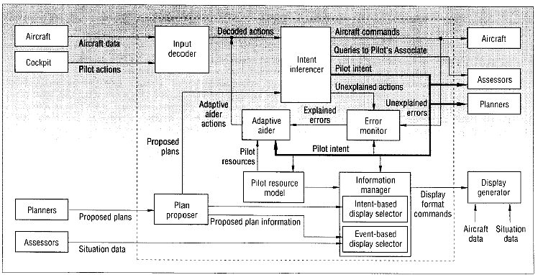
Figure 3: The functional design of the pilot-vehicle interface, from [Banks and Lizza 1991]
Large aircraft construction companies such as Boeing, McDonnell and Lockheed were responsible for different parts of the project, but other companies such as General Electric and Texas Instruments were involved as well. The first phase of the PA project was done by two consortia. A team led by McDonnell focused on air-to-ground missions, whereas the other team lead by Lockheed investigated air-to-air missions. Using a top-down hierarchical task analysis approach, knowledge acquisition was done by interviewing pilots and other experts. The knowledge was implemented as expert systems and specialized methods were added to integrate knowledge from the separate systems. Two large demonstrations (simulated) were held during the first phase, but neither of them functioned in real-time. The second phase of the project investigated real-time aspects, and after this phase research shifted towards a more practical approach which was to develop software for a next-generation fighter aircraft.
Although pilot intent inferencing was not perfect, the system was reported to be working satisfactorily by test pilots. The idea that workload would be reduced when the system takes over tasks proved to be false. During air-to-air combat changing assignments actually raised the pilot’s workload. Since several partners were responsible for developing different modules over a period of 8 years, the integration of the modules was a problem. Different knowledge representations describing the same knowledge were used for different modules. Lisp was used to implement most of the modules, but Fortran and C were also used. Although it was claimed that the project was successful, real-time performance proved to be a large bottleneck. Other encountered problems are knowledge acquisition and knowledge base validation.

Rotorcraft Pilot’s Associate
The Rotorcraft Pilot’s Associate (RPA) is a five-year program of the US Army Aviation Applied Technology Directorate. Its foundation is formed by the Pilot’s Associate project described in section 2.5.1. RPA extends the Pilot’ Associate system and applies it to an attack/scout helicopter instead of a jet aircraft. The goal of the RPA system is to manage the information available in future helicopter operations. The RPA architecture is separated into two parts, dividing the “traditional” automation systems from the more intelligent Cognitive Decision Aiding part of the system (CDAS). The CDAS consists of six modules as is shown in Figure 4 [Miller and Hannen 1999a and 1999b]:
- The Data fusion module turns multiple information streams into one unified information stream.
- The External situation assessment module reasons about potential targets and the significance of external conditions to the mission goals.
- The Internal situation assessment module checks the aircraft’s status and its monitoring equipment.
- A set of real-time planners uses data from the assessment modules to offer suggestions to help reach the mission goals. Each planner focuses on a particular domain, e.g. route planning, survivability, communications, sensor management etc.
- The Cockpit Information Manager (CIM) regulates the interface to the pilots and deals with the pilot intent estimation, task allocation, page selection, window declutter, window placement, and window pan and zoom.
- The Controls and displays and mission processing logic module is responsible for issuing the low-level avionics commands to achieve automation tasks and cockpit configurations commanded by the CIM.

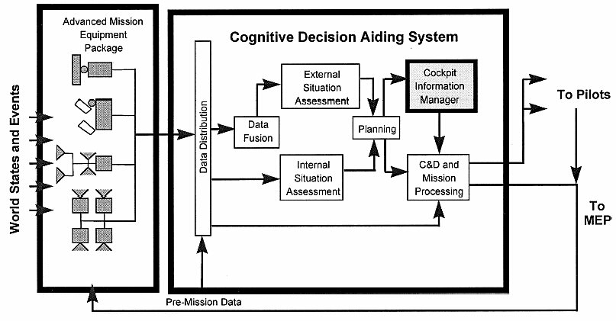
Figure 4: Functional architecture of the RPA [Miller and Hannen 1999]
Simulations studies with the RPA CIM have showed that even though the system is not always correct in its assessments, when giving a choice the test pilot’s prefer flying with all the CIM’s features turned on.

Copilote Electronique
Unlike the Pilot’s Associate and Rotorcraft projects technology-driven design approach, the Copilote Electronique project focused on cognitive processing of pilots. The basis of the Copilote Electronique is a cognitive model that describes how the pilot manages his resources in a low-level air-to-ground mission under pressure of time. The model explains how a pilot uses important information, assesses the situation, and tries to reduces uncertainties during his mission. It also takes the limited cognitive resources of a pilot into account. The cognitive model was designed after extensive cognitive processing and activity analysis. The model was then implemented in a computer simulation and tested for validation. Two levels were implemented, one for short-term navigation and one for long-term anticipation and situation adjustment.

CASSY
CASSY is a crew assistance system developed by the Flight Mechanics and Flight Guidance group of the University of the German Armed Forces in Munich Germany in cooperation with the Dornier company. The purpose of CASSY is to guide the pilot with the objectively most urgent task or subtask, while avoiding overload of the crew in planning, decision-making and execution. CASSY primarily focuses on flight planning and pilot error detection in civil (transport) aircraft under instrumental flight rules (IFR). The system permanently shows its assessed situation to the crew and only becomes active when problems are detected. The structure of CASSY is shown below in Figure 5. It includes [Onken 1997]:
- An automatic flight planner that generates a 3D/4D flight plan either autonomously or interactively with the crew. The planner is capable of re-planning during flight if necessary.
- A monitoring module that monitors all pilot actions, aircraft configuration and checks for violations of specific danger boundaries, such as minimum safe altitudes, stall and maximum operating speeds and thrust limits.
- A piloting expert that checks the expected pilot behavior based on the pilot’s current actions
- A pilot intent and error recognition module that compares the expected behavior of the piloting expert with the crew’s actual behavior and identifies the differences.
- A dialogue manager to perform speech recognition and provide synthesized speech output.

Figure 5: Structure of CASSY [Onken 1997]
A working prototype of CASSY has been tested in-flight in a civil transport airplane. About 10 hours of flight has been recorded. An amount of 100 recorded warnings have been evaluated and in 72% of the time CASSY properly detected a pilot error. In 20% of the time CASSY was wrong, warning the pilot unnecessarily. About half of these errors has been attributed to an incomplete knowledge base. The responses of the test pilots were very positive, even though only a part of the system was functional [Onken 1997].

CAMA
CAMA which stands for Crew Assistant Military Aircraft, is basically the CASSY system, but then adapted to be used in military transport aircraft. The CAMA project was initiated in 1992 by the German Ministry of Defense and the system was based on the experiences with CASSY. CAMA has been developed by the same group that built CASSY and in close cooperation with DaimlerChrysler Aerospace, Elektronik System GmbH (ESG), and the Deutsches Zentrum für Luft- und Raumfahrt (DLR) [Onken and Walsdorf 2001]. The architecture of CAMA is based upon CORBA and allows applications to communicate with each other no matter where they are located or who has designed them. CORBA servers provide the knowledge that is being processed by CORBA clients that form the “cognitive” tasks. A picture of is shown below in Figure 6.

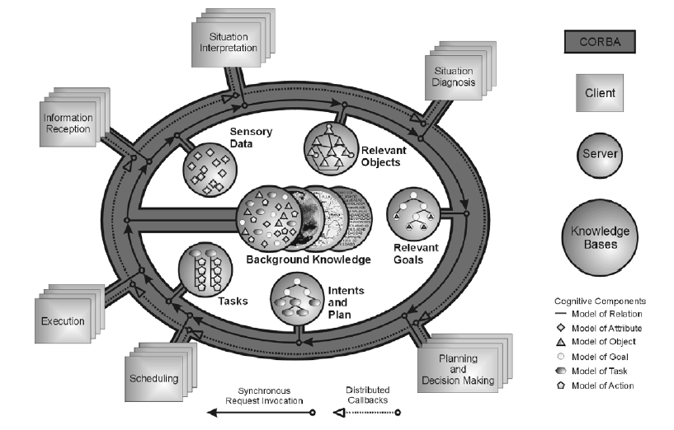
Figure 6: Architecture of CAMA [Onken and Walsdorf 2001]
CAMA uses a state-based approach (Petri-nets) to model the normative pilot actions that follow from the regulations in the aviation handbooks. Case-based reasoning is used to evaluate the pilot’s actual actions and adapt state-transitions so individual pilot’s differences can be learned [Stütz and Onken 2001].
In 1997 and 1998 the first flight simulator test runs with CAMA were performed. In 2000 four separate pilots performed five real life test flights. Results appeared to be successful.

Other projects

Delphins

Power

Cogpit

Flight Deck 2020

Conclusions
Most crew assistance systems seem to focus on military aircraft (e.g. PA, RPA, CAMA). Overall, less attention is given to commercial aviation (e.g. CASSY). We can think of several reasons for this. First of all, practical applications are still a long way off. Funding on CASs is mostly supplied by the Departments of Defense in several countries, who are less reluctant to invest in this kind of long-term research than commercial companies. Second, a military pilot has more to gain from a CAS than a commercial pilot, since their task is much more difficult and dynamic.

CAS functionality

Design issues

The ICE architecture

Figure 7: The ICE system architecture

Situation recognition
Several studies were done that investigated situation recognition. The first study included capturing data from a flight simulator, an analysis of the data, and using a neural network to detect certain state during a flight. The second study consisted of using a rule-based system to determine a particular state. This work was used continued in another direction to include probabilities that specific situations were started of finished. Below we give a short description of the three projects.

The artificial neural network approach
The first attempt to design a system for situation recognition focused on artificial neural networks. Data was captured using the default Cessna airplane of the FlightGear simulator and this data was labelled with one of 7 situations (going up, going down, turning left, turning right, regular flight, standing on the ground and taxiing). In an explorative data study it was found that, using a PCA projection, it is possible to cluster variables and identify these situations (see Figure 8).
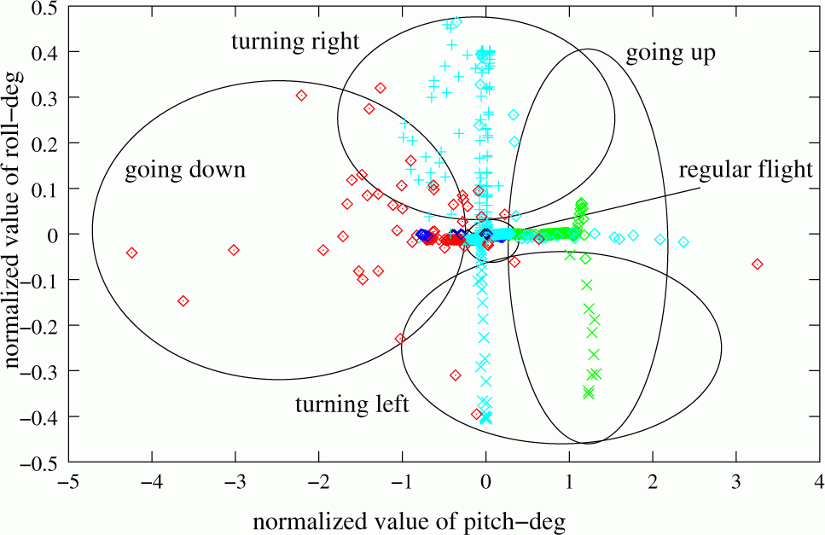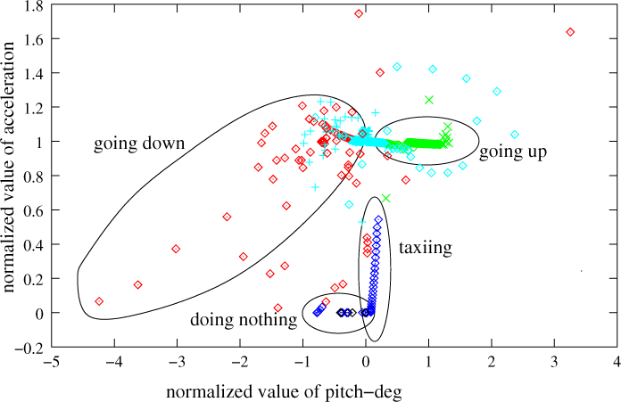
Figure 8: Two projections of flight data: roll and acceleration vs. pitch
An partially recurrent Elman neural network with 2 hidden layers was used to recognize the state of the aircraft. More details about the explorative data analysis and using neural networks for situation recognition can be found in [Čapková et al. 2002].
Artificial neural networks provide a fairly accurate way to recognize and even predict high-level situations. However, there are some important disadvantages. First of all, data is required to train the network and for each type of aircraft data has to be recorded. Second, when small modifications are made to the aircraft configuration or the simulator, the network needs to be retrained. This makes ANN less suitable for rapid prototyping. Third, since an ANN functions as a black box, it is unclear how the network comes to a conclusion. For a CAS, it is desirable that the system can explain its output.

The Pilot Workload Module

Bibliography

Abeloos, A.L.M., Mulder, M., and Van Paassen, M.M. (2000) “The applicability of an adaptive human-machine interface in the cockpit”, in Proceedings of the 19th European Annual Conference on Human Decision Making and Manual Control (EAM 2000), June 26-28, Ispra, Italy.
Banks, S.B and Lizza, C.S. (1991) “ Pilot’s Associate: a cooperative, knowledge-based system application”, in IEEEE Intelligent Systems, Vol. 6, No. 3, pp. 18-29, June 1991.
Endsley, M.R. (1995a) “Toward a theory of situation awareness in dynamic systems”, in Human Factors, Vol. 37, No. 1, pp 32-64
Endsley, M.R. (1995b) “A taxonomy of situation awareness errors”, in Human factors in aviation operations, pp. 287-292, Fuller, R. Johnston, N. and McDonald, N. eds. , Ashgate Publishing Ltd.
Endsley, M.R. (1999b) “Situation awareness and human error: designing to suppport human performance”, in Proceedings of the High Consequence Systems Surety Conference, Alburquerque, NM USA. http://www.satechnologies.com/Papers/pdf/Sandia99-safety.pdf (Jan 8, 2003)
Endsley, M.R. (2000) “Direct measurement of situation awareness: validity and use of SAGAT”, in Situation Awareness Analysis and Measurement, Endley, M.R. and Garland, D.J. eds, Lawrence Erlbaum Associates, Mahwah, NJ USA.
Funk, H. and Miller, C. (2001) “User acceptance and plan recognition: why even perfect intent inferencing might not be good enough”, in Proceedings of the AAAI Fall Symposium on Intent Inference for Collaborative Tasks, November 2-4, 2001, North Falmouth, MA, USA. http://www.siftech.com/English/publications/AAAI-FS-01.pdf (April 10, 2003)
Funk, K. Lyall, B., Suroteguh, C., Owen, G., Sukhia, C., Kurup, R., Wilson, R., Wilson, J., Niemczyk, M. and Vint, R. (1997) “Flight deck automation issues home page”, http://www.flightdeckautomation.com/issues.html (April 7, 2003)
Miller, C.A. and Hannen, M.D. (1999a) “The Rotorcraft Pilot’s Associate: design and evaluation of an intelligent user interface for cockpit information management”, in Knowledge Based Systems, Vol. 12, pp. 443-456.
Miller, C.A. and Hannen, M.D. (1999b) “User acceptance of an intelligent user interface: a Rotorcraft Pilot’s Associate example”, in Proceedings of the international conference on Inteligent User Interfaces (IUI), Redonde Beach, CA, USA.
Mulgund, S.S. and Zacharias, G.L. (1996) “A situation-driven adaptive pilot/vehicle interface”, in Proceedings of the Human Interaction with Complex Systems Symposium, Dayton, OH, August 1996.
Neerinx, M.A. (2002) “Cognitive task load analysis: allocating tasks and designing support”, in Handbook of Cognitive task design, Hollnagel, E (editor). Lawrence Erlbaum Associates, Inc. (forthcoming)
NLR (2000) “Adaptive Cockpit Environment”, memorandum VE-2000-002, Version 1.1, Nationaal Lucht-en Ruimtevaartlaboratorium, The Netherlands.
Onken, R. and Walsdorf, A. (2001) “ Assistant systems for aircraft guidance: cognitive man-machine cooperation”, in Aerospace Science and Technology 5, pp. 511-520, December 2001.
Onken, R. (1997) “The cockpit assistant system CASSY as an on-board player in the ATM environment”, paper presented at 1st U.S.A/Europe Air Traffic Management R&D Seminar, Saclay, France, June 1997. http://atm-seminar-97.eurocontrol.fr (April 14, 2003)
Russell, S. and Norvig, P. (1995) “Artificial Intelligence: a modern approach”. Prenctice-Hall International, Inc.
Schutte, P.C. (2000) “Better machines or better humans?”, in IFALPA Interpilot Magazine 2000, No.2 http://www.ifalpa.org/Interpilot/BetterMachines_00_02.pdf (Oct 31, 2002)
Stütz, P. and Onken, R. (2001) “Adaptive pilot modeling for cockpit crew assistance: concept, realisation and results”, in Proceedings of the 8th European Conference on Cognitive Science Approaches to Process Control (CSAPC’01), September 2001, Munich, Germany.
Svensson, E., Angelborg-Thanderz, M., Sjoberg, L. and Olsson, S. (1997) “Information complexity-mental workload and performance in combat aircraft” in Ergonomics, Vol 40, No.3, pages 362-380, March 1997, Taylor and Francis Ltd.
Taylor, R.M. (1990) “Situational awareness rating technique (SART): the development of a tool for aircrew systems design”, in Situational awareness in aerospace operations (AGARD-CP-478), pp. 3-1 / 3-17, Neuilly Sur Seine.
Veldman, H.E. (1999) “The electronic crewmember, volume 1: survey of previous research”, MSc. thesis, Knowledge Based Systems group, Delft University of Technology, The Netherlands.

